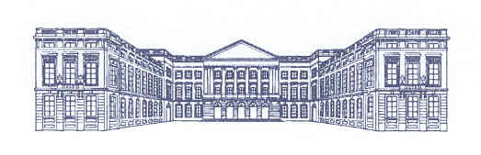
Federal Parliament of Belgium

Conference of the Speakers of the EU Parliaments
Brussels, 4 – 5 April 2011

Draft programme
( date 22.12.2010)

Sunday 3 April 2011

Afternoon | Arrival of the delegations  Welcome and transfer to the hotels.
15.00 – 18.00 | Welcome at the hotels.  Registration and distribution of the Conference dossier and identification badge.
19.00 – 21.00  21.00 | Visit of the Magritte museum followed by a reception.  Evening reserved for embassies

Monday 4 April 2011

Location: Palace of the Nation, seat of the Belgian Federal Parliament, House of representatives.

9.00 | Registration  Entrance: Place de la Nation (main entrance of Parliament)
9.30 | Opening of the Conference - Approval of the agenda  M.André Flahaut, President of the House of representatives  M.Danny Pieters, President of the Senate
9.45 – 12.30 | Topic : Parliamentary scrutiny of the common foreign and security policy, including the common security and defense policy.  Presentation by Mr. André Flahaut, President of the House.
12.30 – 14.00 | Luncheon hosted by the President of the House of representatives,  For the Speakers only.  Venue : reception rooms of the House.  Luncheon hosted by the President of the Senate,  for the Secretaries General and parliamentary officers.  Venue : reception rooms of the Senate.

14.00 – 15.30  15.30 – 16.00  16.00 – 18.30  19.30 | Topic : Parliamentary scrutiny of Europol.  Coffee break (coffee room of the House)  Topic : Parliamentary oversight of the intelligence services.  Presentation by Mr. Danny Pieters, President of the Senate.  Dinner hosted by Mr. André Flahaut, President of the House of representatives and Mr. Danny Pieters, President of the Senate.

Tuesday 5 April 2011
Location: Palace of the Nation, seat of the Belgian Federal Parliament, House of representatives.

9.30  11.00 – 11.30  11.30 – 12.30  12.30 – 13.00  13.00 | Topic : The relationship between Media – Parliaments – Public opinion.  Coffee break (coffee room of the House).  Topic : Participation of national parliaments in the “ European Semester”  Debate on the Conclusions of the Presidency.  Luncheon hosted by Mr. André Flahaut, President of the House of representatives and by Mr. Danny Pieters, President of the Senate.
 | Venue : reading room of the House.

P.S.: an audience with His Majesty King Albert II (for Presidents only) is foreseen on Monday 5 April 2011 hour to be determined.

