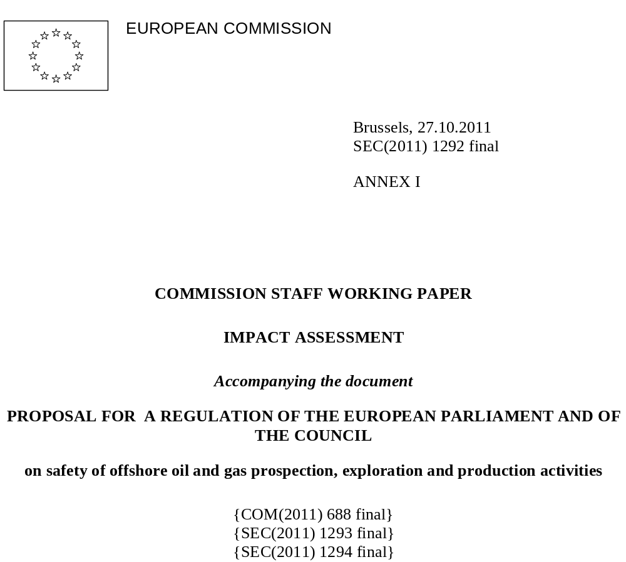
ANNEXES

Annex I | Additional analytical background to baseline scenario
Annex II | List of main meetings with stakeholders
Annex III | Underlying drivers of the problem
Annex IV | Additional analysis of economic, social and environmental impacts
Annex V | Summary of EU acquis applicable to offshore oil and gas activities
Annex VI | Public Consultation questionnaire
Annex VII | Results of the public consultation on improving on Improving offshore safety, health and environment
Annex VIII | Questionnaire to offshore industry
Annex IX | List of studies taken into account
Annex X | Issues amending current legislation (Directives 2004/35/EC, 92/91/EEC and 96/82/EC)
Annex XI | Description and evaluation of the implementation options for individual measures
Annex XII | Overview of industry initiatives (GIRG and OSPRAG)
Annex XIII | Benchmarking between industry sectors and countries

Annex I: Additional analytical background to baseline scenario
This annex addresses the baseline scenario which corresponds to Option 0. It evaluates semi-quantitatively the annualized economic cost of offshore accidents in the EU-27, assuming that no additional EU action/intervention takes place. Because only part of the costs of offshore accidents can be quantified and/or monetised, the purpose of this annex is to define a baseline scenario against which a partial cost-benefit analysis of proposed policy options can later be performed. As such, this annex aims to quantify expected costs where reliable data is available, but it also highlights important qualitative evidence as well as indicative figures that policymakers should also incorporate into their analysis of costs and benefits.
1. Potential costs of an offshore accident
The negative impacts of an accident are hard to quantify precisely; they will of course depend on the type, the scale, the time and the location of the event. In the case of an oil spill, its duration and the type of the oil will also have a major impact. The costs of an offshore accident will include costs to the operator(s) (damage to the installation, lost oil, containment, cleanup, litigation etc.) and third-party costs to victims, to natural resources, the government and the affected individuals/businesses (incl. lost income).
This section will focus on quantifying the two largest directly quantifiable categories of cost incurred as a result of major offshore accidents:
- infrastructure losses; and
- losses associated with oil spills.
The indirect impacts of offshore accidents – their effects on oil prices, the health of the oil industry, or security of energy supply, for example – are not rigorously addressed in this section. These costs may be very substantial, although they are difficult to reliably quantify. For instance, because the price of oil influences the cost of many goods and services in the European economy, oil production shortfalls resulting from major accidents can have a profound economic cost, albeit one that is impossible to measure. In addition, the large revenues in the offshore sector mean that government imposed drilling moratoria may result in significant economic losses. Some have argued that the moratorium on exploratory drilling in the Gulf of Mexico following Deepwater Horizon may have cost billions of dollars and tens of thousands of jobs. Although an in-depth analysis of indirect factors such as those above goes beyond the scope of this report, policymakers should attempt to qualitatively include such factors in any cost-benefit analysis of policies aimed at improving offshore safety.
Furthermore, this section restricts itself to addressing the property losses of ‘major accidents’, defined as accidents resulting in at least one of the following:
- multiple fatalities;
- total loss or severe damage to offshore units;
- a minimum of 1000 barrels, or 136 tonnes, of oil spilt.
Non-major accidents, such as trips, slips and falls, result in less economic loss per incident, but are much more common. Although they are not included in the analysis, these may also decrease as a result of the policies proposed.
Finally, this report does address the costs related the loss of human life (the statistical value of a life is put at €1-2 million by the European Commission and at £1.5 million by the UK HSE). The monetization of human life can pose ethical difficulties, and loss-of-life costs are not estimated to be significant when put into the context of the very large costs this report focuses on.
In light of the difficulties in quantifying the true economic cost of offshore accidents in Europe, this annex aims to use to present policymakers with a broad, but reliable, cost range that is based on the best available data as well as notable case studies.
The Deepwater Horizon disaster demonstrated how huge and far-reaching the consequences of a single accident can be, particularly as regards maritime and coastal pollution. 11 people lost their lives, an estimated 4.9 million barrels (660,000 tonnes) of oil were spilled into the sea and a state-of-the-art drilling rig, valued at US$560 million, was written off as a total loss in the disaster. The oil spill occasioned a response effort involving 48,000 people, 6,500 vessels and 125 aircraft at its peak. Total damages are estimated to reach tens of billions of dollars. In early 2011, BP estimated its costs related to the accident (including costs incurred by the end of 2010 and estimated obligations for future costs) at 40.9 billion dollars. The company committed to pay US$20 billion over a three and a half year period into a Trust Fund out of which legitimate claims are met.
Even a company like BP, one of the largest multinational oil companies, has been shaken by such an accident. In two months, its shares lost more than half their value and still trade well below the pre-accident level. In order to be able to pay the related costs (containment and cleanup, claims from affected businesses and individuals, potential fines/penalties etc.) the company suspended the payment of dividends and initiated a US$30 billion asset divestment program.
Whilst this accident provides one important indication of the potential costs of a similar incident in European waters, significant juridical differences between the US and EU limit the scope for direct comparison. Additionally, the cost of an oil spill depends on a number of variables other than just the simple volume of spillage (see Table 1: Factors affecting the cost of oil spills other than spill volume), and the conditions in much of Europe are unique. For example, a spill in a closed sea with limited natural circulation of water – such as the Mediterranean, the Black or Baltic Seas – will present a different set of challenges than a spill in the Gulf of Mexico. For these reasons, it is important to draw on previous European case histories as much as possible.
Table 1: Factors affecting the cost of oil spills other than spill volume
Location: The costs incurred per unit of spilled oil vary greatly depending on the spill’s location. For example, the extent to which the oil reaches the shoreline is a significant factor boosting the costs of a spill. Moreover, the temperature of the water can make a large difference to its dispersal. Finally, spills can variably reach environmentally or economically sensitive areas, fishing zones or areas with other maritime activities, enhancing the litigation and clean-up costs.
Type of oil: Oil grades vary in terms of gravity, viscosity, volatility, toxicity and other properties, making them more or less difficult and costly to clean up.
Season/weather: In some cases, natural forces serve to either decrease or increase the potential financial impact of an oil spillage. For example, wind speed and cloudiness can respectively affect the dispersal and evaporation of oil spills on the water’s surface. Weather conditions can obviously influence the response efforts as well.
Clean up response/method: In addition to the above variables, the chosen mode of response depends on the legal and regulatory regime governing pollution of the environment. When clean-up methods are required (i.e. when natural clean-up is deemed deficient), the cost of dispersants, in-situ burning and the use of tools such as booms, as well as total labour costs need to be taken into account.

Statistically, the vast majority of reported major accidents in Europe do not result in significant spillages of oil, certainly not at a scale similar to the Gulf of Mexico disaster. In spite of this, the loss of life and/or damage to infrastructure resulting from the most common major accidents – helicopter crashes, explosions, collisions and capsizes – can be very significant. In these cases, the costs are borne by the operator and its insurer, and principally include asset loss, salvage and repair operations and compensation claims. Case histories of such accidents indicate that these costs sometimes run into hundreds of millions of euros, and may exceed €1 billion depending on their severity and the extent of damage, as demonstrated by the Piper Alpha accident (see Table 2: Major property damage losses to North Sea offshore facilities).
Table 2: Major property damage losses to North Sea offshore facilities
Installation | Location | Type | Date | Cause | Cost | Loss of Human Life
Piper Alpha | UK – North Sea | Platform | 6/7/1988 | Explosion | $1.6 billion | 167
Ekofisk | Norway – Continental Shelf | Unmanned platform | 4/6/2009 | Collision | $750 million | 0
Sleipner A | Norway – Continental Shelf | Concrete deepwater structure | 23/8/1991 | Structural failure | $720 million | 0
Ocean Odyssey | UK – North Sea – Shearwater Field | Semi-sub drilling rig | 22/9/1988 | Blowout | $98 million | 1

In cases where there is a significant release of oil and/or gas, additional major costs derive from clean-up and removal costs, impairment of natural resources and correlated economic activities, potential fines or penalties, as well as legal liabilities to third parties, e.g. for loss of earnings in the fishing and tourism sectors. The Deepwater Horizon disaster has demonstrated that these costs can be many times that of the loss of infrastructure, particularly in the case of incidents known as blowouts, where formation fluid flows out of the well or between formation layers after all the predefined technical well barriers or the activation of the same have failed.
Insurance companies consider that, in the offshore sector, blowouts carry the biggest risk in terms of the extent of damage. This is because of the potentially great spill volumes involved in such incidents – one significant reference point for assessing the costs of an offshore incident. While oil spills can also occur as a result of other types of incidents (e.g. collisions, pipeline ruptures), the overall amount of oil released in those cases is likely to be limited. In the case of a blowout, however, oil may be released at a high rate for weeks, or even months, until either successful intervention stops the flow of oil or pressure within the oil reservoir diminishes sufficiently. Because of this, the reinsurer Munich RE proposed in September 2010 a mechanism that would allow the global insurance and reinsurance industry to provide Gulf of Mexico operators with up to a US$20 billion cushion for specialized drilling operations; significantly more than the US$1-1.5 billion limit that covers on the international insurance market are generally subject to. Historical data show that the two largest accidental oil spills at sea have been caused by blowouts (see Table 3: The 10 largest accidental oil spills in the last 50 years).
Table 3: The 10 largest accidental oil spills in the last 50 years
Tanker/installation | Location | Type | Date | Spill volume (tonnes)
Deepwater Horizon | United States | Blowout | 2010 | 666,400
Ixtoc 1 | Mexico | Blowout | 1979 | 476,000
Atlantic Empress | Trinidad and Tobago, Barbados | Tanker | 1979 | 287,000
Nowruz Oil Field | Iran | Blowout | 1983 | 272,000
ABT Summer | Angola | Tanker | 1991 | 260,000
Castillo de Bellver | South Africa | Tanker | 1983 | 252,000
Amoco Cadiz | France | Tanker | 1978 | 223,000
Haven | Italy | Tanker | 1991 | 144,000
Odyssey | Canada | Tanker | 1988 | 132,000
Torrey Canyon | UK | Tanker | 1967 | 119,000

The largest oil spill in Europe resulting from offshore oil activities probably occurred on the Ekofisk Bravo platform in Norwegian waters. As a result of a blowout in April 1977, an estimated 80,000–126,000 barrels of oil (about 2% of the Deepwater Horizon spill) was discharged during the course of a week before the leak was stopped. Rough seas and higher than average air temperatures aided the break up of much of the spilled oil, and as a result no major ecological damage resulted.
Given the low frequency of major oil spillages from offshore facilities in Europe, another way of estimating the financial cost of potential spills is to use figures from tanker spills as a proxy for such accidents, mindful of some qualifications. There have been several such disasters in the European maritime transport sector which demonstrated the potential consequences of an oil spill. The sinking of the Erika and the Prestige tankers in 1999 and in 2002, respectively, triggered new EU-legislation as regard to maritime transport.
Although the volumes spilled were much lower than in the case of the Deepwater Horizon, the Erika and Prestige accidents are considered the greatest environmental disasters to ever hit France and Spain, respectively. In case of the Erika, about 19,000 tonnes of the 30,000 tonnes of heavy fuel it was carrying were spilled. About 400 kilometres of coastline were polluted, causing serious damage to marine and bird life, fisheries and tourism. In 2000, these damages were valued at € 400 million. In case of the Prestige tanker, it is thought that more than 80% of its 77,000 tonne load of fuel oil was released into the sea. The oil spill polluted thousands of kilometres of Spanish and French coastline, as well as causing great harm to the local fishing industry. According to some estimates, the damages amounted to over € 5 billion.
Because more comprehensive data exist for tanker spills, studies have used these data to propose an indicative cost per unit of oil spilled – an exercise that addresses the analysis-skewing effects of concentrating on a select few high-profile cases. In March 2010, the International Maritime Organization’s Marine Environment Protection Committee considered independent statistical studies by Greece, Japan and Norway on global oil spill compensation data. These studies showed very similar non-linear functions of total spill cost versus spill weight, obtained by regression (see Table 4: Non-linear functions of total spill costs (obtained by regression)). The body decided to use the formula proposed by Greece as its basis for their volume-dependent calculations of spill costs.

Table 4: Non-linear functions of total spill costs (obtained by regression)
Reference | Total spill cost function,  V = spill weight (tonnes) | Data source
Japan: Yamada 2009 (MEPC 59/17/1) | 38,735V^{0.66} | IOPCF
Norway: Psarros et al. 2009  (MEPC 59/INF.21) | 60,515V^{0.647} | IOPCF, Safeco project
Greece: Kontovas et al. 2009  (MEPC 60/17, annex 2) | 51,432V^{0.728} | IOPCF
Care must be taken when using compensation costs as a proxy for the true economic cost of an oil spill because the scope of the compensation regimes and the admissible claims are not all-inclusive (for example, they may exclude long-term damage to ecosystems), and the total amount of compensation is capped. Formulae derived from such data therefore underestimate true spill costs. Using the IMO formula 51,432V^{0.728}, the costs of the Deepwater Horizon oil spill would be just over US$893 million, a figure around 45 times smaller than the costs estimated by BP.
The above illustrates how the experience of previous tanker oil spills can lead to the underestimation of the costs associated with the Deepwater Horizon disaster. This is because existing conventions stipulate that compensation is only payable for the costs of “reasonable” measures taken to combat oil at sea and to protect resources vulnerable to oil. However, major and long-lasting oil spills often give rise to strong public reactions putting the government and other public authorities responsible for spill response under considerable pressure to intervene. Offshore blowouts pose the greatest risk in terms of sheer spill volume, and influences such as the above were unquestionably in operation during the months the Deepwater Horizon disaster lasted. The Commission believes that should a comparable blowout occur in European waters, it can be expected that similar public sentiments and political pressures would drive up the ultimate costs of cleanup and compensation. This view is reinforced by the UK House of Commons conclusion that: “Given the high costs of the incident in the Gulf of Mexico, we believe that the OPOL (Offshore Pollution Liability Association) limit of $250 million is insufficient.”
Given the shortcomings of the IMO formula, an alternative source on spill costs can be found in a study by Dagmar Etkin. This sought to approximate per-unit marine oil spill clean-up costs in different geographic locations by examining historical data. In general, spills in more-developed nations with high labour costs, complex regulations for spill response and high standards for environmental protection were found to be more expensive. Some of the data from this study are presented in Table 5: Average Per-Tonne Marine Oil Spill Clean-up Costs by Country (1999 US$). It should be noted that these figures are for clean-up costs alone, and do not include third-party damage claims or natural resource damage costs which may be incurred in addition. The drawback of a fixed per-unit scale such as this is that smaller spills are more expensive on a per-unit basis than larger ones, and therefore this analysis may overestimate the clean-up cost of very large spills. According to the figures in this table, the clean-up costs of the Deepwater Horizon oil spill would be US$18.8 billion – an amount around 38% above BP’s own spill-response figures of US$13.6 billion. Nevertheless, this figure is much more in line with the Deepwater Horizon experience than the figures for tanker spills used by the IMO, and as such will be used as a basis for calculations further on in this annex.
Table 5: Average Per-Tonne Marine Oil Spill Clean-up Costs by Country (1999 US$)
Denmark | 12,324.29
Estonia | 7,518.45
Finland | 2,331.71
France | 2,537.06
Germany | 11,797.67
Greece | 9,403.04
Ireland | 5,299.35
Italy | 7,210.43
Latvia | 10,154.88
Lithuania | 86.11
Netherlands | 7,336.29
Norway | 25,483.32
Spain | 483.56
Sweden | 17,242.75
UK | 3,398.21
United States | 28,235.30

A final source on the potential costs of a blowout in Europe is environmental reports from the offshore industry itself. In February 2011, the environmental statement of the US oil company Hess, seeking to drill a deepwater well off Shetland, received much publicity. In the worst case scenario identified by the document, more than 4 million barrels (550,000 tonnes) of oil could spill into the sea over a period of just over 2.5 months and spread as far as Iceland, Ireland, Norway, the Netherlands and the northeast coast of England. The document also suggests that because of the weather conditions (wind, waves, currents) "surface containment and recovery equipment are unlikely to be effective". We can combine the spill volumes in this scenario with the per-unit marine oil spill clean-up costs to estimate the costs of an accident in Europe.
In the event of a subsea blowout whereby the blowout preventer has failed and oil is freely flowing into the sea, Hess estimates it may take “considerably longer than 1 week” to install a cap that would stop the flow from the well. Assuming this intervention takes 10 days, is successful, and a steady release rate of 88,000 barrels (12,005 tonnes) of oil per day is maintained until the spill is capped, the figures from the Etkin study presented in Table 5: Average Per-Tonne Marine Oil Spill Clean-up Costs by Country (1999 US$) estimate that the spill would result in US$ 1.4 billion in clean-up costs. In Hess' worst case scenario of a 2.5 month, 550,000 tonne release, the spill would cost US$ 6.6 billion to clean-up, according to this same formula. This supposes that the spill affects the UK, Norway and the Netherlands equally. It is to be emphasized, again, that these figures are only for clean-up costs and do not include third party liabilities nor other potentially substantial economic costs. In the case of Deepwater Horizon, BP estimated such additional costs to be around twice the clean-up costs incurred.
In conclusion, the evidence shows that it is very difficult to generalize about the economic costs of offshore accidents. Nevertheless, for the purposes of this study we can assume that the average property damage cost of a major accident is €50 million. In the case of large blowouts in European waters (over 500,000 tonnes), we can assume that directly quantifiable costs for cleanup and compensation will be between €5 billion and €30 billion. This range is estimated using the cleanup-only cost calculations in the paragraph above as a lower bound, and BP-estimated Deepwater Horizon costs as an upper bound. It does not include indirect costs such as the effect on oil prices, the health of the oil industry, or security of energy supply. Although unquantifiable, these costs could also be very significant. They should, therefore, also be factored into any cost-benefit analysis of policies aimed at improving offshore safety, albeit qualitatively.
2. The probability of an offshore accident
Risk is the product of frequency and consequence. Accordingly, high consequence events which occur infrequently may contribute as much risk as frequent events which have smaller consequences. Estimating the frequency with which events occur is as important to overall risk as accurately predicting the consequences. One way of estimating frequency is to look at historical records.
The OGP risk assessment data directory for major accidents was compiled to serve as an industry reference for quantitative risk assessments. It identifies 98 major accidents that have occurred in the North Sea in the years 1970-2007, including helicopter accidents. Whilst this gives an aggregated rate of 2.6 per year, it should be noted that there has been a steady and impressive reduction in the number of offshore accidents in the North Sea throughout this time period.

Figure 1: Fatal, Major and Over-3-Day Injury Rates to Offshore Workers on the UK Continental Shelf, 1995/1996 – 2009/2010 (provisional)
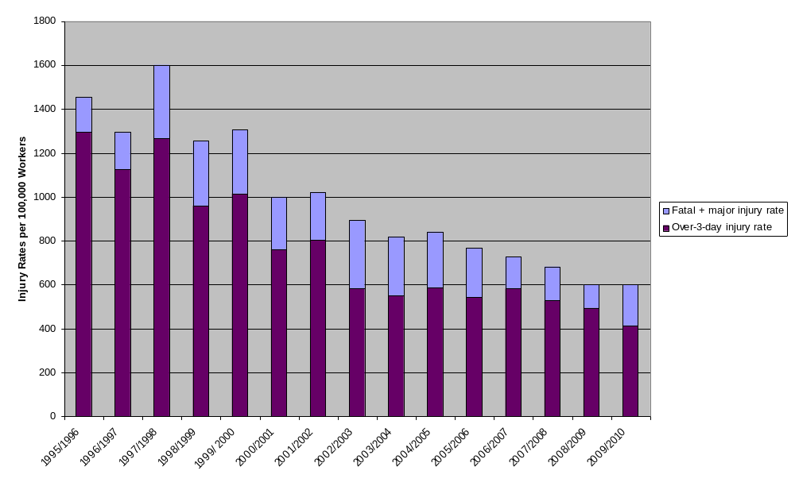
Assuming the major accident rate is now half what is was during the time period of the OGP report, and assuming that the average property damage cost of each major accident is €50 million, this gives an annual figure of €65 in major accident costs, not including costs related to oil spills or the loss of human life (the value of statistical life is put at €1-2 million by the European Commission and at £1.5 million by the UK HSE).
As previously mentioned, blowouts are the category of accident that have the greatest magnitude of potential loss in the offshore sector because of the large oil spills that may result from them. Historical records indicate that very large spills resulting from blowouts are comparatively rare.
The SINTEF Offshore Blowout Database includes 573 offshore blowouts/well releases that have occurred worldwide since 1955, suggesting that such incidents are not uncommon. SINTEF states that most blowouts occurring in the US Gulf of Mexico, Norway and the UK since 1 January 1980 have been included in the database. The database is an industry reference for blowout risk, its data serving as the basis for numerous notable benchmark studies for risk assessment.
According to this database, 64 well releases or blowouts occurred in UK and Norwegian waters between 1 January 1980 and 1 January 2008, i.e. on the average 2.3 per year. For comparison, in the same period 8,283 wells were drilled in the UK, including 1,690 exploration wells, 1,339 appraisal wells and 5,254 development wells. In Norway, 1,036 exploration wells and 2,801 development wells have been drilled in this period.
A recent annual Scandpower report based on SINTEF data compares the risk of different offshore activities. The report reveals that, among the various phases of offshore operations, exploration drilling entails the highest risk of blowout. In case of deepwater, high-pressure/high-temperature (HPHT) wells, the blowout frequency is 1.9×10⁻³ per drilled well “for offshore operations of North Sea standard”. In case of deepwater, but “normal” wells, the frequency is only 3.1×10⁻⁴, i.e. one order of magnitude smaller. The reason the blowout frequency of HPHT wells is significantly higher is not believed to be the high pressure itself, but rather the small margin between pore pressure and fracture pressure in such wells. The probability of a blowout during other activities, like development drilling, completion or production is well below that of exploration drilling, typically in the order of 10⁻⁴ or 10⁻⁶ per operation or well year.
According to the UK Health and Safety executive, an individual risk of death of 10⁻³ per year has typically been used within the offshore industry as the maximum tolerable risk. For comparison, acceptable annual failure probabilities in the nuclear industry are typically in the order of or 10⁻⁶ or better.
In order to use the Scandpower figures to calculate the overall likelihood of an offshore blowout in EU waters, we also need to know the number of active production wells and the annual frequency of different operations that may result in a blowout – necessary because probabilities are expressed in either a per well year or per operation format. Whilst regulators have supplied reliable figures for former, to the best of our knowledge no comprehensive EU-wide source exists providing the latter. We can, however, estimate the frequency of operations that may result in a blowout in Europe by looking at their respective frequencies per well year in the SINTEF database, and scaling these proportions by the number of active wells in Europe (see Table 6: Annual Probability of at least 1 Blowout for Offshore Operations in Europe). This method assumes that: a) the proportion of different operations per well year in the SINTEF database does not significantly differ from that in the North Sea at present; and b) that the sampling bias in this data is within acceptable tolerances.
Table 6: Annual Probability of at least 1 Blowout for Offshore Operations in Europe
Operation |  |  | Blowout Probability / Unit | Unit | Annual No. Units in European Waters | Annual Probability of at least one Blowout in European Waters
Drilling |  | Exploration Drilling, deep (normal wells) | 3.1×10⁻⁴ | per drilled well | 383 (estimated) | 1.1×10⁻¹
 |  | Exploration Drilling, deep (HPHT wells) | 1.9×10⁻³ | per drilled well | 29 (estimated) | 5.3×10⁻²
 |  | Development Drilling, deep (normal wells) | 6.0×10⁻⁵ | per drilled well | 635 (estimated) | 3.7×10⁻²
 |  | Development Drilling, deep (HPHT wells) | 3.7×10⁻⁴ | per drilled well | 48 (estimated) | 1.8×10⁻²
Well Intervention |  | Completion | 9.7×10⁻⁵ | per operation | 608 (estimated) | 5.7×10⁻²
 |  | Wirelining | 6.5×10⁻⁶ | per operation | 10735 (estimated) | 6.7×10⁻²
 |  | Coiled Tubing | 1.4×10⁻⁴ | per operation | 505 (estimated) | 6.8×10⁻²
 |  | Snubbing | 3.4×10⁻⁴ | per operation | 316 (estimated) | 1.0×10⁻¹
 |  | Workover | 1.8×10⁻⁴ | per operation | 1074 (estimated) | 1.8×10⁻¹
Producing Wells (excluding external causes) |  |  | 9.7×10⁻⁶ | per well year | 6315 | 5.9×10⁻²
Producing Wells (external causes) |  |  | 3.9×10⁻⁵ | per well year | 6315 | 2.2×10⁻¹
 |  |  |  |  | Total: | 6.45×10⁻¹

The last column of Table 6: Annual Probability of at least 1 Blowout for Offshore Operations in Europe shows the annual probability of occurrence of at least one blowout because of any of the potential causes. These probabilities are calculated as follows:
Let’s call 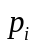 the probability of occurrence (per drilled well, operation or well year, depending on the case – probabilities shown in column 3) of a blowout because of any of the 11 possible causes considered (11 rows in Table 6: Annual Probability of at least 1 Blowout for Offshore Operations in Europe). In order to get no blowout a given year because of a given possible cause, there should not occur any blowout in any of the individual trials (operation or well year). For an arbitrary possible cause , the probability of occurrence of no blowout, 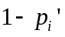, is the probability of not experiencing a blowout in each single attempt:

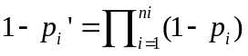.
In this expression 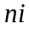 represents the number of operations or well years. The hypothesis of independence between events has been adopted (what happens in one operation or well does not affect what happens in any other one).Thus, the probability of occurrence per year of at least one blowout for each possible cause is (last column):
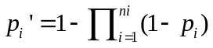
By means of a similar rationale, calling 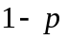to the probability per year of occurrence of no single blowout from any possible source, it may be deduced that the probability of occurrence of at least one blowout is:
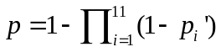
Table 6: Annual Probability of at least 1 Blowout for Offshore Operations in Europe thus indicates that the annual probability of at least one blowout in European waters is around 6.5×10⁻¹, or 65%. Other reliable studies corroborate this figure. A report presenting the results of projects undertaken by Det Norske Veritas on behalf of the UK Health & Safety Executive assesses the annual probability of a blowout to be 5.6×10⁻⁴ for every fixed offshore installation on the UK continental shelf and 4.7×10⁻³ for every floating installation. Given that there were 272 fixed and 42 floating installations deployed in UK waters in early 2011, this suggests a total annual probability of 3.0×10⁻¹ for at least one blowout – a 30% chance each year in the UK alone.
This is not to suggest that Europe can expect an event on the scale of the Deepwater Horizon disaster every one to two years. First, the blowout probabilities presented in Table 6: Annual Probability of at least 1 Blowout for Offshore Operations in Europe are for both oil and gas wells in Europe combined, but Scandpower calculates that the blowout frequency for gas wells is 2.6 times that for oil wells. Assuming an equal number of oil and gas wells in Europe, the annual Scandpower-based probability of at least one oil well blowout in Europe is therefore 1.8×10⁻¹, i.e. 18% per year.
Secondly, history tells us that only a fraction of blowouts have lasted long enough to result in major spills. More work needs to be done to quantify the probability of a massive spill given a blowout, however Det Norske Veritas has used the SINTEF database to calculate expected blowout duration figures for a hypothetical conventional well drilled in 337 metres of water in the Norwegian Sea using state-of-the-art technology and modern procedures. These figures reveal that should a blowout occur, there is a 56% chance of it lasting 2 days or less, and only a 15% chance of it lasting more than 2 weeks.

Table 7: Probability distribution of blowout durations
Duration range (days) |  | < 0.5 | 0.5-2 | 2-5 | 5-14 | > 14
Representative duration (days) |  | 0.5 | 2 | 5 | 14 | 50
Probability | Topside (20%) | 0.49 | 0.19 | 0.12 | 0.13 | 0.07
Probability | Subsea (80%) | 0.33 | 0.2 | 0.14 | 0.16 | 0.17

Assuming that these conditions represent the typical conditions for drilling in Europe, we can calculate that the annual probability of Europe experiencing at least one oil well blowout lasting for over 14 days (with a representative duration of ca. 50 days) is 2.7×10⁻² – an expected recurrence rate of around 37 years.
In summary, historical figures suggest that the recurrence rate for a major oil spill from an offshore blowout in Europe is more likely to be in the order of decades rather than centuries. Assuming a recurrence rate of 35 years and an average economic cost of €5 to €30 billion, this amounts to costs of €140 to 850 million per year. Add to this an annual figure of €65 million in property losses resulting from less costly, but more common, major accidents, and we can estimate a total annual figure of €205 to €915 million in direct, tangible costs for offshore accidents in Europe. These figures do not include indirect costs such as the effect on oil prices, the health of the oil industry, or security of energy supply. Although unquantifiable, these costs must also be factored into any cost-benefit analysis of policies aimed at improving offshore safety, albeit qualitatively.
Policymakers should bear in mind a number of caveats when interpreting the above conclusions.
On the one hand, these conclusions can be considered to be conservative estimates (i.e. on the high side) because although the blowout probabilities from Scandpower are stated as being “for offshore operations of North Sea standard”, some probabilities are derived from data that includes operations in the US Gulf of Mexico where two barriers against formation fluids are also required. Nevertheless, Det Norske Veritas notes that the blowout frequency for the Gulf of Mexico is approximately 9 times higher than in the North Sea, and that the Scandpower probabilities overestimate the chance of a blowout when used in the European context.
Also, Det Norske Veritas notes that successive annual Scandpower reports suggest that the blowout frequency from an exploration well has been reduced by a factor of more than 3.5 over the last 10 years, from 5.5×10⁻⁴ to 1.54×10⁻⁴. While the frequency of a blowout has been reduced, probability figures are based on information collected over a 20 year period in the past, meaning that they should be considered lagging indicators. Historical blowout data reflects neither regulatory improvements nor the latest improvements in the industry related to state-of-the-art drilling technology, barriers with improved technical integrity and better operating procedures.
On the other hand, the abovementioned conclusions do not attempt to anticipate trends in European offshore drilling operations. Although drilling expertise may be improving, the Norwegian and UK regulators have indicated that deeper wells are being planned in their waters, and that high temperature, high pressure and more challenging wells will continue to be drilled. Operators are attempting increasingly technically ambitious operations, and they are expanding their operations to new, often environmentally sensitive areas. Additionally, an increased number of smaller companies are entering the market as the major oil companies sell off older, non-cost effective assets. These smaller companies aim to remain profitable by having a smaller cost base and extending production from these ageing installations and mature fields.
Text box: How dangerous is a particular drilling operation?
Insurers indicate that risk factors for offshore operations include:
1) The worst case discharge rate from a well;
2) The time it would take to drill a relief well;
3) Water and drilling depth;
4) Well temperature;
5) Well angle; and
6) Well pressure.

Additionally, the Scandpower probabilities have a great uncertainty in light of the small number of blowouts upon which they are based. This is to say that where incidents are infrequent, just one additional incident may significantly increase the statistical frequency. This uncertainty has not been quantified by Scandpower; however, some consider that well blowouts resulting in the uncontrolled release of hydrocarbons have happened too infrequently in Europe for a reliable analysis of the historic frequency to be carried out.
Moreover, there are limits as to what historical frequencies are able to reveal. Qualitative information can provide an early warning of an increase in risk so that relevant and effective preventive measures can be put in place in time. In connection with this, reported “near-misses”, in which slightly changed circumstances could have developed into a major accident, suggest the risk of a blowout in Europe is not remote. Just one month after the Deepwater Horizon disaster, on 19 May 2010, well control was lost on the Gullfaks C installation in Norway; according to the Norwegian Petroleum Safety Authority (PSA): “Only chance averted a sub-surface blowout and/or explosion, and prevented the incident from developing into a major accident”. The PSA’s investigation of the incident identified serious deficiencies in the operator’s planning of the drilling and completion operation in this well. Management checks that activities were being conducted satisfactorily were also inadequate.
In light of the above, policymakers should bear in mind the precautionary principle, stating that in the face of scientific uncertainty it is preferable to err on the side of caution, until a thorough data analysis along the lines sketched in this annex is able to clarify the unknowns.
Annex II: List of main meetings with stakeholders
Date | Meeting/Interlocutors
Meetings with industry
11/05/2010 | Commissioner Oettinger and Commissioner Georgieva meeting with high level representatives of the industry
14/07/2010 | Commissioner Oettinger, Commissioner Georgieva, Commissioner Damanaki and Commissioner Potočnik meeting with high level representatives of the industry
29/03/2011 | The International Association of Oil and Gas Producers (OGP) reported to Commissioner Oettinger on industry measures to improve the safety of offshore operations
15/11/2010 | Meeting with the EU Committee of the International Association of Oil and Gas Producers (OGP)
16/05/2011 | Meeting with members of the International Association of Oil and Gas Producers (OGP), working under the GIRG/WEC remit.
03/08/2011 | Meeting with members of the Subsea Well Response Project, working on the development of well capping and containment equipment.
Meetings with regulators
14/07/2010 | Commissioner Oettinger meeting with high level representatives of national regulators
25/06/2010 | Working level meeting with national regulators
15/09/2010 | 1st NSOAF-EU joint workshop with national regulators
10/12/2010 | 2nd NSOAF-EU joint workshop with national regulators
01/03/2011 | 3rd NSOAF-EU joint workshop with national regulators
29/03/2011 | 4th NSOAF-EU joint workshop with national regulators
29/06/2011 | 5th NSOAF-EU joint workshop with national regulators
18/07/2011 | 6th NSOAF-EU joint workshop with national regulators
Meetings with stakeholders within the Berlin Forum process
18-19/10/2010 | Berlin Fossil Fuels Forum plenary meeting with a session dedicated to offshore safety
06/07/2010 | Meeting of the Berlin Fossil Fuels Forum Indigenous Fossil Fuels working group
21/09/2010 | Meeting of the Berlin Fossil Fuels Forum Indigenous Fossil Fuels working group
20/01/2011 | Meeting of the Berlin Fossil Fuels Forum Indigenous Fossil Fuels working group
07/04/2011 | Meeting of the Berlin Fossil Fuels Forum Indigenous Fossil Fuels working group
Meetings with international partners
28/06/2010 | EU-OPEC Ministerial Meeting
19/11/2010 | EU-US Energy Council
23/02/2011 | EU-US Workshop on the progress and outcome of the Deepwater Horizon investigation
07/06/2010 | EC-Norway Energy Cooperation Working Group meeting
20-24/09/2010 | OSPAR Commission / Ministerial Meeting
7-11/03/2011 | OSPAR Offshore Industry Committee meeting
In addition to the above meetings, several bilateral meetings have been held with international and national industry associations, individual companies, national authorities, NGOs and independent verification companies. Furthermore, the Commission has regularly attended the meetings of the G-20 Global Marine Environment Protection (GMEP) group and the Oil Spill Prevention and Response Advisory Group (OSPRAG) established in the UK.
Annex III: Underlying drivers of the problem

1. Drivers related to industry evolution
The offshore oil and gas industry in the EU, and globally, has recently been facing significant changes in its operational environment. These are partly driven by the maturity of many of its traditional operations and they partly stem from discoveries of new hydrocarbon reserves in complex environments, which have been enabled by rapidly evolving technologies. These factors are described below.
1.1 Ageing infrastructure and maturing industrial environment
The industry is increasingly reliant on ageing installations, often in service well beyond their original design lifetime. One reason is that new technology has enabled mature installations to continue to access oil reserves that would otherwise have long been stranded.
In Norway, roughly half of the offshore fields have already exceeded the original field life. In the UK, more than half of the fixed platforms have exceeded the original design life of the field or will do so shortly. The situation is similar for Italy in the Mediterranean. The consequence of the passage of time on the integrity of structures and process equipment is that challenges accrue for the maintenance of reliability. The costs of these challenges are compounded by declining profit margins as production rates in these fields decline.
1.2 Structural shift of the industry towards diversification
The initial operators of ageing platform and declining reservoirs are often led to divest them to smaller, specialist oil companies who have low overheads and are in the business specifically for these low yielding operations. This can lead to a loss of corporate memory concerning the operation of the installation, thus posing a potential safety risk.
The involvement of smaller companies is, however, not inherently undesirable as they generally operate with a shorter decision chain for expenditure (including safety-related). On the other hand, smaller companies often have limited in-house resources, e.g. for well design, and their emergency response capabilities are usually less than those of the larger, original operators who developed the installation.
1.3 Shift to "frontier" operations and new technologies
The scarcity of new discoveries of large, conventional reservoirs has, in recent years, directed the industry to explore more challenging frontier environments. These include high-temperature and high-pressure (HPHT) reservoirs and reservoirs in hostile climatic conditions, in deep water, or in geographically remote locations. For example, in the North Sea the majority of operations have been at depths of 200 to 300 metres, whereas new projects operate as deep as 1,700 metres. There is also a movement towards increasing oil and gas production in the Arctic regions. Similarly, in the Mediterranean and the Black Sea, there is a trend towards expansion offshore activities into more distant areas, partly in deepwater.
In contrast to the Gulf of Mexico, deep-water and HPHT reservoirs in North-Western Europe generally have to contend with more extreme weather and sea conditions. A study of HPHT well performance standards by the UK HSE reported that HTHP operations are set to continue expanding together with a relatively high rate of well control problems – between 1998 and 2003, about 1 such well in 6 experienced some instability.

2. Drivers related to company-specific corporate practice
Besides the drivers that are common to the industry as a whole, levels of risks in the offshore sector are impacted by the practices and behaviours of individual companies. Two main types of drivers can be distinguished here: one type related to the level of use of best available technology and practices, the other reflecting the degree of compliance with the regulatory framework. The latter is often related to the existence of a strong safety culture within a company (or absence thereof). These factors are described in the three sections below.
2.1 Inconsistent use of state of the art practices and technology
Regimes for control of risks in all major accident hazard (MAH) are identified in both the Seveso and Extractive Industries Directives and aim for desirable outcomes rather than specific inputs. Inconsistencies are found in the degree to which companies focus on MAH preventive systems and systemic corporate responsibility (and not solely on individual responsibility, and occupational safety compliance). Despite progress having been made in this area, in the absence of a consistent template for industry (and regulators), greater divergence of practices can in fact be expected. The reason for this is that a greater number of players are expected to engage in offshore exploration and production, brining their own corporate approaches.
2.2 Failures of compliance with rules and standards
Investigations of offshore incidents have frequently found that whilst the planned measures were indeed appropriate to prevent critical events, operators did not maintain or follow them. According to available reports, this seems to have been at least partly evident in the Deepwater Horizon and Montara accidents. Achieving consistency between plans and actual performance is dependent on the degree of compliance with the national regulatory framework and also the internal operating rules and procedures within a company that are designed to comply with the regulatory requirements and which often go further than is legally necessary.
2.3 Inadequate safety culture
Within an organisation, the degree of compliance with external and internal safety rules is directly related to the degree to which safety is prioritised as a standalone corporate value and an integral part of the business model. This is often characterised as a strong "safety culture". Available reports from the USA suggest that gaps in safety culture significantly contributed to the accident of the Deepwater Horizon. Reports by Member States and professional bodies active in offshore operations in the EU agree that those concerns have global impact, including in other European companies . Analysis shows that levels of enforcement in the strongest EU regimes has been broadly constant for the last 10 years. In the most recent report shared between Norway and the UK regulators, Norway reports an upward trend in major hazard potential indicators and finds that companies active in Norwegian waters show lack of consistency in safety performance.

3. Drivers related to the regulatory framework
The level of safety and existence of residual risks in the offshore sector is determined not only by industry practices but also by the quality of the regulatory environment and the oversight enforced by the competent public authorities. Several aspects of the existing EU regulatory environment may affect the industry's management of risk in offshore oil and gas operations. These are described in three sections below.
3.1 Uneven technical expertise amongst regulators
Various Member States responded to the Deepwater Horizon accident by evaluating national regulatory systems. Their initiatives have shown that national regulatory practices vary. While this inconsistency does not necessarily mean that the regimes are ineffective, the variable degree to which national regulators balance the attention given to major hazards and to occupational safety factors in their assessments and inspections influences the behaviour of industry accordingly.
National regulators play a role in verifying that operators correctly account for the safety and long term integrity of their undertakings. It is the regulators that need to provide adequate supervision and guidance to the industry in all relevant EU waters. To achieve this, regulators need to have access to expertise to underpin their interventions and judgements. This can be problematic, especially in cases where Member States have only a handful of offshore installations.
3.2 Suboptimal transparency and sharing of information
Reports on industry performance are most authoritative when prepared by the regulator. Good initiatives exist between some Member States and in some regions for information and experience sharing between regulators. However, there are differences in the extents to which key safety information is acquired and shared across EU borders and to which adequate public assurance concerning the integrity of offshore activities is provided. At present, there are no EU-wide mechanisms for sharing intelligence or for convening regulatory forums, including relevant adjacent regions. Gaps exist in the quality of data in terms of regional coverage (no EU-wide/global data), in terms of comparability (different formats, indicators etc), and in terms of lack of precision (e.g. data from some industry databases are fully anonymised and narrowly focused). These shortcomings appear conspicuous in contrast to arrangements in other high risk industries such as aviation or the chemical industry.
There is also a notable inconsistency in the way relevant information is made accessible to the public. Most national regulators make available information concerning breaches of law (prosecutions, the issue of enforcement notices) either through publishing lists, or having registers that can be viewed by the public. Such enforcement reports give an incomplete picture, however, and are not comparable between jurisdictions. In addition, some regulators publish annual reports of safety performance in their offshore jurisdictions. Taking the EU as a whole, there is no system to provide the public with easily accessible and comparable information on the offshore activities of companies and their regulators in all EU regions.
To summarise, benefits of transparency in encouraging key learning and continuous improvement across the EU are being missed. Complex procedures for accessing information are hindering the development of new research and reducing peer pressure for the use of state of the art safety practices.
3.3 Fragmented regulatory framework
International law covering offshore exploration and production is much less comprehensive than in maritime transport and mainly deals with rights of access to reserves in adjacent seas. Not surprisingly therefore wide differences exist in how the sector is regulated around the world. European and some other states – Canada, Brazil, Australia and New Zealand – have adopted a goal setting regime. Some countries have a more prescriptive regulatory regime while others have de facto no discernible safety regulation.
Discrepancies between different regulatory regimes lead to considerable variations in costs for the industry. In countries that rely on self-regulation, industry can deploy rigs and equipment that would not be tolerated in the North Sea. The EU has an interest in seeing a global level playing field with suitable standards of performance. One clear example of this interest is that Member States can be directly affected by incidents in adjacent, non-EU waters. Achieving a consistent EU approach to offshore safety and environmental protection will greatly assist the EU to promote higher standards beyond the EU.
In addition, no Member State has developed a holistic, independent, single offshore regime that encompasses major hazards to both humans and the environment and that takes account of civil liabilities. Whilst the risks arising from oil and gas activities are broadly similar everywhere, the national organisations in the EU Member States vary considerably.
The differences in the regulation of offshore activities are even more marked when moving from the North Sea to other EU regions. Whilst there are similarities in offshore hazards, the regulation of them outside the North Sea is less clearly related to the global model.
Expressed in terms of safety and reliability, the engineering and product selection options for design and operation would be better supported by the availability of a comprehensive syllabus of EU-suitable standards as an accompaniment to quantitative risk assessment. At the moment, offshore product safety is not comprehensive because existing EU product safety legislation doesn't apply to MODUs, which are considered to be 'ships'. Therefore consistent and high safety requirements for MODUs are only assured in countries where a formal safety assessment regime exists (e.g. the UK, Netherlands and Denmark, who use a risk based approach to regulation).
4 Drivers related to the state of risk-based planning
Whilst it is entirely proper that most emphasis needs to be paid to preventing major incidents, the risk can never be entirely discounted and so provisions need to be present for suitable and sufficient preparedness and response. The factors that make escalation a higher risk than necessary are inadequate risk assessment in emergency plans, lack of joined-up responsibility for response (failure to maximise the resources available), and incompatibility of physical assets and expertise of an incident.
The current regional arrangements for risk based maritime response planning across the EU are not optimal vis a vis ensuring oil and gas activity is properly considered. In the Baltic region, the BRISK project has demonstrated an effective model for such risk based planning for maritime vessels. Other regions such as the Mediterranean and the North Sea are also developing a similar approach. At present, there are EU-wide coordination schemes and EU-level instruments like the Civil Protection Mechanism which play an important role in the coordination of emergency response and provide information on the availability of public resources for emergency response.
The two underlying drivers for this issue are further highlighted below.
4.1 Inconsistencies in emergency planning between MS
The external emergency plans – those pertaining to a national emergency – also depend on the adequacy of the initial risk assessment by the operator so the same concerns must apply to preparedness for a national scale offshore incident as for a localised 'internal' incident in some regions. In addition, a national scale emergency will require the deployment of national assets, coordination by national representatives, consideration to adjoining Member States and others, and the support of EU marine contingency organisations such as EMSA. Some Member States do cooperate with neighbours on emergency planning – particularly so where risk based regimes facilitate the development of site specific risk based scenario planning.
It is also essential to coordinate the essential environmental sensitivity data relating to the state of the water column and the seabed so that the correct response can be planned if an emergency arises. At present, these data are not consistently collected and collated throughout the EU.
Finally, there are few current initiatives for building capacity amongst non EU countries with which the EU shares marine assets. Without specific attention to this, emergency planning will be less holistic and reliable in those regions than where EU has full jurisdiction.
4.2 Cross-border incompatibility of response assets
Companies operating in the Gulf of Mexico (which also operate in EU waters) clearly failed to assess all the possible scenarios of a major incident in a routine and systemic fashion. Therefore the emergency response to Deepwater Horizon had to be conducted as the incident unfolded which is entirely in contradiction of the conventions for civil contingencies. The operator – BP – commanded great resources and expertise. Equally the national contingency resources of the USA exceed those of any nation on earth. Clearly neither attribute may be present in some EU offshore emergency scenarios.
Industry has responded with resolve to the Deepwater Horizon incident and is actively researching multi functional devices for capping damaged wellheads and for solutions for containing and dispersing major spills. This is commendable and must be encouraged to continue. But we have seen that whatever the state of technology, a major offshore emergency response requires all that the industry can furnish, plus that which national civil contingency can provide, with all adjoining countries contributing.
On the matter of compatibility of the response equipment and services, only the immediate response tools need to be available at the site of the accident, or in close proximity. Other necessary equipment may be available at a distance, even if it is in a different continent. The identified need is for the rapid transportation of equipment that can be connected to locally available equipment and which may be handled using available lifting and transport systems. This applies also to human expertise.
5 Drivers related to the integration of public and industry emergency plans and assets
The maritime safety and response arrangements in the EU provide for joined up planning and intervention in a maritime emergency including for pollution incidents. Compared to this benchmark it is clear that the offshore oil and gas sector – which has the capacity to cause pollution many times greater than any single shipping incident – can attain a greater degree of joined up planning between Member States than at present, taking the EU as a whole. Given the specialised nature of the offshore sector – which is a sea based factory environment not shipping, maritime standards are not fully adequate and therefore the risk of a major incident escalating further than necessary remains. The specific drivers for this category are discussed below.
5.1 Lack of information on industry emergency response inventories
In order that the national emergency response plan (in Seveso terms the 'external' emergency plan) is effective for the scenario of a major incident in the oil and gas industry, it is essential that the plan accounts for all emergency response assets and inventories that the industry or operator himself can supply or make available at the start of and during the incident. As such, this would ensure coordination of assets and inventories required for the incident, to make effective and efficient use of available resources. Before the Deepwater Horizon incident, there are indications that the coordination of available assets between industry and national authorities was not commonplace and ad hoc at best. After the Deepwater Horizon incident, the oil and gas industry has reviewed and in certain cases extended and increased their response inventories. National authorities dealing with emergency response of some of the MS (mainly the countries around the North Sea) have since been involved in this process, which rectifies the coordination issue to some extend. However, this will not remedy similar issues around the Mediterranean and Black Seas. In addition, although it is likely that current good practices around the North Sea on this issue will continue as all parties involved realise this to be the best approach, there is no guarantee that this will continue once initial focus on the Deepwater Horizon initiatives have diminished.
5.2 Consistency in the quality of company emergency plans
Analysis of the deepwater Horizon incident revealed shortcomings in the preparedness of the companies involved, both in the initial response and in the race to cap the well and contain the spilled oil. The recent report of the US Coastguard has been instructive that in spite of the obvious potential scale of the pollution and the challenges of ensuring a good prospect of survival of the personnel, the risk assessments and response plans were relatively modest. We also find that major operators in the Gulf of Mexico were prone to copy-out similar emergency response plans rather than develop site specific plans based on proper risk assessments.
We believe the situation in EU is different particularly where a risk based or goal setting regime is deployed – such as the North Sea. Also, the EU has a long tradition of maritime response against which the provisions for the offshore oil and gas sector may be tested. However, emergency planning can only be as good as the risk assessment undertaken for the activity as a whole. The first responsibility is to limit the consequences of an incident once it has occurred to the area under the control of the operator – i.e. the immediate vicinity of the rig or platform or subsea facility. Because such 'internal emergency plans' (in the Seveso terminology) are a natural derivative of an effective risk assessment of the entire undertaking, and because only some Member States have a risk based offshore regulatory regime it follows that emergency planning will, in some regions, be inadequate to ensure rapid and effective response in all regions of the EU.
6 Drivers related to clarity and comprehensiveness of liability provisions
The operator of the Macondo license, BP (drilled by the Deepwater Horizon), estimates the outcome costs of the incident at $40bn. Very few companies could accommodate such a sum, which would leave the host country exposed to unwarranted public financial risk. The insurance market cannot furnish an instrument that guarantees unlimited financial indemnity. In order to prevent liability transferring to the citizens of Member States in which the incident occurs some form of financial instrument would be required. In the UK the OPOL scheme is a risk pooling instrument amongst licensees, but as the limit is set at £250m the arrangement is not sufficient in the adjusted economic consciousness following Deepwater Horizon. This is a complex issue, and it is accompanied by the issue of how to make compensation available quickly to businesses and communities stricken by the effects of a major offshore incident such that they are prevented from failing – compensation that is paid too late to a community that is permanently damaged is not reasonable. The three drivers for this problem are discussed below.
6.1 Clarity and scope of EU legislation on environmental liability
ELD 2004 does not extend beyond territorial waters (20km/12miles). This is in line with the waste framework Directive (WFD) 2000. However the marine strategic framework Directive (MSFD) 2008 extended protection to all marine waters in MS jurisdiction and therefore a problem is created viz under applicable law "water damage" only applies to inner and coastal waters, whereas current EU policy is to treat all EU waters as common good. Therefore this issue needs to be determined in the light of the review of offshore major incidents in the EU.
The status quo would perpetuate the consequences of a marine accident being internalised to the Member State, in contradiction to the polluter pays principle. Also, during an extreme emergency the current framework makes unclear whether Member States could enforce compensation from the polluter for the deployment of national contingency assets.
6.2 Lack of financial capacity guarantees
It is evident that not all Member States licensing authorities take fully into account the capacity of applicants (who may be consortia, or joint ventures) to deal with the financial challenges of responding to a major incident. This is a missed opportunity to provide assurance of capacity and to reinforce to operators that their responsibility for the adverse consequences of offshore activity is without limitation.
6.3 Inadequate compensation schemes for traditional damages
Even with the financial capacity of an applicant established, there is no assurance that sufficient funds will be available in time to settle third party claims. The funds made available in the event of a major incident will most likely be initially required for this incident itself, e.g. capping and containing the flow from a well. Without clear and unambiguous provisions to swiftly settle third party claims, this could negatively affect local business and communities which would suffer the consequences from the major incident.

Annex IV: Additional analysis of economic, social and environmental impacts
This annex complements Chapter 5 on the assessment of impacts by elaborating inter alia on the analytical process used for the assessment. Because the costs and benefits of the proposed policy options aimed at reducing losses from offshore accidents can only partially be quantified and/or monetised, this annex uses a partial cost-benefit analysis to evaluate their merit. Expected costs and benefits are quantified where reliable data is available, but important qualitative evidence is also highlighted for policymakers to incorporate into their analysis where impacts are reliably unquantifiable.
The foremost objective of any policy action in this field is to reduce the risk of accidents and thereby to avoid human, environmental and economic losses. Therefore, the first criterion to be evaluated will be the proposed policy’s impact on mitigating the risks/costs of offshore accidents to the EU-27; in other words, the economic benefits they would bring. Quantifying the extent to which proposed policy actions would improve offshore safety is problematical because no comprehensive international legislation specifically addressing the subject has ever been put in place before. Little data therefore exist that could serve as a direct benchmark for this report.
In spite of this, qualitative analysis and statistics suggestive of the effectiveness of policies implemented at the national level may serve as a basis for informed policy-making. Since many proposed policies have been derived from requirements already implemented in one or more national jurisdictions, this annex examines national offshore safety indicators to demonstrate the likely benefits of introducing similar policies throughout Europe. As well as looking at how the introduction of new regulatory requirements has impacted offshore safety statistics, it also contrasts safety indicators from countries with different regulatory approaches, combining these figures with qualitative sources to provide an indication of the likely effectiveness of the collection of policies proposed.
Following the policies’ safety benefits, the additional financial and administrative costs of implementing the proposed policies in the EU-27 will then be highlighted; in other words, their economic costs. Member States, the industry and the Commission may all face changes to levels of financial and administrative burden in implementing the proposed policies. In addition to the impact on the risk of future accidents, these impacts have to be taken into account as well. Any additional benefits the policy provides in terms of lower risks and/or improved emergency response should be weighed against additional burden imposed.
Financial and administrative impacts can be roughly divided into regulatory costs (the costs incurred by public authorities in providing the oversight necessary to effectively implement the policies) and compliance costs (the costs incurred by industry). All cost elements can further be divided into one-off costs (the initial investment needed to update practices with the regulation) and running costs (the on-going operational cost).
Regarding regulatory costs, the cost to the regulator of enforcing regulations is primarily the opportunity cost of the time taken to enforce and provide support to the operators as required. This was gauged by means of two questionnaires presented to European offshore regulators in combination with calculations from the EU Administrative Burden Calculator. It should be noted that many regulators bill the industry for their services, but include these revenues as part of their overall budget. For the sake of simplicity, this study counts these revenues as part of the regulatory costs and not as part of the compliance cost to industry.
It is important to capture all the costs and benefits to society, thus, costs to both the regulators and industry are relevant. The compliance cost that industry bears can be divided into three categories following the EU Standard Cost Model as defined in Annex 10 of the Impact Assessment Guidelines.
1) Administrative burdens are the costs on businesses of complying with the information obligations resulting from legislation and regulations. An example of administrative burdens in the offshore sector may be the notification of dangerous occurrences, inspections, and reading guidance material. For the purposes of this report, the preparation of safety and health documents have also been classed as an administrative burden. Many of the costs associated with regulatory compliance arise from the time it takes for the duties to be completed. This time could have been spent on something else in the company (productive work). Thus, when calculating administrative burden, we want to capture the opportunity cost of undertaking the compliance activities instead of the productive work.
2) Substantive compliance costs are the costs that businesses incur in order to comply with the content obligations that legislation and regulations require of a production process or a product. In the offshore sector these include the costs of additional equipment or machinery to ensure compliance, or the costs of hiring consultants to help with compliance. In the offshore sector, and especially in objective-based regimes, it may be difficult to estimate the substantive costs of safety compliance – that is to say safety expenditures that companies would not have otherwise judged necessary or worthwhile if not for the formal or informal requirements of the offshore authorities – as these are difficult to separate from what can be considered ‘business as usual’ operational costs.
3) Financial costs are the result of a concrete and direct obligation to transfer a sum of money to the Government or the competent authority. An example of a financial cost in the offshore sector is the fee for notification charged by national regulators.
In this annex, each of these categories of compliance cost was gauged by means of a questionnaire presented to industry, and supplemented with calculations from the EU Administrative Burden Calculator. To simplify the analysis and to save multinational companies from having to complete several, possibly duplicative, surveys for their operations in Europe, this report intended to use a case study approach to get an indication of likely compliance costs in two contrasting jurisdictions; the UK, which has an objective-based regime, and Italy, which currently has a more prescriptive regime. Unfortunately, a lack of suitable questionnaire responses meant that such an analysis was not possible. Gaps in the data have been duly highlighted in the appropriate sections.
For the purposes of calculating some regulatory costs and administrative burdens to industry, the opportunity cost was assumed to be equal to the wage rate of the relevant member of staff, inflated by 30%. This 30% adjustment is to reflect the true economic cost of employing that member of staff and includes employer taxes and pension contributions, as well as so-called ‘overhead-costs’ such as premises, telephone, heating, electricity and IT equipment. As an example, if a worker’s gross wage rate was €20, then we can assume that the true economic cost of employing that person would be €26. The principle behind using the wage rate as a proxy for lost productivity is that it must only be worth employing someone if they are at least as productive as the costs of employing them.
The one-off administrative costs to public authorities in drafting and amending legislation were not judged to be significant in comparison with the overall scale of costs associated with offshore accidents, and therefore left out of this analysis for the purposes of simplification.
As in the case of quantifying the benefits of proposed policy actions, quantifying their financial and administrative impacts is also problematical because no comprehensive international legislation specifically addressing offshore safety has ever been put in place. Nevertheless, since many of the proposed policies have been derived from existing practice, the approach taken in this report is to extrapolate figures from Member States that currently already meet the standards of the proposed policies in order to estimate the additional costs of implementing the proposed policy throughout the EU-27, where possible.
Another methodological challenge this exercise faced was data collection. With a handful of very notable exceptions, it was difficult to get reliable and exhaustive data on the current operating costs of regulatory bodies, and even harder to get the equivalent figures from industry. For the regulatory authorities, significant differences in national legislation and accounting conventions posed challenges to the analysis, whereas the problematical task of disambiguating ‘safety’ expenditures from ‘business as usual’ expenditures may have prevented many industry stakeholders from providing meaningful data. The net result was that the quality of data was patchy with often incommensurable responses from different stakeholders, hindering the quantitative comparison of groups and the identification of possible trends. Any gaps in the data have accordingly been highlighted, where relevant.
Table 1: National Authority Questionnaire Responses Received
 | Questionnaire 1 (Installations and Operations) | Questionnaire 2 (Wells and Regulatory Costs)
BG
DE | ×
DK | × | ×
ES | × | ×
FAR | × | ×
FR
GR
IE | × | ×
IT | × | ×
MT | × | ×
NL | × | ×
NO | × | ×
RO
UK | × | ×

The impact analysis of the policies is further complicated by the fact that, as described in Chapter 2, there are substantial differences between the scales of operations in different Member States and also between the current national regulatory regimes. Member States have opted for different regimes and have dedicated unequal resources and efforts to them. As a result, the impacts of the individual policies will be inevitably different across Member States.
Finally, after the impact on reducing the costs of offshore accidents and financial and administrative impacts have been addressed, any other relevant environmental, social, economic or external impacts of the combined policies will be highlighted in a separate section of this annex.

Policy Option 1: Levelling all EU up to current common denominator in risk based prevention and preparedness regimes in North Sea (North Sea basic standard)
This policy option consists of two discrete measures to be implemented throughout the EU-27: Establishing a goal setting (Major Hazard Report/"safety case") regime; and establishing a regular inspections and penalties regime. First, the option would see the goal-setting approach to offshore safety implemented throughout the EU-27 and not just in the North Sea, as is the case at present. Secondly, it would also ensure that all EU offshore authorities level-up to at least North Sea standards on compliance-related tasks, such as the assessment of Major Hazard Reports (MHRs), site inspection, and the enforcement of defects. This would create a consistently high standard of regulatory assurance that adequate controls to prevent major offshore incidents are put in place by industry in EU waters. As the two measures are closely related, the following subsections address their impact jointly.
It should be noted that, because this option aims to level-up all European offshore regimes to currently existing best practice, some Member States will be more affected by it than others. The calculations presented in the current section specifically address this. By contrast, because every subsequent Policy Option (1+, 2 and 3) proposed in this report is premised on the implementation of the present one, this report assumes Member States will be equally affected by these subsequent Policy Options.

Impact on reducing the costs of offshore accidents
The UK Health and Safety Executive’s Offshore Division has collated statistics on offshore accidents and ill health from 1995/96 to 2009/10. During or just before this period, several key pieces of legislation were introduced mandating the goal setting approach to offshore regulation on the UK continental shelf. Concurrently, significant changes took place within UK offshore industry in order to effectively adapt to the demands of the new offshore safety regime. Safety indicators from the UK experience suggest the effectiveness of implementing analogous policies throughout the EU-27.
Following the recommendations of the public enquiry into the Piper Alpha disaster led by Lord Cullen, Safety Case Regulations 1992 (SCR92) came into force in November 1993, requiring a demonstration that risks to people from major accident hazards had been reduced to the lowest reasonably practicable level. SCR92 was the key instrument of the new goal setting regime for the UK offshore industry. Prior to this, the UK regime was prescriptive in nature. The tables below plot several offshore safety indicators for the UK continental shelf between 1995 and 2010, indicating when SCR92 came into force, along with other key legislation supporting and/or developing further the UK’s objective-based regime.
Figure 2: Fatal Injury Rate for Offshore Operations on the UK Continental Shelf
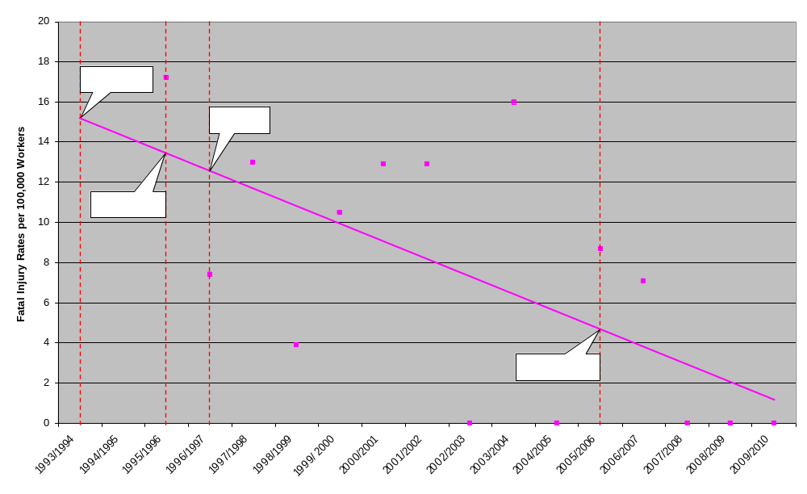
Figure 1 shows that there has been a downward trend in the fatality rate for offshore workers since the introduction of the 1992 Safety Case Regulations, a trend that the UK authorities believe the new regime has played a considerable part in.
Figure 3: Three Year Rolling Average of Injury Rates for Offshore Operations on the UK Continental Shelf
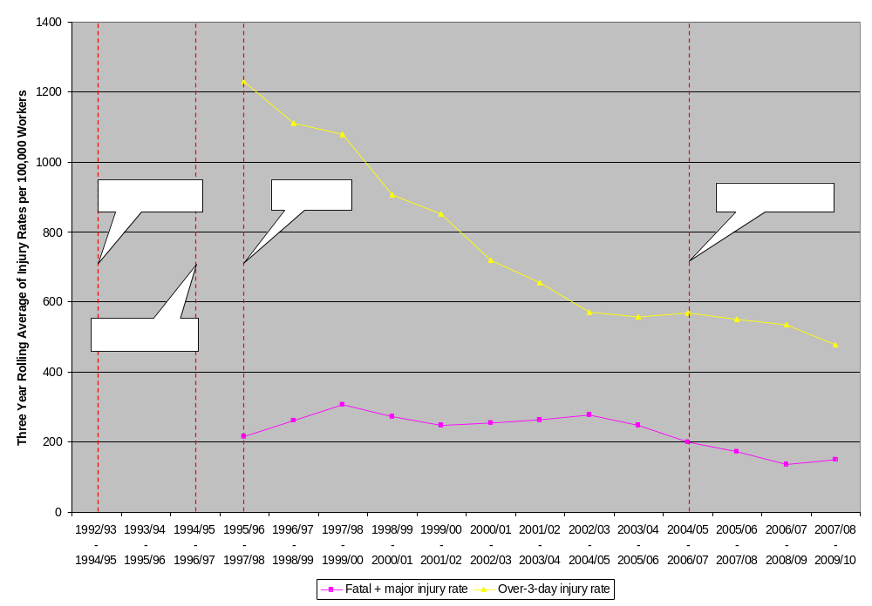
Figure 2 shows that the downward trend in fatalities is echoed by the injury rates for the UK continental shelf in the same period.
Policymakers should note that while several safety indicators for the oil and gas industry on the UK continental shelf show improvement over time, it is difficult to wholly attribute these improvements to regulatory changes for a number of reasons. Industry practices may improve over time and some regulatory changes may reflect an already widely implemented industry practice. The tangible positive effects of improved regulations may only present themselves in the longer term, after initial challenges adapting to them have passed. And compliance levels may significantly vary over time.
Because of the limitations in only using a longitudinal approach to gauge the effectiveness of offshore regulations, as above, it is important to also look at comparative figures to strengthen the analysis. In particular, we can start by looking at global trends to see if improvements to offshore safety in the UK were part of a broader, industry-wide tendency that was also seen elsewhere around the globe.
Figure 4: Breakdown of Worldwide Fatalities in the Offshore Sector by Year Period, 1970 - 2007
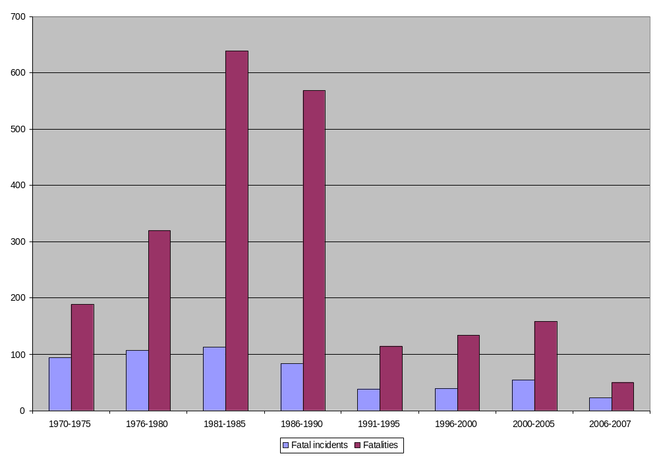
Figure 3 shows that there was a sharp reduction in both fatalities and fatal incidents worldwide between the 1980s and the 1990s. Nevertheless the 1990s onwards have seen these figures gradually creep up again. This was exactly the period when the objective-based offshore safety paradigm was being implemented in the UK, and safety indicators from the UK Continental Shelf were strongly improving.
Because the offshore workforce has varied over time, this chart cannot be directly compared with other charts in this section presenting fatality and injury rates on the UK continental shelf. However, assuming that there have not been major fluctuations in the size of the global offshore workforce, the chart is suggestive that the general trend of improved offshore safety in the UK from the 1990s onwards was not experienced globally. Since most offshore oil and gas operators are multinational entities, we would expect to see any advances in industry best practice reflected in global safety indicators during this period. Improving offshore safety in the UK is therefore not likely to have been due to advances in industry best practice, supporting the UK Health and Safety Executive’s belief that improved safety in the UK can be credited to changes to the UK’s offshore regulatory regime that were implemented during the 1990s.
A recent OGP publication comparing the risk of different offshore activities also found that offshore operations "of North Sea standard" (in terms of equipment used) are safer than operations "not of North Sea standards", at least in terms of the frequency of blowouts.
In 2010, Det Norske Veritas released a study contrasting the Norwegian offshore safety regime with that of the United States. The study found that whereas the Norwegian regulations are primarily performance- and risk-based, the US regulations are dominantly prescriptive and do not require the application of systematic risk management practices. Differences in safety indicators between these countries may therefore also hint at the effectiveness of mandating the goal setting approach to offshore regulation throughout the EU-27.
Table 8: Global Offshore Safety Indicators gathered by the International Regulator's Forum
 |  | Total |  | Derived Rate |  | Derived Rate Unit
 |  | Norway | US | Norway | US | Derived Rate Unit
Fatalities and Injuries | Fatalities | 2 | 19 | 1.68×10⁻² | 4.43×10⁻² | Per Million Hours Worked
Fatalities and Injuries | Major injuries | 96 | 179 | 8.06×10⁻¹ | 4.18×10⁻¹ | Per Million Hours Worked
Fatalities and Injuries | Injuries > 3 days LTI & RWI | 147 | 313 | 1.23 | 7.30×10⁻¹ | Per Million Hours Worked
Fatalities and Injuries | Injuries 1 > and <= 3 days | 273 | 160 | 2.29 | 3.73×10⁻¹ | Per Million Hours Worked
Collisions and Fires | Major Collisions | 1 | 32 | 3.60×10⁻³ | 2.77×10⁻³ | Per Installation
Collisions and Fires | Less than major Collisions | 0 | 29 | 0 | 2.51×10⁻³ | Per Installation
Collisions and Fires | Major fires | 0 | 17 | 0 | 1.47×10⁻³ | Per Installation
Collisions and Fires | Less than major Fires | 0 | 32 | 0 | 2.77×10⁻³ | Per Installation
Well Control | Major Loss of Well Control | 0 | 7 | 0 | 1.25×10⁻³ | Per Well-Related Activity
Well Control | Less than major Loss of Well Control | 0 | 13 | 0 | 2.31×10⁻³ | Per Well-Related Activity

The International Regulators’ Forum collected and compared offshore safety incident data from different countries based on a common set of criteria for the years 2007 to 2009. The results of this exercise are presented in the table above. It indicates that whilst reported injury rates were higher in Norway than in the United States, fatalities were around three times higher in the United States than in Norway even though many of the same companies operate in both countries. Loss of well control was also more common in the United States than in Norway. These well control statistics are supported by the SINTEF blowout database, which reveals that the blowout frequency for the Gulf of Mexico is approximately 9 times higher than in the North Sea, and that the proportions of blowouts resulting in large spills are almost 4 times greater in the Gulf of Mexico (0.23) than in Norway (0.088).
In considering the comparative statistics presented above, the policymaker should bear in mind that different countries and regions have contextual, cultural and historical differences that may affect offshore safety. Nevertheless, given that both longitudinal and comparative statistics suggest that objective-based regulation in the offshore sector leads to improved safety, we can conclude that moving from a prescriptive to an objective-based offshore safety regime results in a significant reduction in accident-related costs.
Italy and Spain are the largest offshore oil and gas producing nations in the European Economic Area who do not already have what is recognized as an objective-based regulatory regime in place, accounting for 408 out of a total of 6315 active wells in Europe (6.5%). They are the Member States most likely to strongly benefit from the package of proposed measures in terms of improved safety. Assuming that Italy and Spain currently have similar offshore accident costs as other European countries on an annualized per-well basis, and conservatively assuming that the economic costs caused by major offshore accidents in Italy and Spain halve as a result of their adoption of objective-based offshore safety regimes, then implementing Policy Option 1 can be expected to result in between €6.66 and €29.7 million in annual savings when compared with the baseline scenario.
In estimating the likely benefits of the proposed policy option, it is also important to take into consideration its future economic benefits in the Mediterranean and Black Sea, where there are several countries in the early stages of the development of their offshore extractive industries. Should these countries follow the regional trend, there is a good chance that they would adopt the less-effective prescriptive regimes hitherto dominant in these regions. EU regulatory action would prevent this. Whilst these putative benefits are impossible to quantify, they should be qualitatively factored into any cost/benefit analysis of proposed policies.

Financial and administrative impacts
In gauging the financial and administrative impact of mandating the goal-setting approach in the EU offshore sector, the resources of national authorities and compliance costs borne by industry were compared in European Economic Area Member States with objective-based regimes and Member States with more prescriptive regimes.
Lapses in compliance – either with regulations or good oilfield practice – have been identified in many audits and inspections, as well as official investigations into recent offshore accidents and near misses. Compliance is the ultimate responsibility of the operator, but regulators play an important, indirect role in verifying compliance through inspection and enforcement regimes, and by holding operators to account when failures to comply occur. In this way, regulators have a responsibility to provide assurance to the public that regulated entities are meeting mandated requirements.
Figure 5: National Offshore Authority Staffing Resources
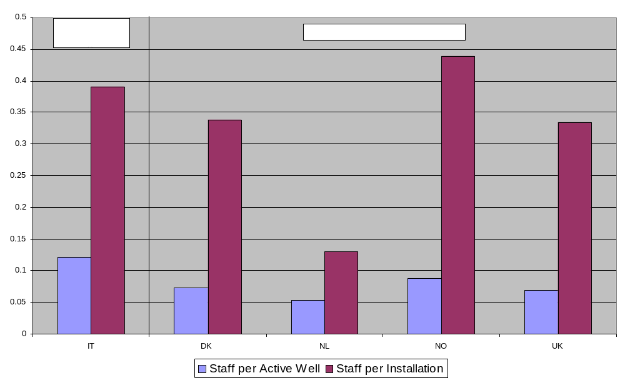
Regarding the regulatory costs to public authorities, Figure 4 shows that there are only moderate differences between the staffing levels of European regulators with objective-based regimes (Denmark, the Netherlands, Norway and the UK) and the staffing levels of the Italian regulator – the largest European regulator currently employing a prescriptive regime. This remains true regardless of whether viewing staffing levels in either per well or per installation format. Although the further comparison of other indicators of regulatory costs (such as annual budgets) was not possible because of shortcomings in the collected data, the chart above suggests that mandating the goal-setting approach in the EU offshore sector would not lead to any change in the annual running costs of national offshore authorities. One-off retraining costs to the staff of the Italian and Spanish Authorities, however, can be expected.
The Spanish offshore authority – a sub-directorate of the Ministry of Industry, Tourism and Trade – has been excluded from the above analysis because economies of scale disproportionately seem to affect the resourcing indicators of smaller regulators. Figure 5 illustrates that the Spanish authority has disproportionately high staffing levels compared to other regulators, regardless of whether these regulators follow a prescriptive regime, as Spain does, or whether they use objective-based regimes. Spain has limited offshore operations at present, with only 13 active wells and 3 production installations. However, it staffs an office of 5 personnel – likely the minimum number of individuals the Spanish authority feels is necessary to maintain the technical competences to provide effective oversight. Other very small regulators, such as the Faroe Islands and Ireland, maintain similar regulator staff levels (6 and 3 respectively, although the latter all part time).
Figure 6: Regulator's Staffing Resources by Number of Wells Overseen
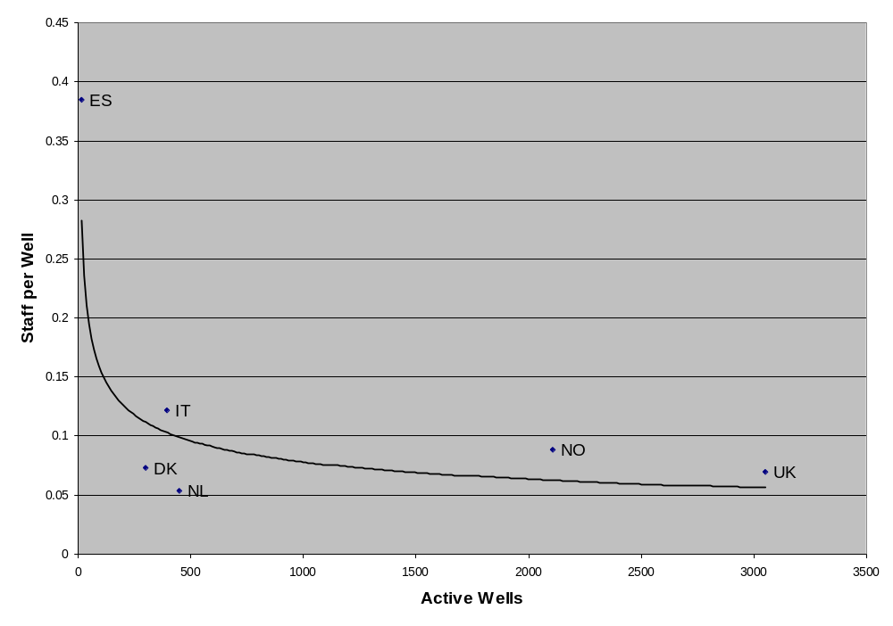
The Spanish authority’s operating budget in proportion to the number of wells or installations it oversees is also many times greater than those of larger regulators (see table below).
Table 2: Select Offshore Authorities' Operating Budgets (€), (Corrected for National Wage Differences)
 | DK | ES | NL | NO | UK
Operating Budget Per Active Well | 5,400  (4,283) | 310,427  (512,120) | 6,401  (5,724) | 13,500 | 9,115  (8,981)
Operating Budget Per Installation | 24,923  (19,767) | 1,345,185  (2,219,190) | 15,655  (13,999) | 67,084 | 43,849  (43,209)

Whilst the proposed policy option is not anticipated to entail significant increased costs to public authorities, compliance costs to industry are likely to increase. One company (Company A) responding to a European Commission questionnaire on compliance costs on the UK continental shelf last year estimates that the largest share (42%) of these costs came in the category of significant one-off expenses for equipment such as lifeboats, and a capping device for use in case of a blowout. Running substantive costs, such as for independent verification and consultancy services, made up 33% of compliance expenditures. Running administrative burdens made up 18% of compliance costs, and running financial costs, including fixed fees charged by different offshore regulators, 7%. These expenditures are shown in Figure 6, below.
Figure 7: Breakdown of Compliance Costs for Offshore Operator Company A on the UK Continental Shelf
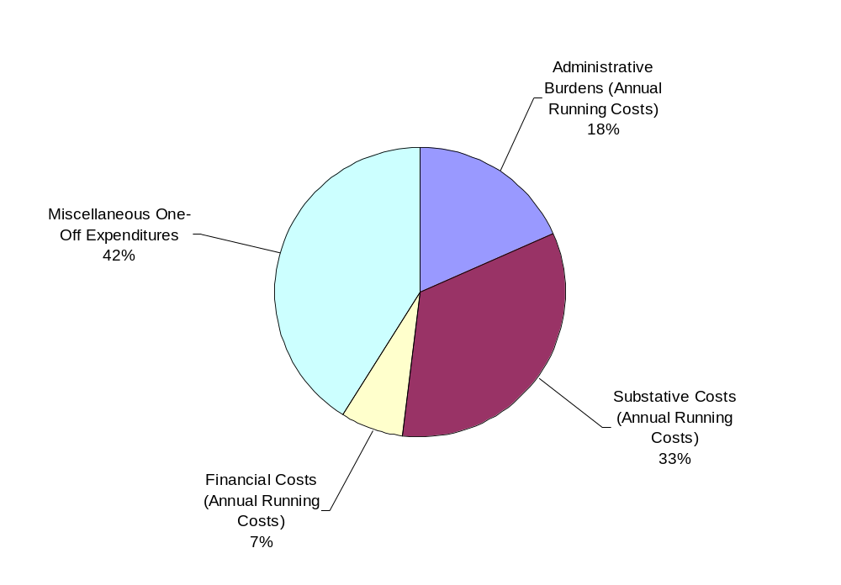
Another company, presented in Figure 7, below, estimates that administrative burdens made up 42% of its running compliance costs; substantive costs 35%; and financial costs 16%. It lists as its miscellaneous costs, mandatory training and offshore medicals.
Figure 8: Breakdown of Compliance Costs for Offshore Operator Company B on the UK Continental Shelf
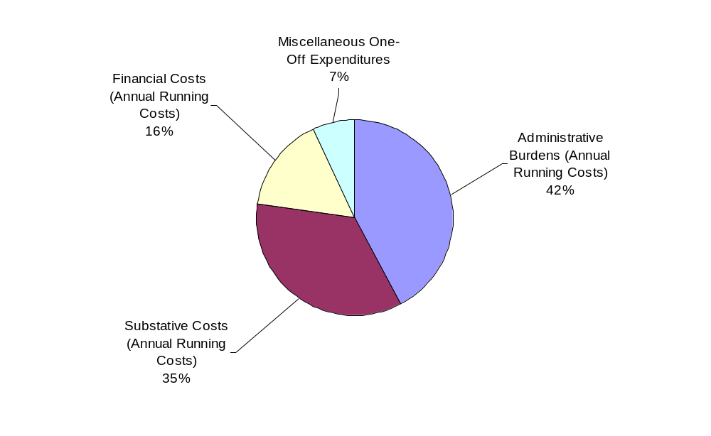A lack of any other detailed questionnaire responses, and potential differences over how companies define ‘safety’ costs and separate these from ‘business as usual’ expenditures, mean that it is not possible to say how representative these company’s compliance cost estimates are of other operators’ costs. Nevertheless, being sensitive to the above limitation, we can use the detailed figures provided by Company A to get a rough indication of the compliance burden borne by companies operating in the UK: around €100,000 per well per year.
A comparison of the compliance costs of operating in the UK (objective based safety regime) and Italy (prescriptive safety regime) was made possible by a questionnaire respondent operating on the Italian continental shelf. Figure 8 shows that 57% of this operator’s compliance expenditures when towards administrative burden; 32% was allocated to substantive costs; less than 1% of expenditures were financial costs; and 16% went towards miscellaneous expenses in the form of information technology safety aids.
Figure 9: Breakdown of Compliance Costs for Offshore Operator on the Italian Continental Shelf
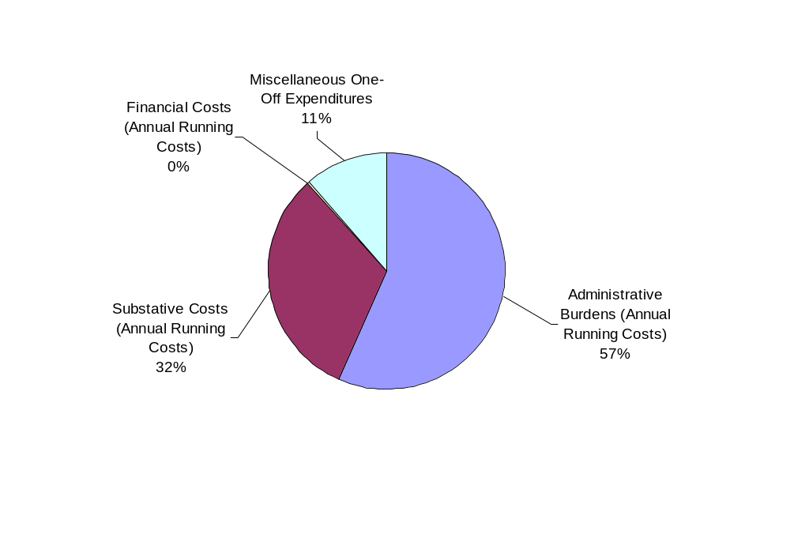
We can use the figures provided by this operator to get a rough indication of the compliance burden borne by companies operating under the prescriptive Italian offshore safety regime: around €13,000 per well per year or roughly 7.7 times less than the reported compliance costs in the UK. This suggests that changes to offshore regulation have the potential to significantly increase the compliance costs of offshore oil and gas operations to industry. Mindful of the limitations of the data provided, we can use reported compliance cost differences between offshore jurisdictions to estimate the possible scale of the impact to industry of mandating the goal-setting approach in the EU offshore sector.
Text box: Some Industry Views on the Costs Offshore Safety
One of the objectives of the impact assessment process is to give decision makers the opportunity to perform an evidence-based cost-benefit analysis of potential policies. In the case of offshore safety, however, some industry voices have expressed their unease with certain aspects of this process – particularly the quantification of the costs of compliance with safety regulations. They have done so on the grounds that: a) these costs are practically inseparable from ‘business as usual’ operation, being profoundly embedded in company management structures; and b) the emphasis would be better placed on the value that effective regulation can add, rather than the burden it places. At least one industry representative has voiced strong support for objective based legislation, stating that: “the goal setting regulation structure should to the highest possible extent be allowed to continue.”
As Policy Option 1 involves levelling-up all EU offshore operations to current North Sea standards, Italy and Spain – the largest Member States still operating more prescriptive regimes – would be the Member States most greatly affected by the proposed policy. Assuming that the compliance costs of operating in the UK are representative of the compliance costs of operating under an objective-based regime in Europe, and assuming that the compliance costs of operating in Italy (13% of operating in the UK, according to EU questionnaire data) are similar to the compliance costs borne by all companies currently operating under prescriptive regimes in Europe, then the additional industry costs of Italy and Spain levelling-up to objective-based regimes would be €87,000 per well, or €35.50 million annually for their combined 408 wells when compared with the baseline scenario.
As before, it is also important to take into consideration higher safety compliance costs to possible future operations in the Mediterranean and Black Sea, where offshore extraction can be expected to increase in the coming years. These putative costs are impossible to quantify, but should be qualitatively factored into any cost/benefit analysis of proposed policies.

Option 1 Summary
Benefits: €6.66-29.7 million annually in reduced losses from offshore accidents in Italy and Spain when compared with the baseline scenario; putative reduced losses from future operations in the Mediterranean and Black Sea.
Costs: €35.50 million annually in additional compliance costs to industry when compared with the baseline scenario; significant one-off retraining costs for the Italian and Spanish authorities; putative additional costs to future operators in the Mediterranean and Black Sea.

Policy Option 1+: Option 1 combined with initial EU-wide improvements to undesirable inconsistencies by clarifying existing EU law through soft law (North Sea+ standard)
This policy option consists of five discrete measures: 1) Verifying technical capacity during authorizations; 2) clarifying the scope of the environmental liability directive; 3) ensuring the cross-border availability of compatible assets; 4) ensuring preparedness for responding to major offshore accidents; and 5) extending EU standards overseas.

Measure: Verifying technical capacity during authorizations.
This measure would see an EU licensing requirement that operators demonstrate their technical capacity to both carry out the activity in question (seismic survey, exploratory drilling, production, etc) and take all appropriate measures to prevent and respond to critical events.

Impact on reducing the costs of offshore accidents
It is not possible to quantify the potential benefits of this measure could bring because companies often share safety data with third parties on the condition of anonymity, making it impossible to exhaustively examine the relationship between company technical capacity and these indicators. That being said, ensuring that oil and gas companies have the technical capability to both carry out their operations and address any potential accident resulting from these operations can be expected to reduce economic losses resulting from offshore accidents for self-evident reasons. Accordingly, such requirements already form an integral, albeit implicit, part of the licensing process in many Member States.

Financial and administrative impacts
Although the additional burden to public authorities is not expected to be significant, legislation mandating that operators demonstrate minimum levels of technical capacity as a prerequisite for the authorization or licensing of offshore operations may impose disproportionately high costs, in terms of lost earnings, on smaller companies unable to meet such standards. In this way, legislation to this end may skew competition in favour of larger companies with broader competencies and more specialized assets. Given that smaller operators play an increasingly important role in developing/exploiting resources that may not be profitable for companies with larger overhead costs, losses resulting from unexploited resources may also be incurred by Member States in terms of lost tax revenues. Correspondingly, communities who rely on the offshore industry for jobs may also be disproportionately impacted. These impacts are difficult to quantify and depend heavily on the specifics of the technical requirements imposed.

Measure: Clarifying the scope of the environmental liability directive
This measure would clarify the scope of the Environmental Liability Directive relating to oil and gas exploration and production within and outside of the 20km/12 miles territorial seas line, effectively strengthening the ‘polluter pays principle’ in the waters where much of the EU’s offshore oil and gas operations take place. This is achieved through soft law recommendations to national regulatory authorities to extend liability provisions to the 200 nm Exclusive Economic Zones. It could involve also a clarification on the applicability of the Waste Framework Directive to maritime oil spill as demonstrated by jurisprudence from the Court of Justice of the EU.

Impact on reducing the costs of offshore accidents
Any gaps in covering legislation may lead to externalities that encourage operators to under-spend on safety and take on too much risk in the anticipation that they will not be held accountable for all costs incurred as a result of an offshore accident. The measure aims to minimize the possible negative externalities of offshore activities and therefore incentivize greater attention to safety issues by offshore operators. Although it is not possible to quantify the extent to which this would reduce losses form offshore accidents, ensuring that oil and gas companies are more liable for the potential consequences of their offshore activities can be expected to reduce the risks of offshore accidents by incentivizing the allocation of adequate industry resources to safety. Accordingly, strengthening the polluter pays principle has been a key recommendation of the official reports into both the Deepwater Horizon and Montara blowouts.

Financial and administrative impacts
The financial and administrative impact of any legislative change to strengthen the ‘polluter pays principle’ in the liability regimes of Member States is not likely to come in terms of any net change in overall economic costs. Rather, in the event of an accident, any legislation in this vein would re-assign to industry potentially large substantive costs that may otherwise be incurred by citizens and national authorities. Any such policy is therefore likely to significantly increase the financial and administrative impact on industry stakeholders involved in a major accident, but benefit other affected groups at least to a comparable degree. This would result in little overall net change in financial costs and economic burdens, but a more equitable distribution of costs in the long-term.

Measure: Ensuring the cross-border availability of compatible assets
This measure motivates Member States to develop interoperable assets for sharing across boundaries and, when required, lend assistance to other Member States’ emergency responses. It additionally motivates Member States to share available intervention assets – both public assets and those owned by industry – through Guidelines encouraging the collation of inventories of such assets and stimulating their interoperability.

Impact on reducing the costs of offshore accidents
This measure will not reduce the probability of offshore accidents but may help to reduce the costs of those that occur in the EU by improved and coordinated emergency response. Due to the varied and unpredictable nature of offshore accidents, as well as the extent to and speed with which Member States follow the proposed guidelines, the extent to which financial losses are mitigated by the proposed measure is unquantifiable.

Financial and administrative impacts
The option is likely to only entail moderate additional costs to public authorities. Indeed, there is a possibility that by reducing the need for additional investments in new response capacities at Member State level, the sharing of national assets might actually result in cost savings. Member States, especially those with comparatively small-scale offshore operations, may rely, at least partly, on the assets of neighbouring member States in times of need. Therefore, economies of scale could be pursued and savings secured. Cost efficiencies could be also secured when deploying the assets, particularly with regards to transport.
The costs to industry, however, may be very significant and manifest primarily in terms of the operating cost of substantial well-capping and containment equipment (further examined in Section 4.1.2 of this annex)

Measure: Ensuring preparedness for responding to major offshore accidents
This would establish Guidelines setting out a framework for emergency response preparedness that is compatible across Member States and facilitates regional cooperation. It entails the creation and maintenance of up-to-date emergency plans for all relevant installations as well as external emergency plans that are compatible between different national authorities. The plans would need to be tested to facilitate cross-border cooperation.
Along with the measure ensuring the cross-border availability of compatible assets, it is in line with the conclusions of the Commission communication "Towards a stronger European disaster response: the role of civil protection and humanitarian assistance" which proposes the creation of a European Emergency Response Capacity based on pre-committed Member States' assets and pre-agreed contingency plans.

Impact on reducing the costs of offshore accidents
Better response capabilities will help to mitigate the consequences of accidents (e.g. by collecting the spilt oil at sea, before it reaches the coast) and may reduce their duration of a blowout. Accordingly, this policy measure will not reduce the probability of offshore accidents but may help to reduce their costs by improved and coordinated emergency response.
With hindsight, a number of sources have highlighted that the emergency response to the Deepwater Horizon disaster could have been improved. The US national spill plan wasn’t aligned with the natural disaster response arrangements with which key State and local politicians were more familiar, and local officials complained that they were not adequately consulted. However, it is not possible to quantify expected costs savings as a result of the measure due to the varied and unpredictable nature of offshore accidents, as well as the extent to and speed with which Member States follow the proposed guidelines.

Financial and administrative impacts
This option focuses on the compatibility of the emergency response plans, rather than on the assets. Therefore, it is unlikely to have significant impacts on capital costs. The cost of preparing and updating an emergency plan is relatively modest. Based on data from the sectors covered by the Seveso Directive, a recent study estimates that the updating of the internal emergency plans of an establishment (to be carried out at least every three years) cost around €9,300. In the light this, as well as the considerable activity being taken jointly by some MS and industry on improving emergency response assets following lessons learned from the Deepwater Horizon disaster, no significant additional costs are anticipated in implementing this measure.

Measure: Extending EU standards overseas
This measure would see the EU seeking to secure agreements on good practice standards e.g. with IMO, neighbouring states, and the governments of IRF countries. It also proposes the creation of a voluntary code of conduct in which European companies commit to applying the same safety standards to their operations abroad as they do in Europe.

Impact on reducing the costs of offshore accidents
Given the difficulties inherent in negotiating and implementing international agreements, the benefits of propagating of good practice standards externally are uncertain and certainly unquantifiable. Regarding the voluntary code of conduct, the strong public reaction to recent offshore incidents suggests that the increased attention such a code would bring could result in tangible improvements in offshore safety, even though of compliance with the code would be difficult to verify outside the EU.

Financial and administrative impacts
Although it is difficult to estimate, any increase in running administrative burden to public authorities as a result of this measure can be assumed to be moderate. With regards to industry, however, strict adherence to a code committing European companies to applying the same safety standards to their operations abroad as they do in Europe may make a significant impact on their compliance costs abroad, possibly resulting in a competitive disadvantage.

Option 1+ Summary
Note: The benefits and costs of the measures in this policy option have been especially difficult to quantify in light of both the substance of the measures proposed and their implementation primarily by means of soft-law. In spite of this, the passage below presents certain estimations as a tool for the decision making process. Readers should remain cognizant of the great uncertainty surrounding these estimations if choosing to include them in their evaluation of the present option.
Benefits: Unquantifiable and uncertain benefits in requiring that EU operators demonstrate their technical capacity; clarifying the scope of the Environmental Liability Directive; motivating Member States to share available intervention assets and coordinate emergency response plans; and striving to extend EU standards overseas. For the sake of argument, if we assume that losses from offshore accidents would be reduced by a further 8.7% (€17.85-79.3 million) when compared with Option 1 as a result of both reduced major accident probability and improved emergency response offered by Option 1+, then total levelized annual losses from offshore accidents would be reduced by €24.5-109.0 million (11.9%) as a result of the measures in both Option 1+ and Option 1 when compared with the baseline scenario.
Costs: Uncertain costs to smaller companies unable to meet proposed technical capacity requirements in terms of lost earnings. Also regarding proposed technical capacity requirements, possible lost tax revenues to Member States as a result of non-development of resources, and possible losses to communities reliant on the offshore sector for jobs. Modest additional administrative burdens associated with motivating Member States to share available intervention assets, coordinating emergency response plans and striving to extend EU standards overseas. For the sake of argument, if we assume that offshore authorities have to increase their overall budgets by 3% to account for increased assessment and inspection burdens imposed by the present option, then this would result in an additional €2.53 million in running costs. If annual compliance costs to industry are increased by 2.5% as a result of measures introduced, this would result in an additional €15.79 million in running costs, giving a total figure of €18.32 of additional running costs to implement Option 1+. Combined with the €35.50 million in running costs for Option 1, this brings us to a total figure of €53.82 million in additional running costs to implement Option 1 and Option 1+ when compared with the baseline scenario.

Policy Option 2: Comprehensive offshore reform improving through new law the North Sea standard up to current best practices and providing greater transparency of perfornce of industry and regulators ("EU best practice")
For the purposes of this exercise, this policy option can be broken down into four discrete measures 1) Extending MHRs to cover environmental risk; 2) establishing a competent authority; 3) establishing an EU-wide regulatory dialogue; and 4) ensuring information sharing and transparency.

Measure: Extending major accident hazard reports to cover environmental risk
In most North Sea authorities currently, the formal risk assessment performed for MHRs tends to be focused on human health and safety. The proposed measure would see the risk assessment performed for offshore operations in Europe expanded to more rigorously address environment damage and the limitation of major accidents in light of recent events. As such, this section builds on the analysis in Section 1.1 of this Annex examining the impact of implementing the goal-setting approach to offshore safety throughout Europe. The proposed measure would also allow the development of more effective internal (industry) emergency plans that must be approved by public authorities within the envelope of the MHR. This would effectively enhance emergency response beyond what is proposed in Option 1+ by improving coherence between industry countermeasures national arrangements.

Impact on reducing the costs of offshore accidents
Section 1.1 of this Annex demonstrated that regulatory changes may benefit safety performance over time, and that the introduction of systematic risk management can bring significant improvements to offshore safety levels. Whilst the reader will recall that the UK has experienced clear reductions in death and major injury rates since the introduction of the ‘safety case’ regime, the figure below shows that for hydrocarbon releases – an indicator closely linked to environmental risk and major incidents – the downward trend has been less consistent.
Figure 10: Reported Hydrocarbon Releases on the UK Continental Shelf by Severity
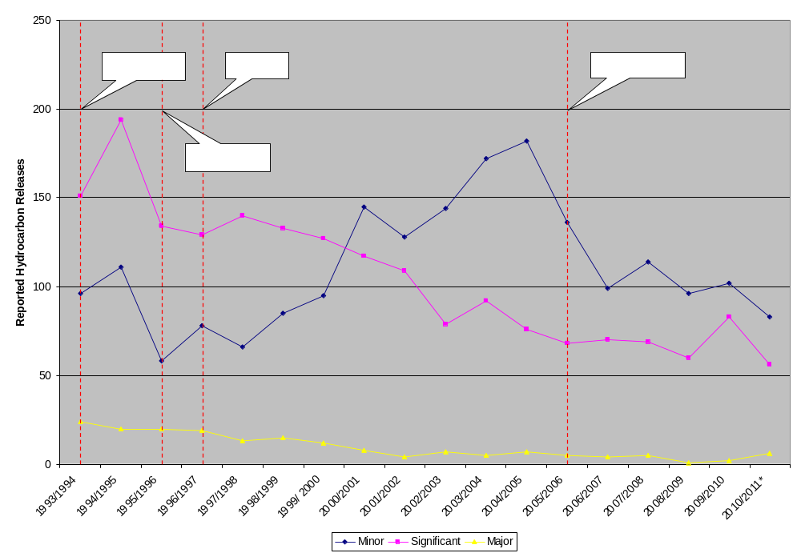
Hydrocarbon releases can be regarded as potential precursors to major incidents. Figure 9 illustrates that there has been no consistent trend in the number of ‘minor’ hydrocarbon releases since the introduction of the UK’s objective-based regime, and that the fall in the number of ‘major’ and ‘significant’ hydrocarbon releases seems to have plateaued as of 2006/2007, and may even be creeping up again. This is consistent with systematic risk management efforts being predominantly focused on human health and safety: More commonly occurring trips, slips and falls are effectively addressed, but it becomes difficult for operators to justify outlays on effective measures to reduce well-control incidents because their potential costs in terms of human health and safety are comparable to other types of offshore accident, such as capsizes and helicopter crashes, even though they can potentially result in the most severe environmental costs.
Other evidence from the North Sea suggests that there is still a clear potential for improvement in well-control, and hence major accident risk. The figure below shows average frequency of hydrocarbon releases per installation per year for 10 anonymous operators on the Norwegian continental shelf between 2006 and 2010. The frequency of releases shows considerable variation between operators. If the 5 worst performing operators on this chart reduced their release frequency to the average level of the 5 best performing operators, then the total number of releases would fall by around 95%.
Figure 11: Average frequency of hydrocarbon releases over 0.1kgs, per installation year, 2006-10
0,0
0,2
0,3
1
2
3
4
5
6
7
8
9
10
Operator
> 1 kg/s
0,1 - 1 kg/s
0,1
Leaks per installation years
Because of its unprecedented nature, little data exist that can be used as a direct benchmark for the effectiveness of the policy measure addressed here. Nevertheless, based on the above data illustrating where safety can be still be significantly improved in Europe, and building on the conclusions of Section 1.1 of this Annex highlighting the strength of the objective-based approach, the Commission estimates that implementing the proposed measure may reduce economic losses from major offshore accidents in EU waters by a further 37.5% – an additional €76.9-343.1 million in savings – beyond the benefits offered by Option 1 and Option 1+ combined. Taking all options together, this would effectively halve major accident losses from €205-915 million annually in the baseline scenario, to €101.4-452.1 million annually.
To this figure must be added the gains of further improving emergency response beyond Option 1+ that come through mandating the approval of industry plans within the envelope of the MHR. Whilst these gains are unquantifiable with certainty, the practice of linking the preparation of national emergency plans to the risk assessments performed by the operators will lead to a greater level of coherence between industry and public authority response. Such consistency has been found lacking in recent major accidents (see Section 2.3 and Section 2.4 of this Annex).

Financial and administrative impacts
In order to estimate the additional regulatory costs of any new EU legislation covering systematic risk management for major accidents, it is important to have an idea of the way different EU regulators currently allocate their resources. Figure 11 shows that European offshore authorities currently allocate between 40-75% of their resources to the compliance-related activities of inspection, enforcement, and investigation. The assessment of health and safety documents (MHRs) takes up between 25-40% of their resources.
Figure 12: Allocation of Regulators' Resources
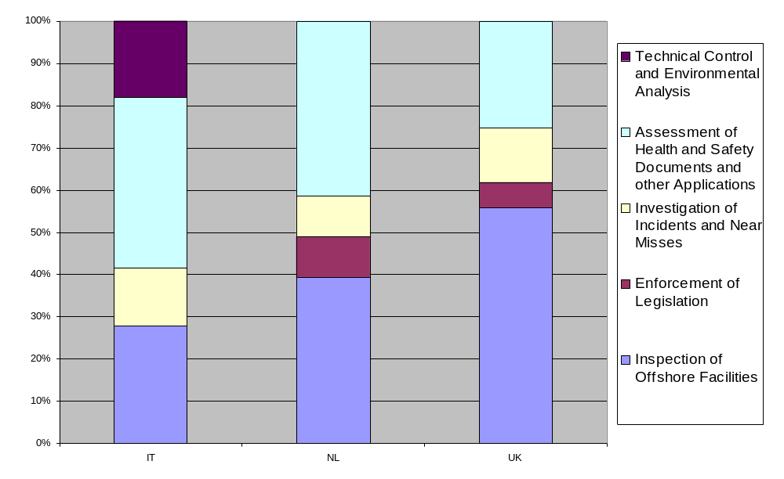Although it is widely acknowledged that effective oversight plays an essential part in offshore safety, regulators typically find it difficult to “prove” or quantify this fact due to the influence of external factors. Nevertheless, some national offshore authorities have pledged to increase inspections in the wake of the Deepwater Horizon disaster. If national offshore authorities increase certain activities without a reduction in competing activities, this almost inevitably entails increases in running regulatory costs.
For national authorities, the Commission estimates that the proposed policy measure will result in a 15% increase in the resourcing of the compliance-related activities of inspection, enforcement, and investigation, and a 10% increase in the assessment of MHRs. This is to account for evaluating and verifying the more complete MHRs that are proposed, as well as the updated internal response plans. Given that the annual budgets of EEA offshore regulators come in at around €85 million in total, the proposed measure would result in an estimated €7.21-12.93 million in additional running costs to public authorities annually, if fully implemented by all EEA regulators.
Estimating the impact on industry is considerably more difficult, given the poverty of the collected industry data (already discussed in Section 1.2 of this annex) and the potentially large differences in industry compliance highlighted in Figure 10. After levelling-up to North Sea standards, the running safety compliance costs to industry are estimated at €100,000 per well per year, as the reader will recall from Section 1.2 of this annex. The Commission estimates that the proposed policy measure will result in a 10% increase in these compliance costs (administrative costs, financial costs and substantive costs, equally), resulting in an estimated €63.2 million in additional running costs to industry annually for all the EEA’s 6,315 reported offshore wells.
Finally, this policy measure would likely see expert group(s) convened to develop operational models for industry and for regulators. Member States, industry and the Commission can all be expected to incur additional administrative burdens associated with the development of such models and in order to attend meetings to exchange ideas. Assuming that the expert group consist of 30 individuals, that these individuals have an average wage rate of €150 per hour, and that this wage rate is inflated by 50% rather than 30% to reflect travel and accommodation costs for these participants, the EU Standard Cost Model estimates one-off costs of just over €250,000 for a 5 day (37.5 hour) programme of meetings held to draft and agree an initial document, and then running costs of just over €100,000 per year for 2 day (15 hour) annual meetings to keep this document up to date with state-of-the-art developments.

Measure: Establishing a competent authority
In order to more effectively and efficiently incorporate environmental damage into the formal risk assessment process, a number of Member States’ authorities may have to reorganize into a single national competent authority.

Impact on reducing the costs of offshore accidents
Establishing a competent authority is an essential component of more thoroughly incorporating environmental risk into the systematic risk management performed for offshore operations. As such, this proposed policy measure’s impact on reducing the cost of major accidents is principally addressed in Section 3.1.1 above. However, the measure would also result in other benefits that must also be added to the abovementioned savings, most notably, the benefits associated with the institutional principles of independence that national supervisory bodies would adhere to under the proposed measure.
Institutionally separating offshore regulators from the resource management and/or revenue collection functions in national governments would strengthen the regulators by ensuring they are free from conflicts of interest in their oversight functions, thereby improving their performance and reducing losses from offshore accidents. Similar principles of bureaucratic separation accordingly form the basis of internationally agreed nuclear safety standards, as well as a Directive proposed by the Commission in 2010 addressing the nuclear sector in the EU-27. On top of this, many organizations, including the International Regulators’ Forum, have argued that regulatory regimes function most effectively when a single entity has broad safety and pollution prevention responsibility, as regulatory gaps and overlap reduce both safety and efficiency.
Whilst it is impossible to quantify the benefits brought in terms of more effective regulation, policymakers should qualitatively include this factor in any cost-benefit analysis of the proposed measure.

Financial and administrative impacts
Although the European Economic Area’s two largest offshore regulators – the UK Health and Safety Executive’s Offshore Division, and the Norwegian Petroleum Safety Authority – both already fulfil the proposed requirements of functional separation, several others may not do. In particular, relevant elements of Italy’s National Office for Mining, Hydrocarbons and Geothermal Resources, the Netherlands’ State Supervision of Mines, the UK’s Department of Energy and Climate Change, and Denmark’s Energy Agency may have to reorganize in order to fulfil the proposed requirements. Moreover, most EEA Member States divide, to a certain degree, their core regulatory activities between two or more authorities.
Depending on how Member States choose to implement the proposed measure, significant one-off administrative burdens can be expected to public authorities in meeting the proposed requirements. There are currently over a dozen national authorities involved in offshore regulation in the European Economic Area with over 500 staff, and significant change may affect up to a dozen of these authorities and a total of around 170 staff. This is assuming that these bodies have to merge with larger independent authorities, or enact significant managerial changes to meet independence criteria themselves. Together with the adjustment necessary to adapt to the strengthened risk assessment regimen examined in Section 3.1 and new data sharing requirements that will be examined in Section 3.4, the Commission estimates that proposed measure will result in an additional one-off costs amounting to 20-50% of EEA regulators’ usual annual budgets in the first year of implementation i.e. €17.5-43.9 million.
Following this initial outlay, however, national authorities may experience modest gains in operating efficiency, as moving regulatory activities ‘under one roof’ allows managers to streamline operations and better capitalize on economies of scale in compliance-related activities, and the assessment of applications. If a modest 1.5-3% in regulatory cost savings at the European level can be achieved through the exercise, the measure would result in economic benefits of around €1.3-2.6 million annually.

Measure: Establishing an EU-wide regulatory dialogue
Supporting the inculcation and maintenance of regulatory best practices would be the setting up of a Commission-led EU Offshore Operators Group that would also enhance the efficacy of existing regional groups such as NSOAF and the fledgling Mediterranean MS forum. Along with EMSA and other EU resources, this group would additionally play an important role facilitating periodical cross border exercises to verify the effectiveness of internal (industry) response plans approved within the envelope of the MHR.

Impact on reducing the costs of offshore accidents
An EU-wide regulatory dialogue is key to realizing the benefits of the new major accident hazard regime introduced in Section 3.1 of this annex. The impacts of the proposed measure are therefore examined in 3.1.1. The economic benefits of periodical cross border exercises to verify the effectiveness of internal (industry) response plans are also covered in Section 3.1.1.

Financial and administrative impacts
In order to estimate the additional costs of the creation of a Commission-led EU Offshore Operators Group, we can start by looking at the resources that current NSOAF members allocate to international cooperation. The Danish offshore health and safety authority indicates that it currently spends around €60,000 on international and other cooperation annually. Assuming that the Bulgaria, Romania and Malta begin programmes of comparable cost, this would entail additional running public authority expenditures of €180,000 annually.
With a staff of 22, the Danish offshore health and safety authority’s expenditure on international cooperation works out at around €2,730 per staff member per year. Further assuming that the remaining EEA Member States with offshore operations – Germany, Denmark, Spain, the Faroe Islands, Ireland, Italy, the Netherlands, Norway and the UK – have similar international cooperation budgets to Denmark’s on a per staff member basis, and have to increase these resources by 30% in order to fully participate in the activities of the EU Offshore Operators Group, then this would result in an additional €414,000 in annual running costs to public authorities at the European level.
This gives a total estimated €594,000 in annual running costs to implement the recommended policy measure.

Measure: Ensuring information sharing and transparency
Legislation mandating increased transparency can be expected to address the current shortcomings in the information-sharing practices of European regulators, and add further value to the EU-wide regulatory dialogue.

Impact on reducing the costs of offshore accidents
On top of freedom of information requests, many regulators already provide the public with significant amounts of easily accessible information, including facts about their programmes, initiatives relating to the Deepwater Horizon accident, the results of inspection projects, and industry targeted health and safety bulletins. They do so as part of their strategy to improve offshore safety in their jurisdictions. Resources devoted to information sharing are justified by the benefits the exercise can be expected to bring.
Over and above this, however, it may be difficult for regulators to justify the collection and compilation of further data if this imposes significant additional costs, or if this data may be important to others but does not have a direct bearing on the conditions in their jurisdiction. The publication of some information may not be welcome because of concerns that this may result in increased public pressure to address issues that regulators feel would not be the best use of their limited resources. Certain national institutions may judge that the “naming and shaming” of non-compliant companies may unnecessarily strain relations with a sector that provides a significant source of employment and tax revenue. And finally, it is understandable that some regulators may be reluctant to disclose data that could reveal shortcomings in their own work.
The abovementioned policy proposal would address the limits of purely voluntary information sharing, and thereby ensure that the added-value of sharing comparable information at the transnational level is realized to the full extent within the EU. Although it is difficult to quantify the extent of these benefits in terms of reduced losses from offshore accidents, the Commission believes that the availability of reliable and directly comparable data on offshore safety is key to identifying and understanding hazard trends in this technologically fast-moving sector. They will also make it possible to benchmark and monitor the effectiveness of any proposed policy changes enacted. These significant but unquantifiable benefits must be included in any cost-benefit analysis of the proposed measure.

Financial and administrative impacts
Currently, Norway’s offshore regulators devote the greatest resources to collecting, compiling and making offshore safety data publicly available in the European Economic Area in total term. However, the Netherlands devotes greater resources to this end as a proportion of its operating budget.
Table 3: Regulator resources allocated to collecting, compiling and making offshore safety data publicly available
 | ES | NL | NO | UK
Total Amount (€) | Less than 20,000 | 260,000-300,000 | 700,000 | 220,000-340,000
As Percentage of Operating Budget | Less than 0.5% | 4.5-5.2% | 2.46% | 0.79-1.22%

Both the Norwegian and UK regulators collect and publish offshore safety statistics on hydrocarbon releases, accidents, incidents, and near misses. Much of this data is directly and easily accessible from their websites, which are the mainstays of both the Norwegian Petroleum Safety Authority and the UK Health and Safety Executive’s information dissemination programmes. Trend monitoring is carried out on this data, either in-house or by a third-party, and the resulting publications are also made available online. The current indicators monitored in Norway and the UK are focused mainly on the human health aspect of offshore safety.
Assuming that the Netherlands, Norway and the UK currently collect and share adequate levels of information on the human health aspects of offshore safety, but need to increase their information sharing resources by 75% in order to meet EU requirements to compile and publish new indicators covering major accident hazard in order to safeguard the environment, this would result in additional costs of €195,000-225,000 to the Netherlands, €525,000 to Norway and €165,000-€255,000 to the UK. Further assuming that the remaining offshore authorities in Europe have to increase their total annual operating budgets by 3.5% in order meet new information sharing requirements (conservatively estimated from Norwegian and UK figures in Table 3), this would result in an additional €900,000, roughly. This comes to a total increase of around €1.8-€1.9 million in annual running administrative burdens to public authorities at the European level.
Additional one-off administrative costs may be incurred as public authorities and industry align themselves with obligations aimed at streamlining information sharing (for example though a new, commonly agreed accident reporting format). Decision-makers should bear in mind, however, that certain measures introduced by the process may result in decreasing financial costs and administrative burdens over the long run, as the introduction of a common European format for collected safety data, for example, may allow regulators to collectively perform data analysis and thereby save costs.
Regarding increases in the costs to industry, one company responding to a European Commission survey on safety compliance costs in the UK estimates its administrative burden for safety (in terms of man hours of its offshore installation managers and management teams) to be €2,762 (£2,350) per well per year. Adjusting this figure by 30% to represent overheads, this gives a figure of €3,591 per well per year. Assuming this is a representative figure for all of Europe’s 6,315 active wells (including Norway), and that the workload of offshore installation managers and management teams is increased by 30% as a result of new EU reporting requirements, then the policy would entail €6,802,392 of additional administrative burdens to industry each year at the European level. To this figure must be added the initial one-off administrative burden to companies in terms of reading and understanding new requirements, and adjusting reporting practices as necessary

Option 2 Summary
Benefits: €76.9-343.1 million in additional savings annually in extending MHRs to cover environmental risk as well as the creation of competent authorities free from conflicts of interest; and €1.3-2.6 million in efficiency gains to regulators in the creation of a single authority for offshore safety. Implementing Policy Option 2 is thus estimated to provide a total of €102.7-454.7 million (49.8%) in benefits annually together with Option 1 and Option 1+ when compared with the baseline scenario.
To this figure should be added unquantifiable benefits to emergency response that are anticipated to come through mandating the approval of industry plans within the envelope of the MHR; the benefits of more effective oversight through the creation of competent authorities free from conflicts of interest; and the benefits that come with a greater awareness of hazard trends through improved transparency and information-sharing practices.
Costs: €7.21-12.93 million in additional running costs to public authorities annually and €63.2 million to industry to extend MHRs to cover environmental risk; one-off costs of just over €250,000 and then running costs of €100,000 per year to Member States, industry and the Commission for the expert group meetings necessary to incorporate environmental risk into the MHRs; one-off costs of €17.5-43.9 million for the creation of competent authorities free from conflicts of interest; €594,000 in annual running costs to set up a Commission-led EU Offshore Operators Group; and €1.8-€1.9 million in running administrative burdens to public authorities and €6,802,392 in compliance costs to industry annually to improve transparency and information-sharing practices. This gives a total of €17.75-44.15 million in one-off costs and €79.61-85.33 million in annual running costs to implement Policy Option 2. Combined with the costs of implementing Option 1 and Option 1+, this makes a cumulative €17.75-44.15 million in one-off costs and €133.43-139.15 million in running costs when compared with the baseline scenario.

Policy Option 3: Consolidating offshore reform by establishing an EU intervention and oversight capability through EU offshore safety agency
This policy option consists of two measures: 1) Establishing an EU intervention capacity; and 2) establishing an EU regulatory body for offshore oil and gas operations.

Measure: Establishing an EU intervention capacity

Impact on reducing the costs of offshore accidents
This Option adds to the intervention capacities currently available by industry and Member States. Although improved emergency response is likely to reduce the cost of major offshore accidents that occur, it is uncertain as to whether an EU intervention capacity would represent the best use of resources to this end. Establishing an EU intervention capacity would most likely involve an expansion of the mandate of the European Maritime Safety Agency (EMSA), which already has significant expertise and equipment, and whose assets – particularly satellite imagery – are already drawn upon by national offshore authorities. EMSA has the capacity to respond to oil spills, but for it to also tackle offshore safety, it would likely also have to acquire a well-capping and containment capability. Because this has been the strong focus of industry since the Deepwater Horizon disaster, this may result in EMSA’s expanded assets may result in little overall impact in practice, and a wasteful duplication of resources.

Financial and administrative impacts
In order to estimate the additional costs of the creation of an EU intervention capacity it is instructive to look at the extent of well-capping and containment equipment for the equipment costs necessary (industry has so far not fully-specified the costs of a capping and containment system), and EMSA staffing resources to get an idea of building the expertise required.
A recent OGP report illustrated the equipment necessary for a flexible capping and containment system that could be deployed in most scenarios. This includes capture devices (hard seal, soft seal, or no seal) with diverter spools that fit over a subsea well, the subsea systems and relevant surface systems and/or vessels for handling, flaring, storing, and shipping to facilities that can effectively dispose of the liquid hydrocarbons and associated contaminated water. Given the amount of equipment necessary, it can be estimated that one-off costs to acquire a similar system may run into many tens of millions of euros, and that the annual costs of maintaining the equipment may run into the millions. Furthermore, it is likely that more than one such system would have to be acquired in order to have response resources within proximity of operations in both the North Sea and the Mediterranean.
The staffing budget of EMSA stood at roughly €20 million. Assuming this needs to be increased by 50% in order to bring in the necessary expertise, this would entail €10 million in additional running costs annually. To this should be added increased operational running costs resulting from the expanded mandate of EMSA, and the maintenance and storage of well control and containment equipment. Assuming EMSA’s current operating expenditures of €32 million have to be increased by 30%, this would result in an additional €9.6 million, giving a total of €19.6 million in running costs to implement the policy measure examined here.

Measure: Establishing EU regulatory body for offshore oil and gas operations

Impact on reducing the costs of offshore accidents
Rather than introducing any new policy action per se, this option would consolidate benefits of Option 2 by seeing a European body created to perform, in addition to national competent authorities, certain policy measures in Option 2, such as assessing, the technical capacity of operators, assessing certain MHRs, offshore inspections, and the management of a database of safety indicators. By adding an specific EU wide oversight function of national regulators, 3rd party verifiers it would to a certain degree improve the coherent implementation of and compliance with EU legislation.
Although it is impossible to quantify the extent to which this would reduce the losses from offshore accidents, a single EU regulatory body can be expected to allow the EU to better extend its practices to overseas operations as a result of enhanced collective bargaining it affords. The assessment of license applications by a single EU body, completely independent of Member States, would also ensure EU-wide coherence and a level playing field across European jurisdictions. Similar but less significant converging impact could be expected where the EU body would provide technical assistance, coordination, training or information sharing services to new or evolving national regimes.
On other dimensions, however, consultations show that regulatory authorities in mature offshore regions fear that the creation of an EU regulatory body could risk destabilising their existing regimes and lead to fewer benefits than in Options 1 to 2 by introducing standards based on the lowest common denominator in the EU and aggravating staffing shortage of qualified personnel such as inspectors. In case of unclear roles, the quality of regulatory oversight in Europe could suffer, either as a result of a unnecessary duplication of measures already taken by national authorities or as a result of uncertainty about the effectiveness of the EU body in the extreme case that it would have sole responsibility for them. Specifically, the EU body could turn to the Member States for non-compliance with EU law but would not be able to effectively enforce sanctions given MS jurisdictions for criminal investigation and prosecution. This limitation could potentially undermine the effectiveness of existing regimes and the EU goal-setting approach.
Other anticipated challenges include, cost recovery mechanisms: the relationship between MS and the agency in respect of non major hazard regulation (eg under the Drilling Extractive Industries and the Safety and Health of workers Directives); the relationship with licensing authorities; the handling of MHRs by the regulator, leading to consents; and the agreement of emergency plans. The new organisation will have to build up the required expertise for assessment of license applications; and local circumstances (language and geology, for example) may mean that many responsibilities are better performed at the national level.
Moreover, the scope of action of the body could be limited by the guarantees given to Member States in existing EU legislation in respect of sovereign assets (Art 194 of TFEU and Directive 94/22).

Financial and administrative impacts
Existing European agencies, such as EMSA and EURATOM, are not entirely suitable for the nature of the offshore oil and gas industry, which is essentially non-maritime and has very different risk profiles to the nuclear sector. As such, an EU regulatory body would have to be established from scratch and not as an extension of a pre-existing institution. In spite of this, the running costs of such agencies can give us a benchmark against which the additional costs of an EU regulator can be estimated.
The total operating budget of EMSA, with over 200 staff at its offices in Lisbon, stood at just over €56 million in 2011: roughly €20 million for staffing costs; just over €4 million for buildings, equipment and miscellaneous expenditure; and just over €32 million for operating expenditure. Assuming that the size of the EU regulatory agency in terms of total staffing resources is 1/5th of the current 506 staff working in all national offshore authorities combined, then the EMSA budget figures would indicate roughly €10 million for staffing costs. As offshore regulators do not require the purchase, maintenance or storage of equipment, other categories of cost in the EMSA budget would not reliably apply to an EU offshore regulator. Instead, we can add an additional 40% onto staffing costs to account for overhead costs, such as buildings, heating, etc., as well as an international travel allowance. This gives an estimated total of €14 million in additional running costs to public authorities to implement the policy measure.
Compliance costs to industry would not be increased.

Option 3 Summary
Benefits: Uncertain benefits to emergency response resulting from an EU intervention capacity; reduced losses from offshore accidents as a result of more effective extension of EU practices to overseas operations, and better assessment of license applications by an EU regulatory body.
Costs: Tens of millions of euros for the purchase of well capping and control equipment and €19.6 million in additional annual running costs to expand EMSA’s mandate and establish an EU intervention capacity; and €14 million in additional running costs in establishing an EU regulatory body. This comes to tens of millions of euros in on-off costs and €33.6 million of running costs to implement Policy Option 3. Combined with the costs of implementing Option 1, Option 1+ and Option 2, this makes a cumulative €167.03-172.75 million in running costs when compared with the baseline scenario, and well over €17.75-44.15 million in one-off costs.
To this must be added the unquantifiable costs in terms of an increase in the likelihood of an offshore accident associated with a possible degradation in the quality of regulatory oversight in Europe caused by the shift of competencies away from national authorities to an EU regulatory body.

Other environmental, social, economic and external impacts

Environmental impacts
Offshore accidents obviously can have a profound impact on the environment and the environmental impacts of the policy options have been already analysed in the previous sections of this annex.

Social impacts
Considering the multifaceted role that offshore oil and gas operations play in the European economy, the impacts of the various policy options are not restricted to particular social groups although some of those, e.g. workers of the offshore oil and gas sector will be obviously more affected than others.
Reducing the risk of offshore accidents will lead to improvements in the health and safety of the workers employed in the sector. As already demonstrated in this annex, countries which already adopted some of the measures proposed above have experienced decreasing fatality and injury rates.
A serious accident would have a direct impact on those working on the installation but may also have repercussions to the whole sector. If the safety of offshore operations in general was questioned, this would set back new explorations and even ongoing operations could be hampered, probably leading to a decreasing employment in the offshore sector (as seen in the Gulf of Mexico since April 2010). Therefore, an option reducing the risks of offshore accidents will also contribute to the sustained employment in the sector. The same can be said about other sectors like fisheries and tourism which would be also negatively affected by a large-scale oil spill, or for communities, such as some in Scotland, who rely on the offshore oil and gas industry.

Economic impacts
Some economic impacts have been presented in the previous sections of this annex; this section will cover various additional relevant aspects.
As many sections of this annex have already highlighted, a harmonization of the rules, standards and best practices applicable to the offshore sector in different Member States will help the functioning of the internal market and enhance competition. Companies operating in multiple jurisdictions will have to conform to more homogenous regulatory requirements, leading to lower compliance costs.
A serious accident could check the exploitation of offshore resources. As a result of the growing significance of offshore oil production, shortfalls in supply may have an impact on oil prices. Therefore, any policy reducing the risks of offshore accidents will also contribute – indirectly – to the reduced risk of such price developments.

External impacts
Apart from the direct external impact of proposed policies, it should be noted that several countries in the European Economic Area are recognized as being world leaders in offshore safety. By virtue of this, European leadership in initiatives such as the codification of best practices, the development of product and safety standards, and the conception of a common reporting format for offshore safety statistics all have the potential to set a precedent for other regions and, thereby, to generate ancillary benefits to offshore safety globally.

Annex V: Summary of EU Acquis Applicable to Offshore Oil and Gas Activities
EU treaties and general policies
The Treaty on the Functioning of the European Union (TFEU) establishes a new provision on energy policy. The Treaty contains provisions for the protection of workers' safety and health, allowing the adoption of minimum requirements in this field and for the protection of the environment, including the precautionary principle and the polluter pays principle.
Besides primary legislation, the EU's Integrated Maritime Policy (IMP) sets the objective for the EU to develop a coherent policy approach to the oceans, seas and coastal areas, aiming at a comprehensive understanding and taking into account economic, environmental and social aspects. One of the tools developed in the context of the IMP is Maritime Spatial Planning (MSP) which is a key tool with regard to good governance of the marine space and its resources. Another relevant policy instrument developed under the IMP is Marine Knowledge 2020 which aims at improving the quality of public decision-making at all levels by providing wider access to quality-checked, rapidly available coherent marine data.
EU legislation on the authorization of offshore activities
In line with the provision of the TFEU about Member States’ right to determine the conditions for exploiting their energy resources, their choice between different energy sources and the general structure of their energy supply, it is up to each Member State to issue licences and other approvals necessary for the exploration and production of hydrocarbon resources within its territory and in waters falling under its jurisdiction. Each Member States sets its own conditions and requirements to be met for license awards. In fact, Member States have adopted a diverse set of national licensing/permitting requirements on key issues like financial and technical capacity of applicants.
Directive 94/22/EC of the European Parliament and of the Council of 30 May 1994 on the conditions for granting and using authorizations for the prospection, exploration and production of hydrocarbons does not impose specific requirements on the applicants as it was designed to deal only with competitive aspects of Member States' licensing procedures, ensuring equal access to national bidding rounds for entities from the entire EU.
EU legislation on equipment
EU product safety legislation has been making already for many years an important contribution to the safety of equipment used in the oil and gas sector. Several product safety directives have a bearing on the sector, namely Directive 2006/42/EC of the European Parliament and of the Council of 17 May 2006 on machinery, and amending Directive 95/16/EC (Machinery Directive), Directive 97/23/EC of the European Parliament and of the Council of 29 May 1997 on the approximation of the laws of the Member States concerning pressure equipment (Pressure Equipment Directive) and Directive 94/9/EC of the European Parliament and the Council of 23 March 1994 on the approximation of the laws of the Member States concerning equipment and protective systems intended for use in potentially explosive atmospheres (ATEX Directive).
The legislation sets out the essential requirements applicable to the equipment concerned and the conformity assessment procedures to be followed by manufacturers before the equipment in placed on the market and put into service. Detailed technical specifications are provided by harmonized European standards developed by the European Committee for Standardization (CEN) and the European Committee for Electrotechnical Standardization (CENELEC). In addition to general standards, there is currently a harmonized standard for some specific equipment (offshore cranes) and other specific standards are being developed for casing elevators and other offshore drilling equipment.
It should be noted that this EU legislation excludes from its scope mobile offshore units and equipment installed thereon. Mobile offshore units are considered as seagoing vessels and their safety is subject to rules established by the International Maritime Organization (IMO) in the IMO Code for the Construction and Equipment of Mobile Offshore Drilling Units (MODU Code). However, the MODU Code does not cover drilling operations.
This situation leads to fragmented regulation where at present the same equipment can fall within or outside the scope of EU product safety legislation depending whether it is used on fixed or mobile installation. Some of the EU and EEA Coastal States consider that it would be useful to apply EU legislation to equipment installed and used on mobile offshore units. The distinction between mobile and fixed units has indeed been overtaken by current technology, since mobile units nowadays frequently remain in place for the lifetime of a well and the equipment of these units is often the same as that used on fixed offshore units.
Further action may be appropriate as regards the standards for well control equipment. At present, the Pressure Equipment Directive excludes blow-out preventers from its scope as its provisions are not considered appropriate or adequate for equipment designed for specific applications in particularly severe environments, including undersea wells. Consequently, the design, construction, use and inspections of well control equipments are currently covered by the national regulations of EU and EEA Coastal States.
EU legislation on the health and safety of workers
In the field of the protection of the health and safety of workers, there exists an extensive body of EU legislation laying down minimum requirements. Currently, nineteen EU Directives relate to workers' safety and health protection in all areas including offshore drilling platforms. The Framework Council Directive 89/391/EEC of 12 June 1989 on the introduction of measures to encourage improvements in the safety and health of workers at work is complemented by the sector-specific individual Council Directive 92/91/EEC of 3 November 1992 concerning the minimum requirements for improving the safety and health protection of workers in the mineral-extracting industries through drilling.
Council Directive 92/91/EEC outlines a number of minimum requirements in the area of health and safety, including some basic well control requirements. In its annex, Part C of the directive sets special minimum requirements applicable to the offshore sector. The Directive was last reviewed in 2009. It should be noted however that occupational safety and health defects are not the primary consideration from the Deepwater Horizon disaster where the lack of control of the major accident risks is the key concern. Where countries introduce regulations specifically against major hazard events, the regulations will focus on the major hazards aspects (blow-outs, platform loss, process safety failures).
Specific provisions regarding work equipment used at work are laid down in Directive 2009/104/EC of the European Parliament and of the Council of 16 September 2009 concerning the minimum safety and health requirements for the use of work equipment by workers at work. Other directives in the field of workers' safety and health protection also apply to workers in the offshore sector, such as those addressing noise, vibration, electromagnetic fields, chemical agents, carcinogens, manual handling of loads, safety signs, personal protective equipment etc. The directives in the field of health and safety at work contain minimum requirements and Member States are allowed to adopt or maintain more stringent protective measures.
EU legislation on environmental protection
There is at present a whole system of legislative measures within the EU environmental legislation aimed at pollution prevention. Built on the precautionary principle enshrined in the primary legislation, it consists mainly of Directive 2008/1/EC of the European Parliament and of the Council of 15 January 2008 concerning integrated pollution prevention and control (IPPC Directive) and Council Directive 85/337/EEC of 27 June 1985 on the assessment of the effects of certain public and private projects on the environment (Environmental Impact Assessment Directive), as amended by Directive 97/11/EC, 2003/35/EC and 2009/31/EC.
The IPPC Directive requires industrial and agricultural activities with a high pollution potential to have a permit. This permit needs to include conditions, based on the application of the Best Available Techniques (BAT), to prevent and reduce the pollution they may cause and to achieve a high level of protection for the environment as a whole. The extraction of petroleum and natural gas does not fall under the scope of the directive, except where it involves the operation of combustion plants with a rated thermal input exceeding 50 MW. Under the Environmental Impact Assessment Directive, proposed projects' likely significant effects on the environment have to be assessed and the necessary measures to prevent, reduce and – where possible – offset any significant adverse effects identified prior to authorisation. The extraction of petroleum and natural gas falls under the scope of the directive.
In addition, Directive 2008/56/EC of the European Parliament and of the Council of 17 June 2008 establishing a framework for community action in the field of marine environmental policy (Marine Strategy Framework Directive) establishes a process through which Member States have to develop strategies to reach the objective of Good Environmental Status in 2020. The assessment of the present situation by each Member State is required in 2012; the necessary measures for reaching the objective must be in place by 2015. Measures are expected to address the cumulative impacts of specific sectors offshore (including fisheries, shipping, dredging, offshore renewables, bio-prospecting) and land-based (agriculture, industry, waste management, wastewater treatment) that may have an impact on the marine environment.
EU legislation on waste and on environmental liability
As regards the responsibility for the clean-up of any oil spill and the liability for damages caused by it, EU legislation is based on the "polluter pays" principle. This principle is reflected in secondary legislation that may apply to offshore accidents, mainly in Directive 2008/98/EC of the European Parliament and of the Council of 19 November 2008 on waste and repealing certain Directives (Waste Framework Directive) and in Directive 2004/35/EC of the European Parliament and of the Council of 21 April 2004 on environmental liability with regard to the prevention and remedying of environmental damage (Environmental Liability Directive).
The Waste Framework Directive applies fully to oil spills, as upheld by the Court of Justice of the European Union. Thus, oil escaping from an offshore installation is covered by the EU definition of waste and the qualification of oil spilled into sea as waste suffices for imposing the obligation to the polluter of cleaning up. No demonstration of fault is needed; the mere fact that oil has been released into the marine environment may lead to imposing obligations on the producer of the waste. In case of oil escaping from offshore installations, the operator would be regarded as the producer or holder of waste and would, in accordance with the polluter pays principle, bear the costs of waste management. The applicability of the Waste Framework Directive to the maritime oil spills is not explicit in EU legislation and is based, as mentioned, on the jurisprudence from the Court of Justice of the EU. According to case law, the legal qualification of "producer of waste or holder of waste" also relates to mother companies, i.e. subcontracting would not constitute a mean to escape liability.
Besides the obligations of waste management, including the clean-up of oil spills, EU environmental legislation also addresses the issue of liability for damages to the environment that can result from an accident or other critical events in offshore activities. The basic legal instrument governing environmental liability at EU level is the Environmental Liability Directive.
The main objective of the Environmental Liability Directive is the prevention and remediation of environmental damage. As such, it aims at restoring the environmental damage to the baseline conditions which would have existed had the damage to the environment not occurred. The scope of environmental damage under the directive is defined as (a) damage to protected species and natural habitats (under the Habitat and Bird Directives), (b) damage to water (under the Water Framework Directive), and (c) damage to land.
The Environmental Liability Directive contains a scope of strict liability for operators who carry out specific activities and a scope of fault-based liability (i.e. requiring a proof of intent or negligence) for damage caused to protected species and natural habitats (but not for damage to water or to land) by any other occupational activity. The regime which will apply to offshore hydrocarbon installations and rigs in case of an accident is the strict liability regime, i.e. without the need of the proof of fault.
While the Environmental Liability Directive applies to all the marine waters under the jurisdiction of Member States for the specific purpose of environmental damage to the "protected species and natural habitats" under Directive 2009/147/EC of the European Parliament and of the Council of 30 November 2009 on the conservation of wild birds (Birds Directive) and Council Directive 92/43/EEC of 21 May 1992 on the conservation of natural habitats and of wild fauna and flora (Habitats Directive), its coverage of the damage to water only applies to the waters covered by Directive 2000/60/EC of the European Parliament and of the Council of 23 October 2000 establishing a framework for Community action in the field of water policy (Water Framework Directive) and therefore does not extend beyond a narrow scope of coastal waters. This gap in the applicability in the Environmental Liability Directive as regards damage to water is worrying in light of the recent experience in the Gulf of Mexico, where environmental damage to marine waters was clearly not limited to the coastal strip and the territorial sea. The gap should hence be closed to address all the marine waters as defined in the Marine Strategy Framework Directive.
EU legislation on emergency intervention
The EU disposes of various instruments to complement the emergency response/civil protection mechanisms of Member States and industry. The Community Civil Protection Mechanism was established by Council Decision 2001/792/EC of 23 October 2001 establishing a Community mechanism to facilitate reinforced cooperation in civil protection assistance interventions. It provides support, on request, in the event of a major emergency and facilitates improved co-ordination of assistance intervention. It covers both civil protection and marine pollution and allows responding to any major disaster inside and outside the EU.
The Civil Protection Mechanism's Monitoring and Information Centre (MIC) is operated by the European Commission and is available on a 24/7 basis. The MIC has 24/7 contact points in both the civil protection and the marine pollution authorities in all the Participating States and coordinates requests and offers for assistance from 31 Participating States: the EU 27, Croatia and the three European Economic Area (EEA) countries - Norway, Iceland and Liechtenstein. During marine pollution emergencies, the MIC coordinates national marine pollution and civil protection authorities and cooperates with the European Maritime Safety Agency (EMSA).
EMSA was established in the aftermath of the Erika (1999) and Prestige (2002) tanker disasters by Regulation 1406/2002/EC of the European Parliament and of the Council of 27 June 2002 establishing a European Maritime Safety Agency for the purpose of ensuring a high, uniform and effective level of maritime safety, maritime security, prevention of pollution and response to pollution by ships.
EMSA focuses on marine pollution and emergency preparedness activities related to vessels. EMSA can already meaningfully intervene in case of oil spills from offshore oil facilities as its capacities can cope with an oil spill irrespective of its source (see Commission proposal COM(2010)611 dated 28/10/2010).
EMSA operates a state-of-the-art maritime transport monitoring centre around the clock. The agency's CleanSeaNet service is a satellite based monitoring system for marine oil spill detection and surveillance in European waters. EMSA has also built a network of stand-by oil pollution response vessels that covers the whole of the European coastline.
Some of EMSA's pollution response capabilities are applicable to the offshore industry without major adjustments (such as the response vessels or the satellite systems). However, operating response vessels close to platforms with spills of oil and gas mixture requires additional safety conditions for crew and equipment. The location of response vessels in Europe should take into consideration also the location of offshore installations and the time requirements of response operations. Other activities would necessitate significant changes for EMSA as they would require a new legal basis as well as additional staff, expertise, procedures and equipment. These increased requirements concern especially any potential expansion of EMSA's preventive activities to offshore oil and gas activities.
Annex VI: Public Consultation questionnaire

PUBLIC CONSULTATION
Improving offshore safety, health and environment in Europe
Questions for the public
Please use this response form for your replies. Thank you for respecting the maximum length for the replies as indicated after each question. This will ensure that your responses are taken into account in their entirety.
Please send the filled response form to the ENER-CONSULT-OFFSHORE mailbox

Authorisations
As described in the consultation document, the competent authorities of the EU Member States define the concrete regulatory requirements and conditions for starting, pursuing and terminating offshore activities within the broader boundaries of EU legislation. These authorities govern also the authorisations for offshore activities in a given area (both in terms of access to exploit a certain geographical area, and in terms of approval to perform concrete activities), regulatory requirements on ongoing activities and closing of operations.

- Which changes, if any, would you recommend to the authorisation conditions for offshore prospection or exploration or production activities? Please specify which authorisations your recommendations concern (all authorisations, those in a specific country, those authorising only a certain stage(s) such as prospection, exploration or production etc) (Please limit your response to maximum 1000 words)
- European law foresees that the competent national authorities shall ensure that authorisations are granted on the basis of selection criteria which consider, among other things, the financial and technical capability of the companies wishing to carry out offshore oil or gas operations. a) What key elements should this technical capacity requirement include in your view? (Please limit your response to maximum 500 words.) b) Similarly, what key elements should the financial capability requirement include in your view? (Please limit your response to maximum 500 words)
- How (such as through legislation or voluntary measures at international, EU or national levels or by industry) should the adoption of state-of-the-art authorisation practices be best achieved throughout the EU? Should neighbouring EU Member States be consulted on the award of authorisations? (Please limit your response to maximum 1000 words)

Prevention of accidents

- Please describe here any recommendations or changes (to the current regulatory framework or practices) - if any - that you consider important to improve the prevention of accidents affecting the health or safety of workers on offshore oil and gas installations in the EU: (Please limit your response to maximum 1000 words)
- Please describe here any recommendations or changes (to the current regulatory framework or practices) – if any – that you consider important in order to better prevent damage to the natural environment from accidents on offshore oil and gas installations: (Please limit your response to maximum 1000 words)

Verification of compliance and liability for damages
The enforcement of offshore health and safety regulations is the general responsibility of national public authorities. The enforcement measures include various activities such as on-site inspections, safety audits and reporting requirements for companies. The organisation, scope and frequency of these measures vary in the different Member States depending on national practices, laws and the local conditions.
While focus on compliance should prevent accidents, a robust liability regime needs also to be in place as accidents resulting in major oil spills may cause extensive environmental, economic and social damage. The financial consequences on the entities found liable for the accident may be significant. EU legislation defines the common principles (e.g. 'polluter pays - principle') and goals for ensuring liability for environmental damages while national laws and courts put them in practice. Concerning environmental liability, the applicable EU law (Directive 2004/35/EC) addresses pure ecological damage in terms of protected species and natural habitats (biodiversity damage), water pollution damage and land damage. As regards affected waters, the ELD covers the territorial waters (up to 12 nautical miles off the shoreline), but not all marine waters under the jurisdiction of EU Member States (up to 200 or 370 nautical miles).
Responsibilities for traditional damage (such as loss of life; personal injury, health defects; damage to property and economic loss affecting for example fishermen) are usually determined by civil courts or tribunals in accordance with national laws and/or case law following goals and principles defined at national level.
Closely linked with the liability is the competence of the liable parties to actually stand up to their obligations. Insurance coverage in the offshore oil and gas sector is partial, with some companies insuring risks to a certain degree and others not. The insurance market does not currently provide products sufficient to cover damages of the magnitude seen in the Deepwater Horizon accident.
Moreover, there are no international or EU-wide funds similar to those in maritime transport that would cover environmental or traditional liability.

- Please describe here any recommendations you would like to make on how to improve compliance of the offshore oil and gas industry with applicable offshore safety legislation and other regulatory measures in the EU. (Please limit your response to maximum 1000 words)
- In your view, which are the key measures to supervise and verify compliance of the industry with offshore health, safety and environmental rules and who should do the supervision and verification? (Please limit your response to maximum 1000 words)

- In your view, should the existing environmental liability legislation (Directive 2004/35/EC) be extended to cover environmental damage to all marine waters under the jurisdiction of the EU Member States? (Please limit your response to maximum 1000 words)

- In your view, is the current legislative framework sufficient for treating compensation or remedial claims for traditional damage caused by accidents on offshore installations? If not, how would you recommend improving it? (Please limit your response to maximum 1000 words)

- In your view what would be the best way(s) to make sure that the costs for remedying and compensating for the environmental damages of an oil spill are paid even if those costs exceed the financial capacity of the responsible party? (Please limit your response to maximum 1000 words)

Transparency, sharing of information and state-of-the-art practices
Transparency of an offshore regulatory regime means the policy and practices on how the regulatory authorities and offshore industry share information with each other, between peers or with the civil society. The degree of transparency affects the awareness of the public authorities, the industry and the civil society, i.e. on offshore oil and gas activities and the way they are managed and controlled. It may also affect the nature of communication, commercial interests of companies, spreading of technologies, lessons learned and cross-border cooperation. An example of transparency in the offshore sector is the practice of some EU national regulatory authorities to publish information such as accident statistics and license award decisions concerning offshore operations.

- What information on offshore oil and gas activities do you consider most important to make available to citizens and how? (Please limit your response to maximum 1000 words)

- What is the most relevant information on offshore oil and gas activities that the offshore companies should in your view share with each other and/or with the regulators in order to improve offshore safety across the EU? How should it best be shared? (Please limit your response to maximum 1000 words)

- What information should the national regulators share with each other and how to improve offshore safety across the EU? (Please limit your response to maximum 1000 words)

- Which means, if any, would you recommend using to promote, across the EU, the use of state of the art practices to protect occupational health and safety during offshore oil and gas operations? (Please limit your response to maximum 1000 words)

- Which means, if any, would you recommend using to promote, across the EU, the use of state of the art practices to protect the environment against accidents caused by offshore oil and gas operations? (Please limit your response to maximum 1000 words)

Emergency response and International activities
The emergency response capacity at present consists of resources and contingency plans on the level of the industry, national administrations and of the EU. In general, contingency plans are required for all offshore installations and are complemented by national and EU contingency plans to respond to large scale accidents. Adequacy of resources and their coordination, both affect the effectiveness of response to offshore accident. In response to recent accidents, particularly the one of the Deepwater Horizon drilling rig in the Gulf of Mexico, the emergency capacities are being strengthened. For instance, new response devices are being developed for use in deepwater conditions.
In the Mediterranean and the Black Sea offshore, oil and gas activities are underway both on EU and adjacent non-EU waters. This causes a risk for cross-border environmental damages from a possible offshore accident, not only across internal EU borders, but also across EU's external border. Apart from an interest in promoting high offshore safety practices also in adjacent regions, the EU participates in international activities to increase safety of offshore activities.
In response to the differing regulatory requirements both within the EU and internationally, some oil and gas companies have adopted company practices or standards that they apply to their activities in the EU and outside. Others adjust their practices more substantially to suit local conditions in the given country.
- In your view what should be the role of the EU in emergency response to offshore oil and gas accidents within the EU? (Please limit your response to maximum 1000 words)
- Please describe any recommendations you may have concerning cooperation with non-EU countries to increase occupational safety and/or environmental protection in offshore oil and gas operations internationally? (Please limit your response to maximum 1000 words)
- Please describe here any recommendations you may have on how to incentivise oil and gas companies with headquarters in the EU to apply European offshore safety standards and practices in all their operations worldwide: (Please limit your response to maximum 1000 words)

Annex VII: Results of the Public Consultation on Improving offshore safety, health and environment
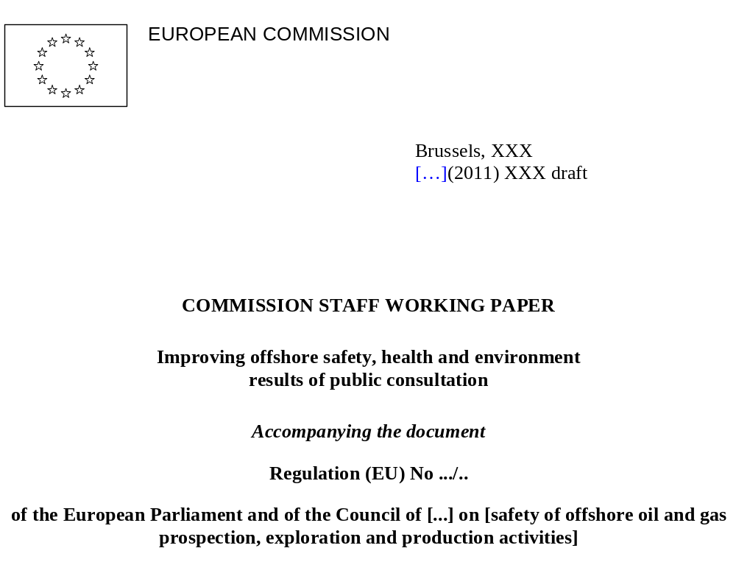
COMMISSION STAFF WORKING PAPER
Improving offshore safety, health and environment
results of public consultation
Accompanying the document
Regulation (EU) No .../..
of the European Parliament and of the Council of [...] on [safety of offshore oil and gas prospection, exploration and production activities]
In spring 2011, between 16 March and 20 May 2011, the Commission organised an on-line public consultation on the possible improvement of offshore safety in Europe, providing stakeholders with the opportunity to submit their views before the Commission develops any legislative or non-legislative proposals in the various policy fields. The consultation was based on a document that gave the background to the regulatory framework for offshore safety in the EU. The consultation outlined the key issues that need to be addressed and included 18 open questions, arranged in the following five topics:
- Authorisations.
Under this topic, the public was requested to give their views on the authorisation practices and conditions for offshore prospection, exploration or production activities.
- Prevention of accidents.
This section requested the public's opinion on prevention of accidents, affecting both the health and safety of workers as well as damage to the environment.
- Verification of compliance and liability for damages.
In this section the public was presented with questions regarding compliance by industry with applicable offshore legislation, regarding the supervision and compliance verification of the industry by competent authorities and on liability for environmental and traditional damage caused by offshore accidents.
- Transparency, sharing of information and state-of-the-art practices.
This section requested the public's opinion on what information on offshore oil and gas activities should be made available to the public, what information should be shared amongst the industry and amongst regulators and on the use of state of the art practices to protect health and safety of offshore oil and gas operations and damage to the environment cause by these operations.
- Emergency response and international activities.
This section presented questions on emergency response to offshore oil and gas accidents, cooperation with non-EU countries regarding oil and gas operations and on the application of EU standards by oil and gas companies in their activities outside the EU.

In total, 64 contributions were received from all segments of the stakeholder community: Member State authorities, industry, NGOs, insurers and citizens. In addition to the oil and gas industry, companies and industry associations from other, related sectors (e.g. shipping, classification societies) also submitted replies. Taking into account the member companies that each industry body/association represents, the Commission has received well over 350 disaggregated replies from stakeholders. The table below shows the composition of the direct respondents.
Oil and gas industry | 17
Other industry | 11
Public authorities | 11
NGOs | 14
Insurers | 4
Citizens | 5
Others | 2
In the following paragraphs, an analysis is provided of the contributions received. All responses were carefully reviewed by the Commission, which included an assessment whether the content of the responses reflected the actual questions and/or had a bearing on the policy topic of the question. During this process, similar responses were combined and some of the responses – although valuable in a broader context – were regarded as having limited bearing on the specific policy topic; these responses were either re-allocated to the appropriate policy topic and combined with other responses or otherwise set aside. The analysis below shows the responses for each of the policy topic listed in the consultation document, for each of the respondents category listed above. If a category of respondents did not have any comments on one of the policy topics, these respondents are not included under the specific policy topic.
Authorisations
Oil and gas industry
The industry is of the opinion that the authorisation processes currently applied in certain Member States are considered to be sound, ensuring the application of state-of-the-art technology and procedures. It was mentioned that Directive 94/22/EC already requires the demonstration of technical and financial capability before a licence can be obtained. Most respondents in this category do not recommend any changes to the authorisation conditions for offshore prospection, exploration and production activities, citing stringent licensing procedures and safety case legislation in place in most member states. The safety case approach must however be combined with robust inspections and auditing of those cases, combined with an independent review by an external party or independent function within the company. It is however recognised that in countries with less experience in offshore oil and gas operations, there could be less solid safety case regulations in place. The EU should work with those countries individually, to bring standards up to those of the best performing countries. Most respondents also agree that the EU should promote setting up a consultative and advisory body of national regulators, e.g. modelled on NSOAF, in which best practises are shared and to ensure MS with less experience in offshore oil and gas activities apply same high standards as more experienced ones. An industry association stated that, while authorisation should account for full liability for damages, it should also balance particular MS needs e.g. to not discourage smaller players. It as also emphasised as essential to secure independence of expert safety regulation from the licensing function. Whilst in favour of financial capability criteria, industry and industry associations stated emphatically that these should not preclude companies of different sizes from entering the market. There is also broad agreement amongst industry respondents that neighbouring Member States should be informed of any authorisation decisions, however there is no need to actively consult those countries during the authorisation process. It is also felt that most legislation is best placed at the national level, as national authorities are best placed to judge applications for permits based on local conditions.
There were two industry respondents that mentioned areas where current legislation/ practises could be improved: 1) some national licensing systems are extremely cumbersome and should be simplified, 2) there is a benefit in a more standardised approach in the EU which should be promoted, i.e. the harmonisation of procedures and standards and equipment taking into account current best practises. For example a drilling contractor should then be granted a certificate to operate in all EU waters. There are also still different local certification and authorisation processes for use of equipment and machineries, making it difficult to employ them cross border. The definition of a general EU framework could be useful to assess and ensure both technically and organisationally relevant HSE standards. Another company highlighted that a licensing process that separates responsibility for authorising drilling permits from rig safety and well operations oversight should be viewed as best practise and where not yet the case, separate regulators for licensing and safety should be established.
Other industry
There is a general view, that the current system for licensing is adequate, with sufficient information publicly available on operational techniques. Respondents were of the opinion that other criteria of the technical assessment of a licensee were e.g. the implementation of a safety management system, the field development plan, contingency measures, primary measures on accident prevention and asset integrity and environmental assessments. Another respondent recommended considering other parameters in the licensing process, e.g. location (of the installation), lifecycle stage (prospection/ exploration/ production), type of company/ operation/ asset. The respondent also suggested considering limitations on license, e.g. duration and scope of the license, options to revoke a license and options for a temporary license.
On the consultation of other MS during the licensing process, opinions in this category varied. Some respondents felt that with consistent high standards applied in the authorisation processes, there was limited benefit of international consultations on authorisations with such a requirement introducing additional bureaucratic burden. Another respondent was of the opinion that existing arrangements and contacts between neighbouring states would already ensure effective authorisation structures.
Public authorities
Two regulators state that more information is available once programmes have started than at the time of applying for exploration licences, so it would be best to assess information at a later stage too. In addition, companies should undergo regulator checks (including financial provisions) before key activities start at each stage of the operation. These checks should include safety, environmental control, and technical and financial capability. Two regulators feel that authorisations should be approved by two different regulators e.g. environment and health. One regulator requested that there should not be an additional layer of EU regulation as this could divert scarce human resources away from core tasks. A blanket approach to all MS is not advisable due to different national circumstances e.g. cultural, legal and geological. National regulators especially argued that the international global framework which is applicable now and any new EU legislation must be compatible. There is concern that the EU, through its actions, might inadvertently undermine the effectiveness of the existing regulatory and supervisory regimes in the oil-producing countries, especially around the North Sea. Their view is that safety regulations will continue to be handled most effectively on a national state level.
For technical capacity, the main comments concerned staff qualifications and experience (especially that of management), lines of responsibility, company experience, management of contractors, and staff audits. Additionally, health and safety, equipment certificates, and environmental protection were mentioned. For financial capability, balance sheets for three years should be provided, along with guarantees, warranties, and proof of sufficient funds or indemnity provisions to meet any kind of incident. With regard to state-of-the-art authorisation practices, best practice, health and safety, and environmental concerns should be advised to the EU with a view to modifying legislation. Many regulators stated that neighbouring MS should be informed but not involved in authorisation decisions. Regulators expressed concern with respect to Member States that are just beginning to develop offshore oil and gas activities. A permanent working group of national regulators could be established, based on the North Sea Offshore Authorities Forum (NSOAF).
NGOs
Several NGOs commented that loopholes in regulatory regimes need to be closed. Whilst UK legislation is held up as a good example, it is considered by some that it is not robust enough. Authorisation processes should be transparent, including environmental impact assessment with possibility of public consultation. One NGO specifically stated that adoption of safety case legislation as a possible minimum standard for the EU is in itself not sufficient, citing various incidents in the UK sector of the North Sea. One NGO requested that the regulator should be separate from any authority that handles energy development/security of supply. All NGOs requested that companies be required to cover all accident costs, without which no licence would be given. The majority of NGOs respondents would only like authorisations to go to companies that can carry full financial liability for any incident, including future decommissioning of systems. Failing that, there were suggestions to replicate the Offshore Pollution Liability Association (OPOL) agreement, or to have an industry-led mutualisation scheme or an EU-wide compensation fund. Licences should comply with EU-monitored minimum binding standards; it was suggested by many that the remit of European Maritime Safety Agency (EMSA) could be extended in this respect. Several NGOs felt that neighbouring countries should be consulted and should also be involved in the authorisation. Some NGOs requested the implementation of best available techniques (BAT) e.g. regular maintenance including requirements for upgrading installations as technology evolves.
Citizens
Citizens in general felt that if a company can't afford to clean up after an accident, it shouldn't be drilling. All citizen respondents would only like authorisations to go to companies that can carry full financial liability for any incident. Strong legislation should ensure that companies are held liable, with mandatory requirements to provide necessary financial security in the event of an accident. One respondent felt that on granting authorisations, a company's past record on health and safety and environmental impacts, both within and outside the EU, should be taken into account. Oil and gas projects should follow public deliberations on permit application. Citizen stakeholders generally suggested that there is a need to involve other countries in authorisation, where cross-border issues are at stake.
Others
One respondent urged that there should be a clear separation between the authority that grants and issues granting instruments and the authority that regulates the operations of those instruments, in view of conflicting demands on officials charged with those separate tasks. However, the respondent cautions that there should not be multiple separations of those authorities. On the issue of the financial capability, the respondent felt that the current system is functioning well, albeit guidance from the Commission could be appropriate and useful on criteria for assessment of financial capability. The respondent also feels that any consultation provisions of other neighbouring MS on authorisations would require careful consideration.
Prevention of accidents
Oil and gas industry
The good historical record of the sector was highlighted in this respect; nevertheless, even industry stakeholders admit that there is a need to challenge the industry to do better. Companies in general support the Commission's review of the current EU framework governing offshore operations. They are equally supportive of the Commission's recommendations for reviews of current safety cases by operators and MS and updates as necessary. Most companies agree that for the protection of the environment a robust and interlocking network of international, EU and national rules is in place, e.g. SEA Directive, EIA Directive, ESPOO Convention, Barcelona Convention, Black Sea convention etc. Any changes to this system risk being sub-optimal and creating a gap in currently applied legislation. Furthermore, such a change should not result in reduced safety standards in those Member States which already have a strong offshore regulatory regime. Most respondents urge the Commission to avoid adopting detailed prescriptive legislation or regulation at EU level, but instead promote the implementation of a goal-setting regime, including dissemination of relevant international standards. One industry association suggested a 'safety case' regime that is goal-setting and includes formal acceptance by the regulator. On product safety, industry is of the opinion that any proposals for action need to be done in close cooperation between the Commission, individual MS/national regulators, industry and the relevant standardisation bodies. Most respondents are against setting-up a centralised EU enforcement/control authority. In order to make improvements in this area at least 2 companies clearly stated that this will not be achieved by new regulations, but by better application of existing standards and best practise. It is felt by most operators that the ‘ALARP’ concept represents a robust regulatory tool to ensure that adequate prevention measures are in place. One suggestion made was that drilling equipment and other safety critical infrastructure be inspected by insurance providers. Also, the performance of the national regulator should in turn be assessed by another national auditing body.
Other Industry
Some respondents recommended the application of goal-setting regulations combined with the Safety Case regime (including third party verification), identical to the one used in the UK and Norway, to all jurisdictions. This would include approval or acceptance of the safety case by the regulator. Respondents are of the opinion that the Safety Case approach can provide a useful tool in addressing some of the areas of weakness in offshore regulation identified by the Commission. In this context it was recommended that future European regulations should require all offshore installations (including rigs) to develop and have approved an EU compliant integrated Safety & Environment Case (which would include IPPC requirements) prior to commencing operations in EU waters. On approval of a safety & environmental case, the respondent suggested that strict regulator guidance should be made available, aiming to deliver harmonisation between regulators so that a safety & environmental case approved in one state would likely receive approval in another MS, should the installation move across borders. Respondents highlighted the requirement for awareness structures and for training in all levels in organisations, to focus on prevention of accidents. Health and safety issues should become a natural element of the offshore industry and must not be perceived as being overbearing or unnecessary. One respondent mentioned the requirement that not only companies that purchase and apply equipment to ensure that environmental damage is prevented (e.g. BOP systems) is subject to a regulatory framework, but also the companies that are manufacturing and selling the components are subject to a similar framework. This should prevent companies from buying cheaper and more unsafe components. Another respondent suggested that the EU may enhance or propose directives which the industry can use as basis of their performance standards, on pressure equipment, electrical devices used in explosive environments, lifting equipment and well control equipment.
Public authorities
For health or safety of workers, there should be a rigorous safety culture with robust training for disaster management involving all staff/subcontractors. It was recommended that legislation proposals should include elements on well design, well construction well and control, as these issues are not or only very limited addressed in Directive 92/91/EC. In addition, it was suggested to introduce goal-setting elements on safety culture in legislation. EU legislation should be based on best practice in NSOAF countries. Others expressed the view that there is a need to take steps to improve the safety culture offshore and ensure that the knowledge and experience of the offshore workforce is effectively used by operators when addressing health and safety. One stakeholder cautioned against a rush to adopt new legislation before lessons emerge from the investigations into the Deepwater Horizon incident that indicate a need for change. Another stated that using worldwide standards in the EU would make it easier for multinationals. With regard to the equipment, this should be certified by the manufacturer or another body, as should safety systems. The UK system includes Safety Cases which are submitted before operations start, and Notifications are sent to the regulator at various operational stages. Finally, there was a request to implement ILO guidelines on occupational safety and health management systems (OSH). In terms of the natural environment, best practice, incident reporting and lessons learned in other industrial activities could be replicated.
NGO's
Additional training is considered necessary by several NGOs, and worker rights should be strengthened to avoid harassment in the event of whistle blowing. Respondent mentioned the need to raise standards in the EU, with the highest safety and environmental standards applied to industrial activities. One respondent feels that industry should invest more on research and development for preventing oil spills. Sanctions could be taken by competent authorities were worker rights are not respected. There could also be an independent regulator to examine and approve well design etc, while some NGOs recommended stress tests of installations, equipment and procedures. Ratification of the Barcelona Convention was mentioned by a few NGOs, as was the extension of Seveso II and the Industrial Emissions Directive (IED) to cover offshore drilling. Two NGOs requested specific funding for R&D, and the EU should monitor abandoned wells.
Citizens
Citizens commented that existing regulations should be strengthened and extended to cover all drilling operations in EU waters. A respondent mentioned that the track record of industry on incidents did not show any improvement in recent years and felt that EU standards should be established to prevent environmental disasters like Deepwater Horizon. Respondents felt that the use of highest standards for equipment should be made mandatory in EU legislation. Old platforms must be updated to the best environmental standards or stop production. A respondent recommended that when drilling a well, a back-up rig should be available within 1 – 2 days travel of the exploration time, should a relief well be required. The respondent also suggested that abandoned wells should be regularly monitored by national and/or EU regulators, and that companies be required to reduce their discharges and spills of hydrocarbons.
Others
One respondent is of the opinion that the most appropriate approach for the offshore industry is a goal-setting approach and the safety case. It is precisely this approach that makes best use of the expertise within the industry and that significantly frees up the regulator to see the bigger picture and emerging problems. Based on experiences in the UK, the respondent cautions for any move toward greater prescription in either EC Directive 92/91/EEC or in entirely new EU legislation. Any greater specificity driven by the Deepwater Horizon disaster may be solely applicable to that incident and thus reduce the openness of the industry and regulators to the need for vigilance with respect to other scenarios. On the prevention of damage to the environment, the respondent feels that the best approach is to continue to work to reduce accidents on a safety case basis.
Verification of compliance and liability for damages
Oil and gas industry
Industry representatives argued that compliance is an issue to which companies devote significant efforts and resources and constantly strive to improve. They are also of the opinion that the current system of inspections is working well. Any proposed changes to the current system should demonstrate how they would ensure the necessary competence and coordination to the rigorous and proven systems that are in place today. Industry cites strong, expert regulators with adequate resources as essential for securing compliance. Regarding potential liability, most respondents do not support a mandated industry-wide pre-loss mutual fund, but rather allow companies to make their own differentiated decisions how to meet their financial obligations. Voluntary compensation schemes like OPOL should be taken as a model. This and similar schemes should be promoted by the Commission. Any EU initiative seeking to improve on national verification systems must demonstrate thoroughly how this would be achieved. The industry stresses that a voluntary financial security scheme is more appropriate for the development of market-driven solutions in which a certain level of insurance capacity can be maintained and developed. The industry also pointed out that the creation of a further liability regime could create unnecessary duplication and legal uncertainty over which regime is immediately applicable. It was highlighted by one respondent that in order to assess any damage caused by an oil spill incident, a baseline condition must first be established against which changes can then be measured. Such baseline metrics are currently not available to all marine waters. Any extension of the current ELD is thus difficult to envisage. One of the companies suggested that a supranational EU safety agency with directive functions, similar to EMSA, could be a useful step forward. A very useful measure would be to ensure there are consistent methods for calculating compensation awards across Europe.
Other industry
Respondents are of the opinion that the current goal-setting regime including the safety case mechanism, as is the current practice in the UK, is the desired framework and best suited for the future. Respondents further mention that the framework should be supported by inspections and assessments by regulators and by third party verification against performance standards, and recommend that the EU establish such a process incorporating the fundamental elements of the UK process for major accident hazards and extends this to health and environmental issues. One respondent felt there should also be a qualification process in place for the independent third parties. In the context of performance standards, one respondent felt that these should also include standards on behavioural aspects; this would require additional competencies of the independent verification bodies in human factors, management of change and organisational behaviour. It was also suggested that the verification process included the possibility for direct feedback from the verification body to the regulator, in stead of only to the owner / operator of the installation. One respondent is in favour of one regulatory body for offshore oil and gas activities in MS; in countries where more regulatory bodies are involved the respondent feels that a single 'umbrella' body for offshore E&P activities should be established, which would draw on expertise from the existing regulatory bodies. Respondents further urge that regulators have adequate enforcement methods and authority to ensure compliance of legislation or permit conditions.
Respondents feel that responsible parties should be able to meet the costs of an incident, as part of their initial license application. Some respondents commented that the current application of the ELD (in the UK) is appropriate to its intended role and should only be extended if robustly justified; others felt that environmental liability should cover environmental damage to all marine waters. Some respondents in this category cautioned that, when extending the ELD, the current exceptions in this Directive on pollution damage arising from ships should remain unchanged, as it would otherwise cause serious disruption in the international regime and create legal uncertainty. On liability for traditional damage, one respondent is of the opinion that a more stringent legal framework is required owing to the increased risk (in the UK) as a result of smaller operators with limited financial strength buying and operating mature assets than the larger operators. In this context, it was recommended that a system like OPOL is developed within the EU to ensure that operators have access to adequate funds to cover remedial damages as a result of an accident. Other suggestions included establishing an EU Emergency Response Fund, in which all operators should contribute.
Public authorities
With regard to compliance, minimum standards and best practice should be shared in the EU with strong cooperation between trade associations and operators. There are requests for greater sharing of information between the different stakeholder groups (regulators, companies, works councils). Respondents mentioned the need to improve safety culture offshore and ensure that worker knowledge and experience of health and safety must be used by the companies, while internal audits and reporting should be part of an environmental management system. One MS requires companies to provide annual public statements on operations and environmental performance. Respondents also stressed the need to ensure that an appropriate regulator is in place, with sufficient resources, well trained and competent staff and with adequate powers to intervene. Key measures proposed to monitor compliance include an independent, regular inspection system with sharing of well-educated inspectors between MS. One respondent mentioned that regulators should also focus on a company's implementation and adherence to its own management system. It was also suggested that there could be a dedicated and qualified company employee working on site with close supervision from the authorities. One regulator suggested that individual MS regulators should be introduced that would share information with the EU. MS with considerable experience of offshore operations should support those that are now starting to develop these activities.
One respondent suggested that costs for environmental assessments and inspections could be borne by the applicants. If environmental liability legislation is to be extended to cover all marine waters under EU jurisdiction, the polluter pays principle could be extended to offshore oil and gas industry. Yet this might encourage some companies to move away from the EU. With regard to handling claims for traditional damage, the legislative framework could be improved according to one regulator, while another says that it is sufficient. It is important, however, to ensure that small companies with a skilled workforce are not discouraged from operating in the market. Costs for covering the environmental damages of an oil spill should include mandatory insurance linked to risk of operation. There could also be a communal fund like the Offshore Pollution Liability Organisation (OPOL), which could be extended to cover other seas.
NGO's
On compliance with regulations, one respondent suggested that MS consider adopting of strengthening disincentives for negligence such as fines, removal of licenses and individual criminal liability. Respondents felt that companies must be liable for all damages, both environmental and traditional damages. EU-wide compliance should be mandatory, and the Environmental Liability Directive should be extended to cover environmental damage to all marine waters under MS' jurisdiction. One respondent recommended exploring arrangements for compulsory third party insurance, to ensure financial guarantees. In this context, the respondent expressed doubts if the current insurance level under OPOL would be sufficient to compensate for the full range of environmental damage and remediation costs. Some respondents recommended a supra-national regulator to oversee national regulators, with powers to ban operators temporarily. Inspections should be regular and unannounced. In terms of individuals, criminal liability is considered essential, as is the need to strengthen the rights of victims impacted by an incident. Finally, finances should be mobilised quickly after a disaster to assist those affected.
Insurers
One respondent felt that when extending the scope of the Environmental Liability Directive (ELD), the current exceptions with respect to maritime transport/shipping should not be affected in any way, and that the proposed extension of the ELD to cover all marine waters under jurisdiction of EU Member States should be concerned only with the offshore oil and gas sector. The insurance industry further stated that oil and gas companies are in the best position to assess their own needs for insurance. The insurers alone cannot provide the sole solution to protect the EU against offshore oil spills. Insurance companies do not feel that the Environmental Liability Directive should be modified to cover all EU waters. Instead, the geographical scope of the guarantee system for offshore oil spills should be worldwide and not resolved through EU law. Respondents point out that several international liability regimes are already in place for losses caused by oil pollution. It is considered more appropriate to focus on these existing treaties and international legislation before introducing an EU-wide mandatory insurance scheme or revising the ELD. One respondent pointed out that European insurance solvency law requires insurance companies to charge adequate premiums to build up sufficient capital reserves. In the context of offshore oil/gas insurance, a small and specialised insurance market, it is very difficult for the industry to build up sufficient capital reserves. This is already very challenging to achieve in a worldwide context, and even more so if the geographical scope is Europe only. Moreover, many offshore oil companies have as much, if not more, financial capacity than insurers due to the amount of capital they regularly generate through their businesses. Their own ability to cover these risks independently of any financial security instruments should be one of the options considered. In this context, respondents refer to OPOL developed by the industry, from which claims for pollution damage are met and the cost of remedial measures are reimbursed.
Citizens
A respondent felt that regulators should be adequate resourced and staffed, to ensure adequate monitoring to guarantee compliance with health, safety and environmental rules by industry. If EU countries cannot ensure this, EU monitors should assist. Citizens feel that legislation should cover all EU waters, not only within the 12 mile zone as most platforms are outside this zone, thus including all platforms and pipelines. Polluters should also pay for (methane) gas leaks which might occur when a well is not properly abandoned. To compensate for traditional damages, a respondent suggested that industry be required to make contributions and commitments to a Joint Fund as a condition for drilling in the region. Additional costs for recovery and compensation beyond the financial capability of the responsible party should then be covered by the Fund. The joint Fund should encourage the collective improvement of best practice and efforts to minimise damage.
Others
One respondent feels that regulatory regimes should provide for both the reward and the punishment of operators in the offshore environment. This would encourage good operators to continually implement best practices and would discourage bad operators from unsafe practices. Operators should be required to demonstrate that it is implementing industry best practices in conjunction with an on-going inspection regime administered by the regulator. It should be done on a safety case basis rather than use a prescriptive formula. The respondent also feels that consistent environmental liability is required in all marine waters under the jurisdiction of EU Member States, so that operators have clear standards to meet. The respondent cautions against a strict liability system which would only allow companies with the balance sheets to pay for any potential risk. Smaller and less financially strong companies should still be allowed to operate in existing areas of operation where the risks are well known and more easily managed.
Transparency, sharing of information and state-of-the-art practices
Oil and gas industry
Industry feels it is not in their remit to judge what information would be most important to citizens. However, the majority of respondents from the oil and gas industry have expressed an interest to work with national authorities and the EU to examine the most appropriate ways of sharing information provided that this does not impose requirements on companies to disclose commercially sensitive information. Industry is pointing to the exchange of information that is currently taking place in forums like NSOAF and IRF. Via SEA and EIA Directives, Espoo etc. a lot of data is already shared today. One respondent mentioned that the information most relevant to be shared is standards applied by operators to prevent major accidents and lessons learned from previous accidents and near misses. One respondent believed the reporting should also include positive aspects, e.g. industry's contribution to research, technology and economy in the EU. Industry supports establishing an advisory body of national experts, to exchange information between regulators and to promote the state-of-the-art practices across all MS to protect health and safety of workers and the environment.
Other industry
Respondents suggested that information like incident statistics, near misses and hazardous observations should become public. One respondent suggested that operators should be obliged to produce an annual HSE Public Statement which should communicate key elements of an operator's activities to the public in clear layman's terms. Complete transparency should be particularly the case in the event of an environmental disaster or a genuine public fear of one. Respondents from the UK pointed out that an industry network for sharing statistics and best practices was already in place. Respondents also referred to NSOAF and IRF as good platforms for sharing information to improve safety across the EU and worldwide, which could also be useful for countries with an emerging oil and gas sector. Others recommended that there should also be cross-referencing between the oil and gas industry and other industries, on safety issues (e.g. pressure equipment, lifting equipment etc.) and environmental issues (usage of chemical and effect on water etc.). Respondents are also of the opinion that national regulators should share the emergency response plans, to enable coordination of international response plans. One respondent suggested establishing industry state-of the-art practices in a publicly available register. On environmental protection, one respondent recommended that EMSA's role should be extended to cover water pollution in general, air pollution, soil pollution and utilisation of chemicals.
Public authorities
Citizens should be provided with information including, inter alia, pollution detection, emergency plans, risks, common indicators, operators, and timing. Views were split as to whether these data should be published by the EU or by individual MS. One respondent suggested the EU should take the initiative to define a common set of indicators, to be used by all MS, giving information on the outcome of safety and environmental effort in a particular MS. It was suggested that companies should be sharing information on, inter alia, emergency operating technologies, occurrence of H2S, best practice, lessons learned from incidents and equipment failure. This information should also be shared with regulators and trade and industry associations to encourage industry buy-in. Workers should have access to occupational and safety-related documentation (OSH, responsibilities, hazards, risks, work-related injuries, health, incidents etc.). In addition, regulators should share best practice (regulation, standards, procedures and incidents), company-related HSE statistics and critical equipment failure. Forums like NSOAF, the International Regulators Forum, OSPAR, the Offshore Industries Committee and those that exist for Baltic and Mediterranean states could be used for sharing details of accidents, incidents, updates, national legislation etc.
For protecting occupational health and safety, best practice (regulation, standards, procedures, incidents) should be introduced, and information shared via a web-based EU database. Forums like NSOAF could be used, but its scope would need widening to allow new entrants.
Goal-setting regimes are best suited to state-of-the-art practices, while an effective regulator should support a robust regulatory framework. Comments on protecting the environment are identical to those for health and safety; in addition the Regional Seas Conventions could collect data etc. as currently done by OSPAR.
NGOs
NGOs requested that citizens be advised of, inter alia, all offshore rig incidents, environmental impact assessments (EIA), inspection reports, payments to governments and officials, and accident records. Companies should share information on accidents, safety measures, equipment, and conduct affecting health and safety. Regulators are asked to share details of EIA criteria, inspection processes, regulatory initiatives, training, sanctions, accidents, risks etc. Health and safety recommendations included comparison with other sectors, while environmental support included, inter alia, monitoring of the sea-bed and sub-surface waters.
Citizens
A respondent suggested that a wide variety of information be made available to the public by oil and gas companies, e.g. plans for any offshore infrastructure, volume of oil and gas extracted, reports on environmental monitoring, health and safety records, accident statistics, number of wells (active and abandoned), emergency response plans, demonstration of the companies technical ability etc. The respondent was also of the opinion that offshore workers should be able to raise concerns about dangerous practices or safety failures, without fear of intimidation.
Others
A respondent cautions that the need of the public to access information needs to be balanced against the need to ensure security of the facilities. Public information should thus focus on knowing what developments will impact the public and what measures have been taken to ensure the safety and protection of the environment, the workers and the public. The respondent is of the opinion that companies should share information in on on-going, consistent and uniform manner, on e.g. safety-related incidents, measures taken to prevent recurrence and best practice developed by companies. In the context the respondents refers to current practice of sharing information by OGP, on sharing of information in industry, and IRF and OSPAR, on sharing of information between regulators.
Emergency response and international activities
Oil and gas industry
Industry responded by highlighting that the Operators Co-operative Emergency Services (OCES) Agreement is the organisational framework employed in the North Sea and adjacent waters and that it works very well. Together with the Global Response Network (GRN), the OPRC convention of 1990, and the capping device currently being developed by OSPRAG, all critical elements are being covered by industry. Most respondents feel that rather than fundamentally changing the scope of EMSA, the EU could focus on strengthening the existing network of Regional Seas Conventions, to which non-EU countries are also contracting parties. Two companies stated that what is missing currently at EU level is a coordinated EU emergency response strategy that integrates different technologies and strategies adopted by individual countries. In this process it would be important to harmonise the authorisation procedures for use of product and technologies required to combat oil spills (especially for use of dispersants and in-situ burning). One respondent saw value in the EU promoting the creation of an integrated Emergency Agency at EU level, making participation of oil and gas companies mandatory. An industry association agreed that EMSA could help clean up but that its remit should not be formally extended.
On the issue of international activities, numerous operators in the oil and gas industry highlighted that they use the same high standards of safety and accident prevention worldwide. However, it is important to note that host governments may require changes in line with natural, legal or other local circumstances. One respondent saw this as an unattainable goal of the EU.
Other industry
Some respondents felt that emergency response is the primary responsibility of operators and national governments. Local knowledge and expertise, as well as understanding response capabilities are most relevant at this level and will be far more conducive to swift, decisive and effective mitigation of the consequences of an incident. Others suggested that initiatives like OSPRAG in the UK are extended to other areas in the EU. On transboundary response, some respondent feel that joint working and coordination arrangement between neighbouring countries already exist. Other respondents were of the opinion that the EU should have a more active role on emergency response e.g. on planning, coordination and funding for managing emergency responses, and have agreements in place with EU countries and also non-EU countries. In this context it was also suggested to extend the remit for EMSA to also include offshore installations. Some recommend that EU response arrangements are reviewed (including onshore response) to ensure that they are adequate to protect to environment in light of a serious environmental incident.
Some respondents are of the opinion that the oil and gas industry already apply EU standards elsewhere in the world. They stress that any fiscal or punitive measure which might seek to ensure this would disadvantage EU-based companies when attempting to operate outside the EU. A more appropriate approach would be to ensure the existence of high quality standards within Europe, the core principle of these are then likely to be taken up by operators where possible without the need for coercion. Others feel that when a company applies for a license in the EU, that company's worldwide experience, asset integrity management and track record in safety and environmental protection should be taken into account.
Public authorities
EMSA was mentioned by various regulators for (i) keeping inventories of response resources in each EU sea area, and (ii) helping to clean up pollution if asked for help by a MS. One regulator considers that emergency response is the responsibility of the operator and MS concerned. An emergency response centre could be financed by MS and companies working in EU waters; neighbouring countries could be invited to participate. For cooperation with non-EU countries, forums such as NSOAF would be useful, especially for MS with limited offshore experience. The International Regulators Forum was also mentioned as good for sharing experience. One comment was that EU law should promote exchange of best practice on offshore health and safety with international organisations, especially the ILO. Legislation should be standardised using best practice from MS that have robust regulatory regimes e.g. North Sea area. Any new EU legislation must be compatible with United Nations Convention on the Law of the Sea. For companies operating worldwide, it will be difficult but advisable to make them apply EU offshore safety standards and practices elsewhere, but perhaps API standards could be used. Alternatively global state-of-the-art standards could be introduced.
NGOs
One NGO requested that there should be economic incentives to operators to act rationally with regard to emergency response, and another requested that the EU should have a co-ordinating role. One respondent was of the opinion, that the public should be given the opportunity to participate in the decision-making process concerning prevention and preparedness measures. The respondent also cautioned against the use of dispersants for oil spills and urged that more study on their environment and health impacts should be done. NGOs see potential in the significant experience of EMSA for also dealing with prevention. Most NGOs require that EU standards be applied wherever a company operates outside the EU, in transgression of which the EU could take sanctions e.g. revoking of licences. NGOs often mentioned that company structure should be changed so parent companies are liable for activities of subsidiaries and/or subcontractors. One NGO stresses the role of the Regional Seas Convention to foster cooperation emergency situations, in particular OSPAR which is well advanced in this regard.
Citizens
A respondent felt that oil and gas companies should be compelled to produce site-specific response plans to deal with oil spills and other major incident, taking specific local conditions into account (temperature, winds, sea state etc.), in stead of the current generic response plans. Some citizens expressed the view that EU should sign agreements ensuring that no oil and gas operations are conducted at weaker-than-EU standards in bodies of water shared with non-EU countries. Oil and gas companies registered in the EU should apply EU standards when they operate abroad. Any party should be able to raise violations of EU standards by such companies in EU courts. Companies that do not adhere to EU standards outside the EU should not be awarded exploration or extraction licences within the EU. In other words, companies that apply one set of principles extra-EU and another set within the EU are not implementing comprehensive best practice.
Others
A respondent mentioned that oil and gas companies must first comply with laws and regulations in which they operate. The respondent feels that when companies have operations in another jurisdiction, they will naturally gravitate to applying the standards and practices of their originating jurisdiction since this are the one with which they are most familiar. However, in the event of a conflict between the standards and practices in their originating jurisdiction and their operating jurisdiction, the companies are obliged to apply the latter. The respondent urges that offshore jurisdiction should harmonise as much of their standards and practices as possible.
Annex VIII: Questionnaire to offshore safety

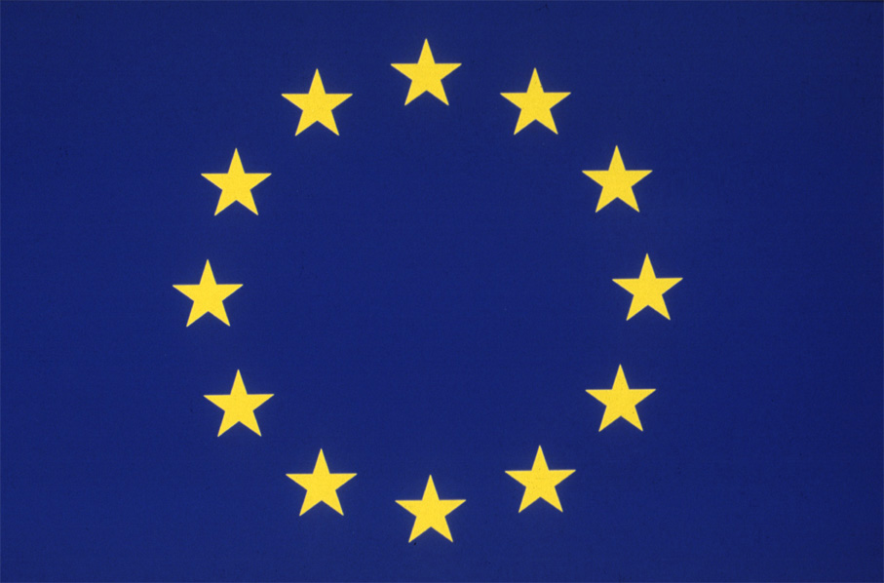

European Commission

Industry

Offshore Safety Cost of Compliance Questionnaire

United Kingdom

Version 1.0
[Date published]

Presented by:
Directorate-General for Energy, Unit B3 Coal and Oil

Cost of Compliance Questionnaire

Introduction
This questionnaire aims at gathering information from industry for the purposes of calculating the potential cost of proposed EU policies. Please fill it out as comprehensively and as accurately as practicable.
If you feel that the format of a question counterproductively restricts your response, please use the comments section to provide a more complete response in accordance with what you believe the question’s intended objective is.

Name

Name of company
Country of origin

Size of your operations in the UK
[In the table below, list the following information relating to the scale of your operations in the UK.]

Number of active wells in the UK with an indication of type (oil or gas, etc).
Number of fixed offshore installations in the UK with an indication of type(exploration or production), size etc.
Number of floatable or floating offshore installations in the UK with an indication of type (exploration or production), size etc.
Number of other offshore installations in the UK including subsea installations with an indication of type (exploration or production), size etc.
Annual production in the UK, either in barrels or tonnes of oil equivalent.

Comments:

Responsibility for costs
[Indicate the extent to which you bear the ultimate costs of safety compliance for your operations in the UK. If you do not ultimately bear all costs, indicate the extent to which sub-contractors or partners in your joint venture bear these costs.
Example: ‘All compliance costs are ultimately billed to us, except for the costs related to the inspection of leased equipment. We currently lease 2 MODUs in the UK.’]

Administrative burden
[In the following table, list the main administrative burdens of compliance for your operations in the waters of the UK on a per annum basis, as well as the resources you allocate to these burdens. If you are unable to provide figures for all your operations in the UK at the national level, then kindly estimate these costs per well or other unit, appropriately indicating this in the comments section below.
Administrative burdens are the costs on businesses of complying with the information obligations resulting from legislation and regulations. An example of administrative burdens in the offshore sector may be the preparation of safety and health documents, the notification of dangerous occurrences, inspections, and reading guidance material.
Use either finances or man-hours. If using man-hours, please indicate the wage rate of the personnel used to carry out the work.]

Category of work | Finances/man-hours | Wage rate

Comments:

Substantive costs
[In the following table, list main substantive compliance costs of your operations in the waters of the UK. If you are unable to provide figures for all your operations in the UK at the national level, then kindly estimate these costs per well or other unit, appropriately indicating this in the comments section below.
Substantive compliance costs are the costs that businesses incur in order to comply with the content obligations that legislation and regulations require of a production process or a product. In the offshore sector these include the costs of additional equipment or machinery to ensure compliance, or the costs of hiring consultants to help with compliance.
It is important to only include expenses over and above ‘business as usual’ operating costs: that means to say safety expenditures you would not have otherwise judged necessary or worthwhile if not for the formal or informal requirements of the offshore authorities in the UK.]

Category of expense | Cost

Comments:

Financial costs of compliance
[In the following table, list the main financial costs of compliance of your operations in the waters of the UK. If you are unable to provide figures for all your operations in the UK at the national level, then kindly estimate these costs per well or other unit, appropriately indicating this in the comments section below.
Financial costs are the result of a concrete and direct obligation to transfer a sum of money to the Government or the competent authority. An example of a financial cost in the offshore sector is the fee for notification charged by national regulators.]

Category of expense | Cost

Comments:

Other compliance costs
[In the following table, list any other compliance costs associated with your operations in the waters of the UK that you feel do not fall into the categories mentioned above i.e. that are neither administrative burdens, substantive costs, nor financial costs. If you are unable to provide figures for all your operations in the UK at the national level, then kindly estimate these costs per well or other unit, appropriately indicating this in the comments section below.]

Category of expense | Cost

Comments:

International comparison
[In the following table, indicate how your compliance costs in the UK compare with compliance costs in other countries you operate in.
If possible, use a percentage scale to indicate.]

Name of country 1
Administrative burden
Substantive costs
Financial costs
Other costs

Comments:

Name of country 2
Administrative burden
Substantive costs
Financial costs
Other costs

Comments:

Name of country 3
Administrative burden
Substantive costs
Financial costs
Other costs

Comments:

Scaling
[In order to scale the costs of compliance of your operations, list the following information in the table below.]

Annual revenue of your offshore operations in the UK
Annual operating expenditure in the UK
Annual pre-tax profits of your offshore operations in the UK

Comments:

Annex IX: List of studies taken into account
The disaster of Deepwater Horizon oil rig triggered a wave of reviews and studies aimed at assessment and review of various regulatory frameworks applicable to the offshore oil and gas activities. Many of the reports took strong advantage of the resources that were recently put forward to respond to accident and present a very solid, labour intensive, argumentation, pooling together contributions form various relevant areas. The considerable efforts by independent experts, national regulators and the industry provided for valuable sources of data and recommendations for change of practice that served as a crucial input for the Impact Assessment report.
As the conclusions of many studies show strong similarities, there is a solid basis for proposals for policy action. In this context, the range of reports listed in this annex, along with targeted consultations with stakeholders and the public consultations, made it possible for Commission services to identify crucial areas where improvements should be made to ensure that EU's regulatory framework and practices are based on the available state of the art practices. It is worth noting, that despite that up to date studies and reports are directly connected with the event in the Gulf of Mexico, they often present much wider analysis of relevant regulation and practices in general context of offshore oil and gas.

US studies and reports following the events in the Gulf of Mexico

  - Final Report of the National Commission on the Deepwater Horizon Oil Spill and Offshore Drilling (January 2011)
  - Staff Working Papers of the National Commission on the Deepwater Horizon Oil Spill and Offshore Drilling (about 30 papers, e. g. Economists' Perspectives on Liability Insurance, Ishan Nath, March 2011)
  - Deepwater Horizon Joint Investigation Team preliminary report covering issues under Coast Guard jurisdiction (April 2011, Final report scheduled for July 2011, but publication has been delayed)
  - Report of the National Academy of Engineering and National Research Council commissioned by UK Department of the Interior (November 2010)

Activities of the Member States and third countries

UK House of Commons Energy and Climate Change Select Committee: Special Report "UK Deepwater Drilling—Implications of the Gulf of Mexico Oil Spill" (January 2011), UK government response to the report

UK Oil Spill Prevention and Response Advisory Group progress reports (last, Second Interim Report, August 2011)

Dutch State Supervision of the Mines (SSM) conclusions on the review of the drilling practises and procedures (September 2010)

Norway: The Deepwater Horizon accident – Assessments and recommendations for the Norwegian petroleum industry (Petroleum Safety Authority, June 2011)

Australia's Report of the Montara Commission of Inquiry and a draft Government response (November 2010)

Report by international organisations

G-20 Global Marine Environment Protection Working Group Draft report: "Review of International Regulation of Offshore Oil and Gas Exploration, Production and Transport with Respect to Marine Environmental Protection" (March 2011)

OSPAR Draft internal Draft report on national legal framework and practices of contracting parties ("Drillex" activity) (March 2011)

Reports by the industry

BP's Deepwater Horizon Accident Investigation Report ("Bly report", September 2010)

UK Oil Spill Prevention and Response Advisory Group (OSPRAG) – OSPRAG Second Interim Report (April 2011)

Global Industry Response Group (GIRG, established by International Association of Oil and Gas Producers – OGP) report: International recommendations on well incident prevention, intervention and response (May 2011)

Transocean: Macondo Well Incident – Transocean Investigation Report (June 2011)

Studies and reports by independent parties

The forensic examination of the Deepwater Horizon blowout preventer (BOP) by Det Norske Veritas (DNV) (March 2011)

DNV Position paper on Effective Offshore Regulatory Regime (July 2010)

DNV Report commissioned by OLF/NOFO - Summary of differences between offshore drilling regulations in Norway and U.S. Gulf of Mexico (August 2010)

ClientEarth (an NGO) report: International and EU regulation of offshore drilling Analysis and proposals for reform (September 2010)

Annex X: Issues amending current legislation (Directives 2004/35/EC, 92/91/EEC and 96/82/EC)
This Annex provides supporting information for the reason amending the Environmental Liability Directive 2004/35/EC as proposed in this Impact Assessment, as well as the rationale for not amending Directive 92/91/EEC on the minimum safety and health requirements for workers in the mineral extracting industry and Directive 96/82/EC on the control of major-accident hazards involving dangerous substances ('Seveso 2 Directive 1996'). The following sections have been developed in close corporation with DG ENV and DG EMPL.
A. Amending Environmental Liability Directive 2004/35/EC
Problem definition
- The ELD (2004) was adopted after the entry into force of the Waste Framework Directive (WFD 2000), which applies in coastal and territorial waters, but before the adoption of the Marine Strategy Framework Directive (MSFD 2008), which covered then all marine waters under sovereignty or jurisdiction of EU MS.
- As a consequence, the ELD used the water definition applicable at time of its adoption, i.e. the WFD definition. Thus, one specific problem identified is that, under the currently applicable EU law, "water damage" only applies to waters defined under the WFD, but not to all EU marine waters.
- Since the common goods to be protected under EU law have been extended as from 2008, this situation raises a question of whether there is a need for updating the ELD to the progress and to the gradual extension of the EU environmental acquis.
- This specific problem, which relates to the problem of an overall fragmented legislative framework that may not be adjusted to the concerns identified by the Deepwater Horizon incident, requires the identification of options and a decision on the best way forward.
Options
In relation to the geographical scope of the ELD, there are basically two options:
- The first option is maintaining the status quo. The consequence of this baseline option is that the EU law on environmental liability would not be adapted to the gradual extension of EU environmental policy, which since 2008 moved on to protect all marine waters under MSFD and not just coastal/territorial waters under WFD. This option may be maintained, but raises a question on the legislative coherence of EU policy, to the extent that the ELD was designed to protect the common goods under EU law (biodiversity, water, etc.), which are now more comprehensive.
- The second option relates to adjusting the ELD, in terms of geographical scope, to the objectives of EU law, as gradually developed. The 6th Environmental Action Plan (2002-2010), adopted by co-decision by Parliament and Council, requested a thematic strategy be developed for the protection of European seas, having identified a gap in the common goods to be protected at EU level. This request led to a Commission proposal in 2005 for a Marine Strategy Framework Directive, adopted by legislators in 2008. To the extent that EU policy evolves in accordance with the directions by Parliament and Council, the question is raised on whether it is appropriate to partially adjust partially existing instruments (such as the ELD) to such a gradual policy evolution, or whether it is preferable to keep them in their original form, irrespective from overall progress in policy.

Impacts
- Now that the problem of the limited geographical scope of the ELD for marine waters has been specifically identified by the European Parliament resolution, one question to be considered is whether keeping the status quo would be acceptable, having regard to the experience from Deepwater Horizon.
- The status quo would perpetuate a framework where some of the consequences of accidents on marine waters from operations are not adequately internalised (which is a major purpose of the environmental liability framework), in accordance with the polluter pays principle.
- One specific case at stake is the remedial action that may be taken by MS to control on the spot the possible consequences of a major accident once it occurs. After the Deepwater horizon incident, the US carried out a major deployment of US military and civil means of contention, which prevented a serious aggravation of the environmental disaster.
- However, in the EU, in the current legislative situation, the water damage at the place of origin of the accident would not be covered by the ELD, and therefore it is not certain that some of the key consequences sought by the ELD would apply either (e.g. ensuring that the operator remains responsible for the containment costs by public authorities and/or third parties to prevent the spread of the oil spill at the source of the offshore accident).
- In terms of impacts, any partial adjustments of existing instruments (such as ELD) to policy progress (such as MSFD) need to take into consideration potential impacts, including distributional impacts. One important question is whether the potential impacts from the adjustment would be of a separate nature of those considered by legislators at the time of the adoption of the ELD, or whether there is a logical policy continuation of the intervention logic decided at the time, which aims at making the polluter pays principle in terms of prevention and reaction.
- The adjustment of the geographical coverage of the ELD to cover all the waters currently subject to environmental protection under EU law (i.e. not only the waters under the WFD from 2000, which predated the ELD from 2004, but also the MSFD from 2008) could potentially affect a number of operators as well as the public.
- In distributional terms, having regard to specific economic sectors, the shipping industry would not be affected by any change in the geographical coverage of the ELD, since the sector is currently subject to a broad sectoral derogation "ratione materiae" contained in the ELD itself (it is a sector already subject to sectoral international regimes, under IMO agreements). There is no proposal to address this issue now.
- The specific sector that would be affected by an extension of the definition of "water damage" would be the offshore hydrocarbons industry. The basic consequence of a legislative adjustment would be to promote the internationalisation of costs, not only in case that an accident occurs (polluter pays), but also in terms of preventive measures to reduce such risk. The operators would be made more explicitly responsible for any damage of the public goods currently identified by EU law, and notably all marine waters since the MSFD came into force in 2008.
- By contrast, one consequence of the legislative adjustment is that there would be positive impacts on other sectors potentially affected negatively by any offshore accident. This applies to fisheries, coastal tourism (and recreation) and possibly shipping (since major accidents affect navigation routes, as shown by the Deepwater horizon incident), as well as the European public in general.
- In other terms, the consequences of an amendment in geographical scope of the ELD to address marine waters would be above all distributional, as opposed to incremental. In accordance with the polluter pays principle, the sector in charge of potential damage to the common goods identified in current EU law (marine waters) would take expressly enhanced responsibility.
- Therefore, any geographical extension of the ELD to address water damage for marine waters would be after all a direct extension of the intervention logic inherent of the existing ELD, as already agreed by the legislators, updating it to the current geographical coverage of EU environmental law.
- It should be further noted that the extension of the scope of "water damage" to marine waters would concern the water quality in case of significant damage. By contrast, significant damage to protected species and natural habitats is already covered at present by another provision of the ELD, reaching out to all marine waters (the exclusive economic zone and the continental shelf, where Member States may exercise jurisdiction). Thus, the significance of any geographical adjustment would only address water damage and not damage to protected habitats and species (already covered).
- In addition, experience on the application of the ELD shows that very few cases have occurred so far across the EU where Member States had to apply their legislation transposing the ELD. This is mainly due to the fact that ELD is applicable in the case of a significant environmental damage and it is a general perception by Member States' experts that the ELD brings in fact a positive change to business attitude, by forcing operators to take a more environmentally precautionary attitude to their activities. This is the preventive effect of the Directive. In other terms, the main consequence of any geographical extension of the ELD to water damage at sea is above all a matter of prevention, which is coherent with the overall logic of intervention on this issue, and would in fact close a gap in an otherwise comprehensive consistent structure.

B. Issues regarding Directive 92/91/EEC and Directive 96/82/EC
As discussed in chapter 4 of this Impact Assessment document, options for implementing measures proposed in this document concerned the amendment of the following EU Directives:
- Directive 92/91/EEC on the minimum safety and health requirements for workers in the mineral extracting industries through drilling.
In order to improve the prevention of major hazards accidents and minimize risks for the environment in the oil and gas industry, amendments to 92/91/EEC have been considered. These amendments would concern the following issues:
- Incorporating environmental risks in the risk assessment and in the report documenting the results of this risk assessment performed on installations (in 92/91/EEC this report is referred to as the 'safety and health document')
- Submission of the report to the Competent Authority in Member States.
- Competent Authority in Member States to conduct a verification of the report.
- Directive 96/82/EC on the control of major-accident hazards involving dangerous substances ('Seveso 2 Directive 1996')
The amendment considered was to extend the scope of the Seveso 2 Directive to include offshore installations.
After consultation with representatives from DG EMPL and DG ENV respectively, it was concluded that amendments to these Directives was not considered possible or advisable. The preferred method for implementing of the measures suggested is by a separate legislative proposal, which is consequently reviewed and endorsed in this Impact Assessment.
The following paragraphs provide a further clarification on the problems and difficulties that would be encountered when amending the respective Directives. The text of these paragraphs has been drafted with the support of representatives from DG EMPL and DG ENV.
1 The Minimum safety and health requirements for workers at work Directive 89/391/EEC (the Framework Directive) and the Mineral extraction by drilling Directive 92/91/EEC (the Directive)
The Framework Directive and the Directive derive from Article 153 of TFEU. The Directive provides a number of key provisions that are relevant to the aims arising from the Commission's review of offshore major hazard prevention. The Directive is an established, widely respected and comprehensive instrument concerning the minimum requirements for improving the safety and health protection of workers in the mineral extracting industries through drilling, pursuant to Art.16 of the Framework Directive; as such it potentially provides the following model clauses for some key aspects of offshore safety and environment protection:

- General obligations, especially the requirement for making and updating a safety and health document
- Well control
- Prevention of risks of explosion
- Special minimum requirements applicable to the offshore sector, particularly: special hazards; management system; remote control in emergencies; means of evacuation and escape; helicopter operations; and installations stability.
In considering the application of the Directive to offshore oil and gas operations it was seen that a new provision - aside from, but building on the Directive- could satisfy the objectives of Article153 2.(a) TFEU should the aim be limited to implementing a risk assessment report system similar in effect to that utilised in various forms by North Sea Member States. This would need a separate provision from the Directive to require the safety and health document prepared by the operator pursuant to the Directive to be sent to Member States for verification. In addition, for the system to be workable, the form of the submitted document and the regulatory procedures would need to be specified in detail as it is in the North Sea (safety and health document in NL; safety case in the UK). In this region, Member States put into national regulation detailed specifications which focus on assessment of major hazard potential, and publish detailed guidance on their verification procedures).
Going beyond the minimum standards defined in the Directive for Member States to adopt a fully risk based safety regime for offshore major hazards would entail three further provisions to complement the Directive. First a requirement for Member States to develop a system of inspection, investigation and penalties that supports such a regime and focuses on the offshore major hazards measures described in the safety and health document. Second, clarification that the revised requirements apply to certain installations and significant infrastructure where there could be doubt as to the scope of the Directive (e.g. subsea facilities and connecting pipelines). Third, a requirement for the operator to send pre-drilling well notifications to the regulator specifying well design and operating plans.
These additional requirements could also be achieved by amendments to national law without infringing the original design intent of the Directive.
Difficulties arise from this point if it is intended to develop a holistic system centred on the Directive that includes: environmental risk and prevention assessments; an integrated process incorporating risk assessment verification, inspection and enforcement by safety and environment regulators; stable reporting requirements by operators to Member States; and preparation of internal and external emergency plans (the former being required within the safety and health document to minimise escalation of an incipient major hazard event, the latter being the planned national response to a major event should the internal emergency plan not work).
It was concluded that separate provisions are necessary to implement comprehensive safeguards in EU offshore operations because it is not feasible to develop an offshore major hazards and response regime centred on the Directive whilst remaining within its original design intent. There are currently no plans to amend the Directive but a review of the Directive has been set up and this is welcomed. That review will not be completed before the current overhaul of offshore safety is finished.
2 Seveso 2 Directive 1996 (Seveso)
Seveso provides a number of solutions to achieving desired regulatory outcomes for preventing major offshore incidents and limiting the consequences should nonetheless an incident occur. The Seveso model is a respected system for joined up regulation by EU major hazards safety and environment inspectors, a quality mostly lacking offshore notwithstanding the potential major impact on the environment arising from safety-related events. The applicable model clauses are found in Seveso Articles relating to:
- Notifications
- Major accident prevention policy
- Safety report
- Modification of an installation…
- Emergency plans
- Information on safety measures
- Information (major hazards) to be supplied by operators
- Information supplied by EUMS to the COM
- Competent authority
- Prohibition of use
- Inspections
- Information system and exchanges
Because the measures arising from the review of offshore safety bear close association to to the objectives of Seveso , the possibility, advantages and disadvantages of applying Seveso to offshore installations needs to be assessed.
Seveso covers already around 10.000 high-risk establishments onshore. The inclusion of a further 1.000 offshore installations would extend but not dominate Seveso's scope. Seveso is a goal setting directive, meaning that most of the Seveso provisions are designed for different industrial sectors and are therefore sufficiently flexible to fit offshore installations. A good portion of the Seveso provisions could be applied, as the list above clearly shows.
However, offshore oil and gas is a unique industrial sector – essentially comprising large industrial sites set into the sea - with very different stages of exploration and exploitation for which more specific provisions should and more detailed provisions could be designed. Offshore installations have relatively minor inventories of hydrocarbons on the facilities themselves, therefore the Seveso approach - "high quantities = major hazards" - does not fit. More precisely, the Seveso scope is defined by amounts of dangerous substances above specified threshold quantities, which is not a feasible criterion for offshore installations. Therefore the design of Seveso does not allow an easy inclusion of offshore installations without introducing changes that may create difficulties in other sectors for which Seveso was designed (for example by lowering threshold quantities of flammable substances).
In terms of specific legal duties, Seveso provisions that arise from having residential populations and other hazardous installations adjacent to the Seveso site are irrelevant to offshore oil and gas. Further Seveso, by its nature, does not provide for consideration of the evacuation, escape and rescue of a marooned offshore workforce, which is a primary consideration in offshore risk assessments. Finally and importantly, Seveso does not provide for formal acceptance of Seveso safety reports (referred to in the offshore impact assessment as major hazard reports) by the regulator. This function has been identified in recent EU legislation addressing safety and pollution control as a key requirement (e.g. in the Directives for Waste from Extractive Industries, and CCS), and has been assessed, equally, as a key requirement in the overhaul of offshore safety. Therefore it is undesirable to rule out such a provision for offshore at this stage.
Therefore it is concluded that whereas substantial aspects of Seveso can and should be incorporated into the draft offshore legal instrument, amending Seveso to bring offshore installations into scope is unlikely to be effective, and moreover risks damaging Seveso's coherence with the sectors to which it currently applies.
Annex XI: Description and evaluation of the implementation options for individual measures
Each of the 11 measures retained for further analysis in Chapter 3 has several possible means of implementation ("implementation options"). These are summarised in the following table and described in details in the individual tables attached at the end of this Annex.
Table
How measures may be differently implemented within the policy options
No. | Measure | Sub options for implementation of the measures
No. | Measure | A | B | C | D
1 | Detailed verification of the technical capacity of potential operator | Guidelines to Directive 94/22/EC  (Option 1+) | Setting criteria in EU legislation for verification by MS  (Option 2) | Assessing technical capacity by an EU body (agency)  (Option 3) | N/A
2 | Establishing regular inspections and a penalties regime | Guidelines on inspections/ sanctions | Setting minimum requirements in EU legislation  (Options 1, 1+, 2) | Inspections by EU body (agency)  (Option 3) | N/A
3 | Submission of formal safety assessments for acceptance by the regulator | Guidelines to Directive 92/91/EEC | Utilising 92/91 for inclusion of MAH + acceptance by regulator | EU legislation separate from 92/91 to cover MAH  (Option 1, 1+, 2) | Assessing MHRs by EU body (agency)  (Option 3)
4 | Extension of MHR into a comprehensive risk management model | Guidelines to Directive 92/91/EEC | Amending 92/91 to MAH + environment | EU legislation separate from 92/91 to cover MAH + environment  (Options 2,3) | Include offshore oil and gas under Seveso Directive
5 | Extending EU practices to overseas operations | Positive incentives (voluntary)  (Options 1+, 2) | Negative incentives: publication | Mandate global industry practice | Enforce consistency x-EU  (Option 3)
6 | Establishing a Competent Authority | Adopting EU recommendations or guidelines | Amending existing EU legislation | Adopting new/ specific EU legislation  (Option 2) | Establishing EU body (agency)  (Option 3)
7 | Establishing a platform for regulatory dialogue | Promoting voluntary arrangements | Mandating Commission- led regulatory dialogue  (Option 2) | Establishing EU-wide regulatory agency  (Option 3) | N/A
9 | Comprehensive information sharing and transparency | Voluntary information sharing/ publication | EU mandating sharing / publishing of information  (Options 2, 3) | Establish EU database (Commission or agency) | N/A
10 | Preparedness for effective emergency response to major offshore accidents | Industry to provide suitable / sufficient emergency plans | Enhance cross-border preparedness through MS agreement  (Option 1+) | EU mandating requirements and coordinate exercises  (Options 2,3) | N/A
11 | Ensuring cross-border availability and compatibility of intervention assets | Industry ensuring availability and sharing of assets | Voluntary agreement by MS to share assets and expertise  (Option 1+) | EU mandating option B  (Options 2, 3) | N/A
12 | Clarifying the scope of environmental liability | Guidance on the applications of the Waste Directive | Extending scope of 2004/35/CE (ELD)  (Options 1+, 2, 3) | Sector-specific EU liability legislation for environmental damage | International/ global solution
The table distinguishes between implementation options that are considered feasible (the un-shaded options), options that are feasible but with some disadvantages or negative consequences (mainly some of the institutionalising options, the yellow shading) and finally those that are not considered feasible (the grey-shaded options). As can be seen, some measures can be implemented through alternative means which often differ by the degree of their complexity or policy ambition. The measures alone also differ in the degree of change to the present rules and practices which they would entail. The rest of this annex sets out the detailed analysis which the table above summarises.

Analysis of possible implementation means for individual measures
1. Detailed verification of the technical capacity of potential operator
Option A | Adopting EU guidelines for Art. 5.1a of Directive 94/22/EC
Option B | Defining detailed binding criteria in EU legislation (amending 94/22/EC or separately)
Option C | Assessing technical capacity at EU level (e.g. through a dedicated body such as EMSA)
Even if the preparation of the guidelines envisaged under Option A achieved setting more than just basic and low-level common standards for the licensing process in the EU, the guidelines would not be mandatory for both the applicant and the licensing authorities, potentially resulting in little change in the licensing processes of Member States. This would to a large extent not fulfil the purpose of the objective, as it gives insufficient possibilities for a comprehensive strengthening of the licensing process of all Member States. Based on this analysis, A is not supported.
Option B is endorsed as it provides the highest likelihood of ensuring changes to the licensing processes of Member States. It will provide for clear criteria, targeted at the critical operations of license applicants. This option is regarded as the minimum requirement for ensuring that the licensing process is conducted professionally, with equal screening criteria for all applicants. Authorisation is a key provision to guarantee that all measures to prevent accidents and to limit their consequences are taken, and best available techniques are applied. Further measures like the risk assessment, safety management systems or internal emergency response to be provided by an applicant are prerequisites for granting an authorisation.
Option C has the advantage that assessment of license applications is performed by a single EU body, completely independent of Member States, issuing some form of clearance ("health check") to companies wishing to operate in any European jurisdiction. This would ensure EU-wide coherence and level playing field across European jurisdictions. It is not, however, evident that it would necessarily lead to a more robust assessment than under B as it also presents several drawbacks: (1) the new organisation will have to build up the required expertise for assessment of license applications; (2) Member States may have specific requirements for screening criteria (because of local circumstances) which could complicate the work processes of the new organisation. The scope of action of the body could be limited by consideration of the guarantees given to Member States in existing EU legislation in respect of sovereign assets (Art 194 of TFEU and Directive 94/22/EC).
2. Establishing regular inspections and a penalties regime
Option A | Guidelines on inspections/sanctions and support to regulatory cooperation
Option B | Mandating minimum requirements for inspections/sanctions
Option C | Inspections to be carried out by an EU agency
Non-mandatory guidance under Option A could only be high level due to the wide differences in EU civil and criminal regimes. Experience in the EU shows that, where Member States already have major hazard regimes involving some kind of approval system, non-statutory approaches are not sufficient to ensure that regulatory authority contains the necessary costly resources and expertise. Voluntary mechanisms are also unreliable for securing high performance from the industry, particularly where the industry is rapidly evolving, which is the case in the offshore industry where the shift towards diversification amongst both contractors and operators is set to continue. It is unlikely that Member States can achieve effective intervention approaches that will bring the least capable regimes to the level of the best performing ones without a firm EU mandate on the minimum requirements. In addition, the absence of an EU mandate is unlikely to deliver a consistent enforcement and sanction regime that would act effectively across the EU in a similar and effective way. Overall, we therefore discard Option A.
Option B is endorsed as the most likely means to achieve consistent and effective regulatory oversight across the EU by:
- Enabling Member States to identify and pursue the resources necessary to establish a high performance regulatory agency
- Clarifying and mandating the key priorities for EU regulators' practical interventions
- Having minimum requirements for enforcement and sanctions to drive consistent performance by industry throughout EU waters
This option would allow for the key principles that an effective oversight system should comprise be spelled out in a legislative text already now while the detailed parameters of the key priorities could be adopted subsequently through delegated or implementing acts prepared in cooperation with an expert committee of Member States' representatives.
Option C could deliver a consistency of inspection regimes but the EU body would not be able to extend its action to the enforcement of sanctions; this would have to remain reserved to Member States in view of the interlink with national criminal regimes and frameworks for the pursuit of legal enforcement. This limitation could potentially undermine the effectiveness of existing regimes in some Member States; its implementation would thus require safeguards that the efficacy of current EU goal-setting regimes would not be diminished.
3. Submission of formal safety assessments for acceptance by the regulator prior to operations with major hazards potential
Option A | Adopting EU guidelines to Directive 92/91/EEC
Option B | Utilising Directive 92/91/EEC for the inclusion of major accident hazard (MAH) aspects and submission to/acceptance by the regulator
Option C | Adopting a specific legislative instrument separate from Directive 92/91/EEC for issues not related to health and safety of workers, extending the goal-setting approach to cover major hazard impacts
Option D | Assessing major hazards reports at EU level (e.g. through a dedicated body such as EMSA)
A drawback of Option A is that the guidelines are not mandatory. This gives insufficient assurance that the required change in control of major accident hazards is indeed established.
For Option B, the planned review of the effectiveness of Directive 92/91/EEC in consultation with social partners could provide an opportunity for an improved and better focused legal framework on major hazard risk prevention, with minimum disturbance to current good practices and endorsement of the provisions already available for risk assessments in the Directive.
Option C would be suitable should a solution complementary, but entirely legally separate, to Directive 92/91/EEC would need to be sought.
For Option D, the analysis of strengths and weaknesses outlined for Option C under the previous measure can be applied by analogy.
4. Extension of the major hazards report into a comprehensive risk management model for EU offshore
Option A | Adopting EU guidelines to Directive 92/91/EEC
Option B | Amending Directive 92/91/EEC to extend its scope to MAH and environmental risks
Option C | Adopting a specific legislative instrument separate from Directive 92/91/EEC for issues not related to health and safety of workers, extending the goal-setting approach to cover major hazard impacts and environmental risks
Option D | Including offshore oil and gas industry in the Seveso regime
The main drawback of Option A is the likely and undesirable infringement of the original design intent of Directive 92/91/EEC, thus risking undermining the efficacy of the instrument. The planned review of the effectiveness of the Directive in consultation with social partners is, however, supported and encouraged as we say above.
Option B, although appealing at an intuitive level, is not within the scope of the Directive, which is to set minimum requirements for the protection for safety and health of workers, pursuant to the framework Directive. This renders unfeasible the introduction of different sectoral requirements into Directive 92/91/EEC irrespective of the outcome of the pending review.
Option C is endorsed as providing an effective framework for better preventing a major accident. The extension of the existing formal safety assessment process to focus on the controls necessary to prevent a major hazard, combined with the actions to be taken following a major accident and the resulting impacts are complementary to Directive 92/91/EEC. This would enable important reforms to proceed without disturbing existing legislation. This specific framework regulation guarantees the same level of safety as provided by Seveso for human Extending EU practices to overseas operations health and the environment for on-shore installations and is preferred to an amendment of the Seveso legislation to extend its scope, which would not be appropriate given the specific characteristics of offshore oil and gas installations.
Option D is not recommendable because the design of Seveso does not allow an easy inclusion of offshore installations without introducing changes that may create difficulties in other sectors for which Seveso was designed (for example by lowering threshold quantities of flammable substances). Offshore installations have relatively minor inventories of hydrocarbons on the facilities themselves, therefore the Seveso approach - "high quantities = major hazards" - does not fit. The Seveso scope is defined by amounts of dangerous substances above specified threshold quantities, which is not a feasible criterion for offshore installations.
In view of the necessary special consideration given to both the Drilling Extractive Industries and Seveso Directives, we provide at Annex X more detailed considerations.
5. Extending EU practices to overseas operations
Option A | Positive incentives (voluntary code of conduct)
Option B | Negative incentives - publicise lax standards of EU companies' operations outside EU
Option C | Mandate global industry practice for companies headquartered in EU
Option A is endorsed as the likely most suitable means by which the EU would gain a reputation for high standards through the conduct of its flagship companies. EU companies are unlikely to refrain from signing up to an appropriate code of responsible conduct to convincingly establish their commitment to international best practices.
EU and Member States have no statutory insight beyond the EU it would be very difficult to identify industry practices which are not in line with the European legislative framework. The policy of pursuing EU level intervention in EU companies' lax performance overseas is not supported. Where a company is already in a poor public light (e.g. as was BP after Deepwater Horizon), an expression of EU disapproval is considered to add little value in those circumstances. Option B is rejected in view of its difficulties and uncertain value (and potential legal complications).
In Option C, there would be foreseeable difficulty in setting up the legal framework to enforce the obligation. Questions such as who would enforce it, how should 'EU company' be defined, what would be the requisite level of evidence and where is the rationale for public interest are all potentially insoluble challenges. These measures at worse could drive companies to establish their status outside the EU. Option C is rejected as unlikely to achieve.
6. Establishing a Competent Authority in each jurisdiction
Option A | Adopting EU recommendation or guidelines to Member States
Option B | Amending existing EU legislation
Option C | Adopting a new/specific legislative instrument
Option D | Establishing EU-wide competent authority (through existing or new EU body)
The main drawback of Options A and B is the absence of suitable EU legislation at present. Using any of the relevant existing pieces of legislation (e.g. Directives 94/22/EC or 92/91/EEC) would inevitably limited the scope of action of the Competent Authorities only to the field covered by the respective legislative text. Alas, as outlined in chapter 3, the Competent Authorities should be in the position to act on a full range of issues related to the management of risks in the offshore sector.
Option C appears best suited for the purpose. As the need for Competent Authority is directly linked to the creation of a comprehensive risk management model for the offshore sector, which in turn would be most effectively achieved through a specific new legislative initiative (see 4.1.3), the provisions on Competent Authorities could and should be an integral part of such an initiative.
Option D would be hampered by the same considerations as similar options considered in 4.1.1 and 4.1.2. The arguments against this option provided in those parts, and notably related to guarantees given to Member States in existing EU legislation in respect of sovereign assets (Art 194 of TFEU and Directive 94/22/EC), would apply by analogy.
7. Establishing a platform for regulatory dialogue and information sharing amongst jurisdictions
Option A | Promoting voluntary arrangements amongst regulators (extend NSOAF model)
Option B | Mandating regulatory dialogue led by the Commission
Option C | Creating an EU wide regulatory agency

Option A carries the weakness that the aim of levelling up the effectiveness of all EU Member States intervention programmes to the level of the most effective regimes in the North Sea cannot be expected through voluntary means. Whereas an expanded NSOAF would bring benefits to less resourced regimes, it can be argued there is little gain evident for existing NSOAF members. Further, NSOAF works well precisely because it is comprises members who already have high performance regulatory regimes, although with some disparities and weaknesses amongst them. Therefore it is not coincidence that an equivalent to NSOAF has not started up in other EU regions (nor that NSOAF members UK and Norway were the founder members of IRF). Therefore we discard this option of having no likelihood of achieving a benefit that outweighs the cost of it.
Option B means setting up a Commission-led group of all EU offshore regulators and shaping for this group an agenda that supports the inculcation and maintenance of regulatory best practices and that would also enhance the efficacy of existing regional groups such as NSOAF, and the fledgling Mediterranean MS forum. In order to establish such an EU-wide platform, the SLIC Directive provides an obvious and well tried model. Overall, this option is endorsed as the most effective and efficient means to support MS' adoption of a consistent approach to best regulatory practice.
Option C would be meaningful to consider alongside other strong options for implementing the measures that, in effect, institutionalise the offshore reform package, particularly:
- Assessing technical capacity at EU level (e.g. through a dedicated body such as EMSA) (4.1.1)
- Inspections to be carried out by an EU agency (4.1.2)
- Assessing major hazards reports at EU level (e.g. through a dedicated body such as EMSA) (4.1.3)
- Establishing EU-wide competent authority (through existing or new EU body) (4.1.6)
- A database managed at EU level (Commission or an agency) with centralized publication of information (4.1.8 – below)
Option C would be the implementing option for this measure should the listed options come to be the preferred means for implementing those measures to which they relate.
8. Achieving consistency of product safety standards across the sector
Not develop[ped further in this impact assessment.

9. Comprehensive information sharing and transparency
Option A | Encouraging information sharing and voluntary publication of relevant information
Option B | An obligation on Member States to publish information in a common format
Option C | A database managed at EU level (Commission or an agency) with centralized publication of information
Option A is discarded because it is unlikely to attain the goal of consistency and hence comparability of performance data. It would fail to remedy existing problems of comparing data between all EU jurisdictions. Even in more evolved regimes such as the UK and Norway, the comparison of data is costly and time consuming because of differences in reporting criteria and classifications.
Option B provides for an EU level solution, thus it will avoid inconsistency of requirements and unnecessary burdens on industry. It presents the best and least burdensome means to:
- Extract data from industry
- Share information that is reliably consistent
- Improve the metrics available to Member States to better position regulators' interventions and give better public assurance of validity
- Encourage transparency by replacing voluntary systems with formal data collection
- Incorporate environmental impact reporting
- Cover accident reporting and lessons learned
This approach would enshrine better regulation principles by levelling up the requirements between the EU national systems, without the imposition of an additional layer of reporting. While the general principles and obligations could be spelled in a general legislative text, the metrics to be collected and data formats would be specified through implementing or delegated acts. It would be helpful to involve Norway in the formulation of any such acts as Norway has an outstanding record for data publication.
Option C is discarded for a lack of evidence that all relevant Member States could not reach a similar level of transparency based on common requirements and common data format, thus attaining high levels of collaboration without EU control over the process. It would be overly burdensome on Member States and unnecessarily costly to the EU. Data verification would become more complex and costly, and may result in delayed publication, rendering the information of diminishing value. This option could be reviewed in due course if the collective output of Member States were shown to be unreliable.
10. Preparedness for effective emergency response to major offshore accidents
Option A | Industry to demonstrate the existence of suitable and sufficient emergency response plans
Option B | Securing MS agreement to enhance cross border preparedness for responding to offshore major accidents
Option C | EU to mandate the minimum requirements for offshore emergency response plans amongst Member States and to coordinate periodic multi-agency emergency exercises to test the plans
In Option A, operators would have to take responsibility as the lead providers of plans and resources. However, the Deepwater Horizon disaster showed that amongst even the super-major oil companies operating in the Gulf of Mexico (all of whom also operate in EU waters), there was a tendency to replicate between themselves the same inadequate environmental risk assessments for the purposes of planned response. Option 1 is discarded as it is considered that this level of EU action for emergency response would be both unlikely to gain public confidence and would only partly achieve the objective. The important part currently played by industry in emergency preparedness and response should, however, be emphasised, especially as it is envisaged that it will not only continue but further develop.
Option B builds on Option A. It establishes the basis of emergency preparedness for MS – in effect sets a planning template for national emergency response plans - such that plans can be shared and resources allocated on a collaborative basis between MS in the same region, but also to open up the potential for helping other regions combat extreme emergencies. It also motivates MS to develop interoperable assets for sharing across boundaries when it is required to lend assistance to other MS emergency responses. As a natural corollary to this measure, MS would collate industry inventories and stimulate interoperability of industry and national assets, which then opens up the whole of the EU to transferring equipment and expertise should this be necessary to bring a major incident under control.On balance Option B could go a long way towards meeting the aim of consistent preparedness across all EU areas, but recognising that it does not give assurance that other Member States would be in a position to lend all assistance to the affected country. Depending on the package of measures that are preferred (see below, under Option C), Option B may be suitable.
Option C goes further than Option B and provides for EU level minimum requirements for offshore emergency response plans and the preparation of standard operating procedures for Member States to put into practice in collaboration with the oil and gas operators and other Member States in their region. The minimum requirements would be formulated in cooperation with Member State experts. Among other things, they would establish the principle of Member States sharing assets, and therefore of sharing planning. Emergency plans should always be tested, therefore under this option periodic transboundary exercises would be conducted with EU oversight and the lessons learned would be used to review the standard operating procedures generally. We propose this option as being the best available means to:
- Ensure consistent and meaningful contributions to emergency response by industry across the EU
- Facilitate sharing of emergency plans between neighbouring Member States
- Securing all necessary assistance to the affected Member State(s)
- Ensuring compatibility of coordinated response, and
- Continually improving knowledge and provision of effective emergency response in EU waters by periodic exercises
However this implementation is only feasible should environment impact and emergency preparedness be included in the major hazards report (see 4.1.4). Otherwise this option for implementing the measure would be unworkable.
11. Ensuring cross-border availability and compatibility of intervention assets
Option A | Industry to ensure availability of their emergency response equipment and materials, sharing as necessary and possible
Option B | Member States to enter voluntary agreements to make available national assets for emergency response, including expertise
Option C | In addition to Option 2, the EU to mandate transboundary sharing of emergency response assets and expertise, and from other EU areas where appropriate
Option A is necessary but does not go far enough to ensure that compatible assets can be made available at the time and point of need. The work to date by the industry should certainly not be dismissed, rather they should be commended, built upon and extended.
Provisions under Option B go further than Option A and would be expected to work best in local regions of the EU because, under such an agreement, and subject to EU minimum requirements for offshore emergency plans (under the previous objective), all regions would make the necessary provisions based on local risk assessments and marine environmental data from monitoring. In addition, under this option Member States would be expected to ensure inventories are formally collated and periodically updated.
It follows that an interdependency of assets requires interoperability of equipment and compatibility of fittings and couplings etc. This provision would support that objective, particularly over time, as response equipment is replaced. Going further, more consistent expertise would be expected to develop in response to greater standardisation that would facilitate the transfer of expert personnel across the EU. Possible links with the EU Civil Protection Mechanism should be explored. The EU itself also offers, through EMSA and on request from the affected State, additional marine pollution response assets.
It is considered that these desirable outcomes are achievable by suitable arrangements between Member States under broad guidance that could be prepared at EU level with Member States' agreement.
A combination of Options A and B are most likely to secure the best available emergency response to offshore major incidents through:
- Building on the technical progress made by industry and its experience gained in responding to challenging offshore incidents
- Facilitating the sharing of compatible resources at both industry and national level where a Member State may be overwhelmed by the scale of the incident and ensuring the local inventories are accurately recorded and available
- Concentrating expertise and inventories on a regional basis, suitable to regional risks
- Agreeing interoperability of hardware
- Agreeing the transferability of key dispersants and other materials between Member States
- Collating key environmental data for all EU areas to make full assessment of the most effective responses feasible
- Deploying current EU resources in broad support of regional responses.
Option C is not endorsed. Currently, most Member States have well-established and apparently effective arrangements for offshore emergency response that are being reviewed and probably upgraded. There is no indication that Member States would not readily lend all assistance to other Member States stricken by an emergency as is the case in the framework of the EU Civil Protection Mechanism. Furthermore, the EU level framework for sharing plans and for coordination of periodic exercises (proposed in 10.) will give assurance or otherwise test that voluntary agreements will suffice.

12. Clarifying the scope of environmental liability
Option A | Issuing guidance on the applications of the Waste Directive to oil and gas accidents
Option B | Extending the scope of the Environmental Liability Directive to water damage in all marine waters
Option C | EU to develop sector-specific liability legislation for environmen11tal damage
Option D | International/global solution (e.g. IMO liability convention)
Option A assuming the provision of EU guidance to help disseminate actively the interpretation by the Court of Justice of the European Union and national courts of existing waste legislation is discarded because it would address only some of the present problems arising in the analysis of liability regimes in offshore oil and gas operations. While it could clarify the assignation of environmental liability to the polluter for all water damage to all marine waters of Member States, with the corresponding obligation to remedy all environmental damage, and provide clarity regarding the unconditional consideration of oil or gas leaked from an offshore operation as waste, it cannot close the gap which exists with regard to primary, complementary and compensatory remediation of damage to marine waters beyond coastal and territorial waters.
Option B is endorsed as providing the necessary change to the regulatory regime. The change of the scope to the Environmental Liability Directive, by extending the current scope of water damage based on the Water Framework Directive (WFD) to include also the Marine Strategy Framework Directive (MSFD) would make all significant damage (including immediate threat of significant damage, thus launching preventive action) to marine waters in Member States' jurisdiction beyond territorial waters (exclusive economic zone and the continental shelf where applicable) subject to the EU framework for full environmental liability.
Option C is discarded because it would have far-reaching effects that would undermine the general policy of broadly applicable frameworks for various types of liabilities, without achieving significant additional benefits over and above those resulting from Option 1. Such an approach would further fragment the existing EU-wide environmental liability framework and be at odds with the broad aims of the Commission (and duty holders) towards joined-up systems of regulation and liability.
A drawback of Option D is that it would likely be a very long time in gestation and would bring no immediate remedy to the observed limitations in current EU legislation. An obvious benefit would be the global nature of this solution.
13. Ensuring financial capacity of operators to cover liability
Not developed further in this impact assessment.
14. Establishing compensation regimes for traditional damage
Not developed further in this impact assessment.
Annex XI – table 1
Measure 1: Detailed verification of the technical capacity of potential operator
Option | Description
Option A: Adopting EU guidelines for Art. 5.1a of Directive 94/22 | Under Option A, the EU would provide guidelines for Article 5.1a of Directive 94/22/EC on hydrocarbon licensing. These guidelines would specify the (minimum) required information that an applicant for a license should provide to the licensing authority of the Member State. This should assist the licensing authorities of the Member State in designing their model (criteria, procedures) for assessment of the adequacy of the technical capacity of the applicant and the operating procedures for the implementation of the model.
Option B: Defining detailed binding criteria in EU legislation (amending Directive 94/22 or separately) | Option B takes a step beyond Option A. Under Option B the EU would specify in legislation the criteria for the licensing process in sufficient detail to secure the goal of a consistent level of technical capability amongst all companies operating offshore license in the EU. This could be done by amending Directive 94/22/EC or through separate legislation. It would be important to ensure the involvement of industry and Member State authorities in the process of the designing of the criteria and also allow for their dynamic evolution over time. The latter point in particular points to the inclusion of comitology provisions in any legislative solution. In any case, the criteria should include a specification of the critical operations for which demonstration of technical capacity is required. The types of critical operations covered should include well design, drilling, well control and process safety engineering. In addition, a demonstration of adequate provision for response to emergency scenarios should be provided. Consideration could be given to a requirement that the information provided by an applicant is verified and assessed by a third party. Such legislation should also define criteria for the licensing authorities on how information provided by the applicant to demonstrate its fulfilment of the required technical capacity should be assessed.
Option C: Assessing technical capacity at EU level (e.g. through a dedicated body such as EMSA) | Option C makes provision for the assessment of the technical capacity of license applicants at EU level through a dedicated body, e.g. EMSA.
Annex XI – table 2
Measure 2: Establishing regular inspections and a penalties regime
Option | Description
Option A: Guidelines on inspections/sanctions and support to regulatory cooperation | Option A deals with the concern that the approach to assessment of safety reports, site inspection and enforcement of defects is variable between all countries that practice such regimes. . In terms of achieving consistency of enforcement and sanction, non mandatory guidance would need to acknowledge there are wide differences in EU civil and criminal regimes.  Guidelines would comprise a broad generic framework of necessary measures, leaving Member States to determine the appropriate level of detail. Measures would include verification of: issues raised in the operator's safety report; well design; safety critical elements relating to major hazards prevention (e.g. well control and production systems); maintenance of safety integrity levels; management of change of major hazards systems; mitigation systems against incident escalation, evacuation and rescue, and environmental impact; appropriate enforcement measures to deal with any failure by operators to maintain suitable standards. Preparing the guidelines would be an opportunity for exploring gaps in the framework of EU responses to Deepwater Horizon where an EU level coordination function would be helpful. For example in coordinating lessons learned from some major incident investigations (but subordinate to any criminal investigation being conducted by the national authority); providing leadership and/or secretariat functions to regional groups (based on the NSOAF model); publication of EU reports into performance of the offshore sector based on EU Member State submissions could also be considered.
Option B: Mandating minimum requirements for inspections/sanctions | Option B effectively places the development of guidance under Option A into a mandatory framework. Experience in the EU shows that where Member States already have major hazard regimes involving some kind of approval system, non-statutory approaches are not sufficient to ensure that regulatory authority contains the necessary costly resources and expertise. Voluntary mechanisms are also unreliable for securing high performance from the industry, particularly where the industry is rapidly evolving, which is the case in the offshore industry where the shift towards diversification amongst both contractors and operators is set to continue. It is unlikely that Member States can achieve effective intervention approaches that will bring the least capable regimes to the level of the best performing ones without a firm EU mandate on the minimum requirements. Whereas all aspects of safety and environmental protection offshore are important, an EU mandate will give focus to the major hazard priorities.
Option C: Inspections to be carried out by an EU agency | Option C makes provision for an EU-level supervisory body. This is a logical consideration for the establishment of absolute consistency in the oversight and supervision of a modified regime across the EU, including in the application of sanctions. EU-level supervision of national jurisdictions is likely to require the creation of new major hazards instruments (as discussed under measure 4.1.1, 'Detailed verification of the technical capacity of potential operator, Section 4.1.1 of the Impact Assessment report).  There are a number of models that could be adopted for EU level intervention. The model of the International Atomic Energy Authority (IAEA) is an example where there is an obvious public mandate for a UN-based intervention policy. International air safety. The International Civil Aviation Organisation (ICAO) is another model which has safety as a key strategic objective and gives oversight to national civil aviation regulators.  Within the EU, the European Maritime Safety Agency (EMSA) monitors over 20,000 vessels across Europe and inspects classification societies etc. On the environment side, EMSA provides pollution response vessels to help Europe better respond to major oil spills. EMSA has no current expertise in drilling and production operations.
Annex XI – table 1.3
Measure 3: Submission of formal safety assessments for acceptance by the regulator prior to operations with major hazards potential
Option | Description
Option 1: Drafting of EU guidelines to Directive 92/91/EEC | Option A makes provision for the specification of guidelines, for the application of measures for occupational safety and health, and for measures for the control of major accident hazards (MAH), presented in a major hazards report (MHR), including submission of the report to and acceptance of the report by the regulator. The guidelines should specify how and when they should be applied during the various stages and operations during the life cycle of the installation.
Option B: Utilising Directive 92/91 for inclusion of MAH aspects and submission to / acceptance by the regulator | Option B builds on option A by extending Directive 92/91/EEC, mandating the elements of major hazards control including the requirement to submit the major hazard report (MHR) to the regulator for acceptance. This would retain the authority of the well understood Directive but at the same time would extend it beyond its present scope.  The option proposes a potential strengthening of the measures for offshore safety through the forthcoming review of Directive 92/91/EEC and update of the safety and health documents, in line with the Commission's communication on this subject in October 2010.
Option C: Adopting a specific legislative instrument separate from Directive 92/91 for issues not related to health and safety of workers, extending the goal-setting approach to cover major hazard impacts | In Option C new measures are proposed to secure better regulation of major accident prevention. Whilst it is recognised that existing legislation (particularly in the provisions of Annex C to Directive 92/91/EEC) acknowledges the stringency of provisions needed for major accident prevention and response, Option C proposes separate but aligned legislative provisions that place specific duties on industry and the regulator to take the measures necessary to cover the impact of major offshore accidents in EU waters that can lead to a large number of casualties and/or total loss of the installation. This also includes submission of the major hazard report (MHR) to and acceptance by the regulator. Any resulting reforms across the EU would be those that are specifically necessary for major offshore hazard control and would be complementary to Directive 92/91/EEC, which adopts the goal setting approach.
Option D: Assessing major hazards report at EU level (e.g. through a dedicated body such as EMSA) | As in the previous measure, Option C makes provision for an EU-level body for assessments of the major hazard reports (MHR) submitted by industry. This is a logical consideration for the establishment of absolute consistency in the review and acceptance process of MHR's, including in the application of sanctions.
Annex XI – table 1.4
Measure 4: Extension of the major hazards report into a comprehensive risk management model for EU offshore
Option | Description
Option A: Adopting EU guidelines to Directive 92/91/EEC | Option A makes provision for the specification of guidelines, for the application of measures for occupational safety and health, and for measures for the control of major accident hazards (MAH) including to the environment, presentation of these measures and the emergency plans in a major hazard report (MHR) and submission of the report to and acceptance of the report by the regulator. The guidelines should specify how and when they should be applied during the various stages and operations during the life cycle of the installation.
Option B: Amending Directive 92/91 to include MAH and environmental risks | Option B builds on option A by extending Directive 92/91/EEC mandating the elements of major hazards control and to incorporate environmental aspects and emergency plans in the major hazards report (MHR). It would follow the globally recognised model for major hazard risk control and apply to the lifecycle of the project: Identification of major hazard scenarios for specific operations, Derivation of the risks arising from the scenarios by evaluating consequence and likelihoods of occurrence, Development of suitable control measures according to the risks, including to the environment, and that will secure a good prospect of recovery of stranded workers, Development of appropriate management systems to ensure that control measures are functional and subject to continuous improvement, Independent verification of the critical safety elements, specifically including well design. This would retain the authority of the well understood Directive but at the same time would extend it beyond its present scope.  The option proposes a potential strengthening of the measures for offshore safety through the forthcoming review of Directive 92/91/EEC and update of the safety and health documents, in line with the Commission's communication on this subject in October 2010.
Option C: Adopting a specific legislative instrument separate from Directive 92/91 for issues not related to health and safety of workers, extending the goal-setting approach to cover major hazard impacts and environmental risks | In Option C new measures are proposed to secure better regulation of major accident prevention and the impacts for e.g. the environment. Whilst it is recognised that existing legislation (particularly in the provisions of Annex C to Directive 92/91/EEC) acknowledges the stringency of provisions needed for major accident prevention and response, Option C proposes separate but aligned legislative provisions that place specific duties on industry and the regulator to take the measures necessary to cover the impact of major offshore accidents in EU waters that can lead to total loss of the installation and major damage to the environment. This also includes submission of the major hazard report (MHR) to and acceptance by the regulator. Any resulting reforms across the EU would be those that are specifically necessary for major offshore hazard control, including environmental impact prevention, and would be complementary to Directive 92/91/EEC, which adopts the goal setting approach. The priority areas where detailed rules would be set out at EU level include inherent safety, maintaining primary containment of the oil and gas (process safety), emergency plant and equipment to mitigate and contain drilling and production incidents, and wider-scale emergency response in the event of an incident escalating into a full emergency. Because of the complex nature of major hazard prevention in the offshore context, and because of the need to tackle environmental as well as safety issues, it is not reasonable to anticipate the development of new or amended standards and guidance by existing standards bodies (such as CEN) or authorities (such as IPPC) acting alone. A coordinated approach by industry, regulators, standards bodies and other key stakeholders would be essential under this option. It would require the adoption of a legal instrument laying down the main principles and themes while making recourse to comitology and expert groups to elaborate detailed implementing provisions for individual themes/principles.  Option C would set an agenda, preferably with a clear timeline, for improvements in safety critical areas in line with the development of necessary standards and guidance that could be incorporated forthwith into the inspection and enforcement programmes of Member States. This would ensure that objective focus is maintained, and would reduce the chance of a drift in industry and regulatory attention from the top priority improvements, some of which will be challenging to deliver.
Option D: Include offshore oil and gas industry in the Seveso regime | Option D is introduced to extend the scope of Directive 96/82/EC (Seveso II Directive 1996) to incorporate offshore oil and gas installations. This would ensure that provision for the control of major-accident hazards under this Directive would also be required for the oil and gas facilities offshore. The Directive specifies requirements for: a written and implemented major accident prevention policy; a safety management system; a safety report for the facility; establishment of a Competent Authority; inspections to be conducted by the Competent Authority; reporting by the operator of relevant information regarding the facility and availability of emergency plans for the facility. Extending the scope of the Seveso Directive would be a considerable change, as the current scope is defined by the inventory of dangerous substances (which determine the major hazard scenarios) and currently limited to facilities on land (with prominent issues regarding external safety and land-use planning).
Annex XI – table 1.5
Measure 5: Extending EU practices to overseas operations
Option | Description
Option A: Positive incentives (voluntary code of conduct) | Option A would encourage European companies to make a voluntary commitment (code of conduct) to apply the same standards and procedures which are used in EU waters. The majority of relevant EU companies claim that they already follow strict EU standards during their global operations, yet information from stakeholders suggests that there is still significant inconsistency in this approach. There are "softer" options that could effectively contribute to the use of EU standards in third countries, especially in connection with the importance that offshore companies typically attach to their good reputation. For example, this opens up opportunities for measures built on increased transparency and publication of relevant data. Ultimately, companies would not want it to become apparent, following an incident or criminal prosecution in a non-EU country, that they disregard their EU commitments to maintaining high standards worldwide.
Option B: Negative incentives - publicise lax standards of EU companies' operations outside EU | Option B would report on those companies which demonstrably apply laxer standards outside Europe. The EU would have to carefully verify what it publishes as it may have the potential to damage the reputation of the company concerned. The effort required to verify the legality of any potentially harmful reporting would need to be tested against the value of the diluted report that may result. Obvious lapses, such as BP's Deepwater Horizon disaster, result in losses of shareholder value with severe consequences for the company.
Option C: Mandate global industry practice for companies headquartered in EU | Option C would mandate global industry practices for companies headquartered in the EU. The challenge of effectively overseeing extra-EU operations would still exist. There are examples of similar obligations, for example in the legislation restricting the shipment of waste to third countries.

Annex XI – table 6
Measure 6: Establishing a Competent Authority in each jurisdiction
Option | Description
Option A: Adopting EU recommendations or guidelines to MS | Option A must recognize that even in the absence of policy action at EU level, some changes in the industry will take place because industry organisations, individual companies and a number of member states are already examining necessary changes to operational practices and technical standards in the light of the latest developments and events in the sector. Under this option, the EU could support such processes by issuing guidelines or other non-legislative supporting instruments. Company and industry actions, self-initiated or incentivised/required by national authorities, have indicated areas and directions in which improvements are, will be, or could be forthcoming.
Option B: Amending existing EU legislation | Option B would seek to amend existing EU legislation to establish Competent Authorities for the oil and gas industry in Member States. The existing legislation relevant for the oil and gas industry are e.g. Directives 94/22/EC or 92/91/EEC. The amendments would also need to specify minimum requirements and/or best practices for Competent Authorities, thus extending the current scope of the Directives.
Option C: Adopting a new/specific legislative instrument | Option C makes provision for an EU mandate to achieve throughout the region the best regulatory arrangements for delivery of the key elements of this measure. In major hazards industries – e.g. hazardous chemicals and nuclear – industry-wide conformity has been accepted as vital to the integrity and continued operation of the industry, giving it a legitimate social license to operate. Where environmental regulation is separated from safety, the Seveso Directive, for example, has established jointly competent authorities. It is realistic to assume that only under the encouragement and protection of an EU mandate could Member States introduce relatively quickly the statutory requirements that would act effectively on the industry and equally on themselves.
Option D: Establishing EU-wide competent authority (through existing or new EU body) | Option D assumes the establishment of a new regulatory body at European level. An EU-level supervisory body is a logical consideration for establishing absolute consistency in the oversight and supervision of a modified regime across the EU. However, the concept could not, however, replace all the activities of the national regulators because of the differences in legal regimes.  There are a number of models that could be adopted for an EU-level regulatory body. The European Nuclear Safety Regulator's Group is an example but may not suit the type of risk inherent to the offshore oil sector, and has not been designed for the large number of companies in the industry. Another example is the European Maritime Safety Agency (EMSA), which inspects classification societies, safeguards the standards of on-board equipment and provides pollution response vessels to help Europe to respond better to major oil spills, and more. EMSA has no acquired expertise in drilling and production operations. However, EMSA is fully involved in oil spill response arrangements and will therefore have a role to play in any development of EU safety standards for offshore oil and gas.
Annex XI – table 7
Measure 7: Establishing a platform for regulatory dialogue and information sharing amongst jurisdictions
Option | Description
Option A: Promoting voluntary arrangements amongst regulators | Option A aims for the voluntary establishment of a platform (or platforms) for exchange of information between regulators in Member States with offshore oil and gas operations. This exchange could include discussions on topics like best practices (both in industry as well as for regulators), lessons learned from incident and accident investigations, industry performance statistics, transboundary issues, development in regulation etc. As such, these voluntary arrangements could draw on the experience gained by NSOAF (and IRF) and could even be extended to include other offshore areas than the North Sea.
Option B: Mandating regulatory dialogue led by the Commission | Option B would build on Option A, by mandating the (voluntary) arrangements for exchange between regulators in EU legislation. A similar body already exists for the Senior Labour Inspectors Committee (SLIC), which is well established and authorised by EU acquis. The SLIC-model could serve as a template for establishing the corresponding body of regulators for the oil and gas industry.
Option C: Creating an EU wide regulatory agency | Option C is in fact identical to option D in the previous measure (4.1.6), to establish an EU-wide Competent Authority. Such a Competent Authority would also serve as a platform for information exchange between Member States.

Annex XI – table 8
Measure 8.: Comprehensive information sharing and transparency
Option | Description
Option A: Encouraging information sharing and voluntary publication of relevant information | Option A relies on soft measures to promote information sharing and public disclosure. It encourages voluntary publication of relevant information. Currently, EU members collect data and some (e.g. UK, Norway and other members of NSOAF) share data and perform approximations to produce comparative reports on safety performance.
Option B: An obligation on Member States to publish information in a common format | Option B aims to reconcile differences in EU national classifications by introducing an EU reporting template and a standardised EU reporting system for incidents which would capture most of the currently collected data. Securing agreement for the scope of such a database amongst Member States and the involvement of MS experts (via comitology) in the preparation of the data template provides an added opportunity to adopt some performance measures – or metrics – that could provide more information than is currently collected on the global databases of IADC or OGP. To date, such information has only been available when researchers have been given access to data held by national regulators and oil companies. In addition to current standard reporting criteria (incidents and accidents), consideration could be given to capturing other important data. For example: well instability; hydrocarbon leaks; total platform shutdowns; environmental infringements; and personnel musters. It is envisaged that the system could go further than some Member State systems but be at the level of reporting of some of the more rigorous regimes. It would be the responsibility of Member States to collect the data under this option and to prepare national reports. Having established the system it would be straightforward for groups of countries to publish regional reports of performance and to collate this into an EU report in due course once the system is proven.  There would be further scope for countries to attach to their websites, or otherwise publish, more detailed reports on investigations of the more serious and instructive incidents and to provide links to further information as the system develops. Interaction in this manner would facilitate Member States collaboration, following the example of NSOAF.
Option C: A database managed at EU level with centralized publication of information | Option C envisages a database managed at EU level (by the European Commission, or an agency of the European Commission) with centralised publication of information; this option would bring the highest level of reliability and consistency attainable. This option would shift the responsibility for management of data – its quality, and consistency - from the Member States to the Commission. There would be added reliability in data quality and consistency compared to the sum of national approaches to data verification.
Annex XI – table 9
Measure 9: Preparedness for effective emergency response to major offshore accidents
Option | Description
Option A: Industry to demonstrate the existence of suitable and sufficient emergency response plans | Option A takes as its point of departure the fact that industry activity provides both the benefit and the risk in exploiting the offshore reservoirs. In Option 1, operators would act as the sole providers of plans and resources which would have to be demonstrated to Member State authorities.
Option B: Securing Member States agreement to enhance cross border preparedness for responding to offshore major incidents | Option B notes that onshore, under the Seveso Directive, operators must prepare internal (on-site) emergency response plans within the formal safety report that is assessed by the regulator. These on-site plans generally form the basis of external (off-site) emergency response plans used by local planning authorities to coordinate response to a major and escalating incident. This may include drawing on the national civil contingencies provision.  Under this option, EU Member States take the lead in formulating national (external) emergency response plans in collaboration with industry, whilst retaining the emergency command and control function. Such plans would include the rescue of large populations, potentially exceeding 200 people, and the prevention of marine pollution. In doing so, Member States should formulate the external emergency plans in cooperation with neighbouring states, to align their respective plans, assets and procedures to the best possible extend. This would ensure efficient corporation between Member States in the event of a major accident. In addition, the external emergency plan should be thoroughly tested through exercises, include cross-border ones.
Option C: EU to mandate the minimum requirements for offshore emergency response plans amongst Member States and to coordinate periodic multi-agency emergency exercises to test the plans | Option C goes a step beyond Option B by mandating a framework for emergency response preparedness that is compatible across EU Member States, and particularly in a regional context. An example would be the Northwest European deep water environments, which pose significantly different emergency scenarios to the Mediterranean or Black Sea areas. Such a framework would set out the necessary components of an emergency response plan but emphasising the transboundary cooperation and the necessary level of obligations to ensure that Member States do indeed lend all assistance where this is necessary to avert catastrophe. Seveso offers a useful model for emergency planning guidelines. EU surveys of the functioning of the Seveso requirement for off- and on-site emergency response plans have shown significant lapses amongst Member States, despite the provisions being mandatory. This suggests that an EU legal requirement for Member States to review and periodically test offshore emergency response plans is the minimum necessary to secure consistency. To be fully effective, testing of plans should be transboundary; such exercises enable several exercises to be condensed into one multinational activity, adding value to all the Member States concerned.
Annex XI – table 10
Measure 10.: Ensuring cross-border availability and compatibility of intervention assets
Option | Description
Option A: Industry to ensure availability of their emergency response equipment and materials, sharing as necessary and possible | Option A involves endorsing the industry and Member States to develop the expertise and hardware, and site it conveniently in relation to the assessed risks.
Option B: Member States to enter voluntary agreements to make available national assets for emergency response, including expertise | Option B provides for an understanding between Member States to share all available assets, both national and privately owned by industry, with other Member States at the time and point of need. As stated, offshore emergency response requires all that the industry can furnish, plus that which national civil contingency can provide.  The current regional arrangements for risk based response planning across the EU may need improving to ensure oil and gas activity is properly considered. In the Baltic region, the BRISK project has demonstrated an effective model for such risk based planning. Other regions such as the Mediterranean and the North Sea are also developing a similar approach. At present, there are EU-wide coordination schemes and EU-level instruments like the Civil Protection Mechanism which play an important role in the coordination of emergency response and provide information on the availability of public resources for emergency response. A similar overview is missing for industrial resources at the transboundary level.  It is also essential to coordinate the essential environmental sensitivity data relating to the state of the water column and the seabed so that the correct response can be planned if an emergency arises. At present, these data are not consistently collected and collated throughout the EU.  On the matter of compatibility of the response equipment and services, only the immediate response tools need to be available at the site of the accident, or in close proximity. Other necessary equipment may be available at a distance, even if it is in a different continent. The identified need is for the rapid transportation of equipment that can be connected to locally available equipment and which may be handled using available lifting and transport systems.
Option C: In addition to Option 2, EU to mandate transboundary sharing of emergency response assets and expertise, and from other EU areas where appropriate | Option C assumes that major incidents need to be addressed by a coordinated response led by the EU. In its communication of October 2010, the Commission outlined its vision of how to transform the EU's current ad hoc response into one that is pre-planned, predictable and immediate. This relates, in particular, to oil spills that may overwhelm a single jurisdiction and may, in addition, seriously affect adjacent Member States' waters. Option C proposes that the EU takes the lead in coordinating major incident responses, deploying mainly national assets supplemented by other resources as necessary, either at a national or EU (e.g. EMSA) level.
Annex XI – table 1.11
Measure 11.: Clarifying the scope of environmental liability
Option | Description
Option A: Issuing guidance on the application of the Waste Directive to oil and gas accidents | Option A seeks to build on existing legislation without making radical changes. It aims to simultaneously circumvent some common problems relating to a lack of clarity of what is covered by law, but without making new law. It is envisaged this would be particularly beneficial in applying the General Waste Directive to offshore oil spills, where currently some EU case law exists but definitive clarification has not been made.
Option B: Extending the scope of ELD to water damage in all marine waters | Option B involved change to the scope of the Environmental Liability Directive which for water damage is currently limited by reference to the definition of EU waters under the Water Framework Directive. It is acknowledged amongst key stakeholders, and supported by resolution of the European Parliament, that this is not helpful or logical. Accordingly, this option seeks the extension of the scope of the Environmental Liability Directive to address geographical gaps, and to cover all marine waters under Member States' jurisdiction.
Option C: EU to develop sector-specific liability legislation for environmental damage | Under Option C, the EU would develop sector-specific liability legislation to bring complete clarity to a relatively self-contained corporate community. This solution could additionally be expanded to cover traditional damage (such as damage to economic activities, such as fishing or tourism, and the resources needed to support them) but related specifically to offshore accidents.
Option D: International/global solution (e.g. IMO liability convention) | Option D represents the international solution, in which an international body such as IMO would develop a convention on off-shore accidents and pollution and to address remedy of environmental damages. This would apply equally within the EU and to shared jurisdictions where offshore oil and gas activity can be intensive.

Annex XII Overview of industry initiatives: GIRG and OSPRAG
This Annex provides information on two important initiatives, which have been developed by the oil and gas industry shortly after the accident on the Macondo well in the Gulf of Mexico in April 2010. Although both initiatives diverged to a certain degree during their development, both had the common goal to improve well incident prevention and intervention, and to improve response capability in the event a well incident does occur. The initiatives are:
        - Establishment of the Global Industry Response Group (GIRG) by OGP;
        - Establishment of the Oil Spill Prevention and Response Advisory Group (OSPRAG) in the UK.
Both initiatives will be discussed in more detail in the following paragraphs.
1 Global Industry Response Group (OGP)
The International Association of Oil & Gas Producers (OGP) encompasses most of the world’s oil & gas companies, associations and upstream service companies. An essential part of OGP’s mission is to represent the interests of the upstream industry before international regulators and legislators. OGP also helps members achieve continuous improvements in safety, health and environmental performance and in the engineering and operation of upstream ventures.
In July 2010, OGP established the Global Industry Response Group (GIRG). The initial purpose of this group was to identify, learn and implement lessons learned from the Macondo, Montara en similar well incidents. Furthermore, the work of the group was divided into three core areas, with a dedicated team assigned to each of these areas to identify possible actions for OGP and the industry. These areas are:
          - Prevention: to reduce the likelihood of well incidents, by development of better capabilities and practice in well engineering design and well operations management.
          - Intervention: to improve well capping response readiness and to investigate containment solutions.
          - Response: to deliver effective and fit-for-purpose oil spill response preparedness and capability.
During the course of 2010 and 2011, work in each of these areas has progressed with results, conclusions and recommendations for each area communicated in May 2011. In addition, OGP briefed the Commission on their progress regarding the initiatives in May, June and August 2011. The initiatives are summarized in the following paragraphs.
1.1 Well engineering design / well operations management (prevention)
To reduce the likelihood of well control incidents and share lessons learned, the well engineering team working under the GIRG remit has recommended creating a new and permanent Wells Expert Committee (WEC). Under the governance of OGP, it is intended that the WEC take forward the following actions:
- Introduction of a three-tier review process on well design and operations management, encouraging companies (1) to execute meaningful self-audits, (2) to incorporate independent technical oversight and (3) to comply with local regulatory framework.
- Encourage companies to share data and lessons learned from all well incidents and establish a database for this information.
- Promotion of a human competence management system to ensure staff and management teams have the required skills (e.g. on well control).
- Identify new and improved technical and operational practices for the overall governance of well construction.
- Recommend to industry that a 'two (independent and physical) barrier' policy is in place during the life of the well.
- Recognition of existing internationally and nationally agreed standards as a baseline for industry improvements.
OGP has reported that the Well Expert Committee (WEC) is now operational, with a Chairman nominated. The committee members have met, addressing the key issues on which the WEC will be working during the coming months. Work in the WEC has been allocated into five work streams, concerning several issues e.g. development of a well control incident database, BOP's, training and competency, international standards and dissemination across industry of the recommendations in the GIRG report.
1.2 Capping and containment (intervention)
The primary tasks of the group working on the intervention issue, was to determine whether a single, worldwide, standardised capping and/or containment system for deepwater wells could and should be designed and deployed. To take this initiative forward, the group recommended the establishment of a consortium, to further investigate and deliver improved capping response. At the time of reporting, eight major companies in the oil and gas industry have signed the Interim Joint Development Agreement (IJDA) to create the consortium. The aim of the response consortium is to address the following issues:
- Manage the selection and design of caps and associated equipment.
- Manage the selection and design of subsea dispersant hardware.
- Study the need for and feasibility of global containment solutions.
- Investigate and develop procedures for specific operational issues related to the capping and containment of hydrocarbons released during a blowout.
The activities of the consortium will be coordinated with other, similar initiatives that are currently underway in this field, e.g. by the Oil Spill Prevention and Response Advisory Group (OSPRAG, see further) in the UK. OGP has reported that the efforts of the consortium are well underway. The consortium expects to have identified possible capping and containment designs and the need for and feasibility of containment solutions by the third quarter of 2011.
1.3 Oil spill preparedness and response
Regarding effective and fit-for-purpose oil spill response preparedness and capability, the group working in this issue recommended that OGP and IPIECA form a joint industry project (JIP, funded by industry). The aim of this project is to improve coordination between key international stakeholders, e.g. response organisations, governments and companies. The following list provides a summary of the issues on which the project will conduct work:
- Establish principles on dispersants use with key stakeholders.
- Promote research that advances understanding and response methodologies and risk assessment models.
- Enhance or develop recommended practices on e.g. in-situ burning, response exercise, surveillance methods and technologies for tracking oil spills.
Funds and resources have been allocated for the project, which is estimated to cover a three year period. A total of 19 work streams have been identified, which will be allocated to five workgroups.
2 Oil Spill Prevention and Response Advisory Group (UK)
The Oil Spill Prevention and Response Advisory Group was established in the UK in May 2010 to identify and address emerging cross industry issues arising from the Macondo well incident in the Gulf of Mexico. The group is formed of senior representatives from operator and contractor companies as well as participants from government agencies (e.g. regulators) and oil spill response companies. Technical, administrative and secretariat support is provided by Oil & Gas UK, the trade organisation of the UK oil & gas industry. OSPRAG's work has been structured according to four priorities:
        - Preventing the possibility of an escape of hydrocarbons from a well.
        - Minimising the length of time and volume of any escape of well hydrocarbons.
        - Ensuring effective spill response strategies.
        - Ensuring sufficient financial arrangements are in place to cover the response to any spill.
The work in OSPRAG has been carried out through four subsidiary review groups: the Technical Review Group, the Oil Spill and Emergency Response Review Group, the Indemnity and Insurance Review Group and the European and International Issues Group.
In the following paragraphs, the results of each of the review groups will be summarised.
2.1 Technical Review Group
This group consists of representatives from the industry, contractors, regulators and offshore unions and its role is to review key processes for well control and containment provision. Sub-group are formed to review specific areas, including:
- Well capping and containment options.
- Well examination, verification and well control.
- Competency, behaviours and human factors.
- BOP inventory en recommendations for improvement.
- Flowing well status.
The work of the Technical Review Group led to two key industry initiatives which are corresponding to and carrying forward the group's recommendations. These are:
        - Development of a new Well Life Cycle Practices Forum (WLCPF).
        - Design and manufacture of the OSPRAG well cap.
2.1.1 The Well Life Cycle Practices Forum (WLCPF)
The WLCPF has been established in December 2010, under the stewardship and governance of Oil & Gas UK. The forum meets every two months and will serve as the permanent forum for the UK upstream oil and gas industry to address well life-cycle related issues. The WLCPF consist of members and observers from oil and gas operators and the forum interfaces with drilling and well services contractors and regulators in the UK. The purpose of the forum is to provide an active body through which its members can:
- Implement the recommendations from the Technical Review Group.
- Indentify and review well life cycle cross industry issues.
- Share best practices.
- Create and resource workgroup to work through well-related issues.
- Interface with other industry stakeholders.
- Prepare a series of recommendations and guidelines for consideration.
        - Workgroups have been created under the forum dealing with specific topics, like: BOP issues, relief well planning, well life cycle integrity, competency and well examination. It is anticipated that work of the Technical Review Group will be taken forward by the WLCPF, when OSPRAG's work will come to a natural conclusion in the summer of 2011 and the group is disbanded.
        - 2.1.2 The OSPRAG cap
        - The primary solution identified by OSPRAG is a capping device in order to seal off or 'cap' the flow of oil and prevent is from entering into the marine environment. The device can be deployed from a multi service vessel of drilling rig and can be attached to various parts of the subsea BOP stack. Manufacture of the OSPRAG cap is now in progress and is designed to become a key element of the UK industry's oil spill response contingency plans. Completion of the device is due in summer 2011.
2.2 Oil Spill Emergency Response Review Group
The Oil Spill Emergency Review Group was established to deliver an assessment of the capability of the UK to respond to a significant and ongoing release of oil from exploration or production operations on the UK Continental Shelf. To this effect, a systematic review was undertaken, consisting of the following elements:
- Assessment of the threat (e.g. geographical, quantities).
- Assessment of the UK response strategy and an assessment of the ability to deliver the response.
- An exercise of the response capability.
- Confirmation that the response capability is fit for purpose.
- Reflection of the strategy in individual operator Oil Pollution Emergency Plans (OPEP) and the National Contingency Plan.
In order for the industry to be fully prepared in its response capability, ten work streams have been initiated by OSPRAG under this review group. Some of these work streams are: development of a counter pollution 'toolkit', subsea dispersant injection and dispersant stockpile, integrated shoreline response, OPEP work group and response exercises.
Work under this review group will probably not be completely resolved before OSPRAG concludes, which is anticipated in the summer of 2011. OSPRAG has agreed to recommend that an Oil Spill Forum be established under Oil & Gas UK governance, to ensure that an effective, robust and sustainable spill response capability is maintained for upstream operations on the UK Continental Shelf. Draft Terms of Reference and potential membership for this forum are in preparation.
2.3 Indemnity and Insurance Review Group
This group was established to assess the potential remediation and compensation costs associated with a large oil spill in the UK Continental Shelf, determine how these are provided for and if these provision require improving. Work in the group began with an understanding of the provisions currently in place in the UK, such as OPOL, the financial checks carried out by the regulator (DECC) and operators' own insurance provisions. This phase is now complete and work now focuses on five areas:
- Reviewing protection for third party costs above the OPOL limit.
- Oil Spill Modelling.
- Reviewing OPOL processes.
- Wider financial responsibility.
- OCES arrangement and exercise.
2.4 European and International Issues Review Group
This group acts as a communications focal point to ensure other relevant bodies are informed about the work of OSPRAG, and visa versa. The group does not act as a decision making body or seek to work technical issues. The group ensures that work in OSPRAG is coordinated with activities taking place elsewhere in the world. As such, the group has links with European National Oil Industry Associations as well as OGP, IPIECA, API and UK regulatory authorities (DECC, HSE and MCA).

3 GIRG and OSPRAG initiatives vs. the Commissions' proposals
When the initiatives under the GIRG and OSPRAG remits are matured and implemented by the oil and gas companies, they should result in enhanced prevention of blow-outs and better provision for containment and emergency response in the event a blow-out did occur. As such, the initiatives are welcomed by the Commission.
When viewed in the traditional qualitative risk analysis method ('BowTie' method, see figure below), the initiatives will result in barriers for prevention of an incident (in this case the uncontrolled release of hydrocarbons from a well) and barriers for limitation after an incident did occur:

Undesirable
event
Hardware
barrier
Organisational
barrier
Hardware
barrier
Organisational
barrier
Prevention
Limitation & Recovery
H
A
Z
A
R
D
S
(I
N
T
/
E
X
T)
C
O
N
S
E
Q
U
E
N
C
E
S
Unsafe
act
Loss of
integrity
Uncontrolled
release of
hydrocarbons
Unsafe
act
The majority of the initiatives however will impact on the right hand side of the bow-tie model, i.e. to limit the consequences of an incident and to aid recovery after the incident. These include the initiatives for e.g. well capping and containment of hydrocarbon releases, the use and deployment of dispersants etc.
In all, the initiatives developed by OGP and in the UK are in line with the following measures discussed in chapters 3 en 4 of this Impact Assessment document:
- Establishing a goal setting (MHR) regime (measure under options 1 & 1+).
- Establishing a comprehensive risk management model of EU offshore (measure under option 2).
- Ensuring information sharing and transparency (measure under option 2).
- Ensuring preparedness for responding to major offshore accident (measure under option 1+)
- Ensuring financial capacity of operators to cover liability (stand-alone case II)
- Establishing compensation regimes for traditional damage (stand-alone case II).
It should however be noted, that the measures proposed under the OSPRAG initiative in the UK have a regional or even a national drive. The results and outcome of the proposals (e.g. capping and containment equipment) may not be (made) available outside the North Sea area or even UK waters. As such, the option packages proposed by the Commission should have the effect that results and lessons learned from the UK initiatives will be disseminated throughout the EU, which could also benefit regions bordering the EU. In addition, the measures proposed in this Impact Assessment document should serve to retain the momentum in the development of the proposals both in OGP and in the UK. Of particular note in this respect is that the capping and containment equipment proposed is currently being designed and constructed. Field test and exercises will be required to demonstrate suitability and adequacy, for deployment and operation of the equipment.
The option packages proposed by the Commission in this Impact Assessment document should have the effect that the initiatives underway in both OGP and the UK are further developed and executed, in order to ensure:
- The proposals and measures will be completed, with a reasonable timeframe.
- New equipment designed and constructed as a result of the proposals is field tested.
- Measures resulting from the proposals are implemented in the oil and gas companies.
- Regular exercises to be conducted with all stakeholders involved, to test effectiveness of equipment, plans and procedures.
Annex XIII: BENCHMARKING BETWEEN INDUSTRY SECTORS AND COUNTRIES
1. In the context of this report, benchmarking relates to comparative safety performance of the oil and gas sector. Indicators of industry safety performance are commonly regarded as either leading or lagging.
Lagging indicators
2. Lagging indicators are data that are most likely to be compared; they are normally related to accidents that have occurred, and in EU mostly characterised as fatal, major injury (e.g. amputation, loss of an eye), lost time injury or LTI (absent from work for over 3 or 4 days), occupational diseases (legionella, occupational cancer) or dangerous occurrence (explosion, well blowout). Member States have their own comprehensive provisions (in the UK the Reporting of Injuries, Disease and Dangerous Occurrences Regulations); and DG Sanco also publishes injury statistics periodically for the EU .
3. With the exception of hydrocarbon releases, data of this kind do not show up the incidents that are related to major hazard near misses, compared to occupational situations that are localised to the work-site and mainly affect individuals (slips and trips, and manual handling injuries). The International Association of Oil and Gas Producers (OGP: the independent oil companies trade association) publishes in its annual safety report a catalogue of 'high potential incidents', some of which are clearly major hazards related (like well barrier failures), some are less clearly so, but otherwise potentially serious (like falls to the sea, and electrical burns)
4. Nevertheless there is a value in the relationship of injury rates between countries and sectors as a crude indicator of control of workplace safety because there is a linear if unquantifiable relationship between these data and reliability of control systems (i.e. it would not be expected that a worst-in-class occupational safety performance would be accompanied by a best-in-class major hazard control performance). However, it is definitely not the case that an upward trend in occupational safety performance indicates a similar trend in major hazard precursors. We return to this below under 'leading indicators'.
4. All Member states have their own classification systems for lagging indicators of injury and occupational types which make it infamously difficult to compare injury rates between countries. Also, most systems do not facilitate comparing offshore oil and gas industry performance with onshore industries due to different ways of counting data. The latest EU report on injuries advises that statistics are not completely comparable. Visiting country websites for national comparative injury data is a challenging – often fruitless – exercise.
5. Cross EU benchmarking for the oil sector between MS or between sectors cannot be taken beyond saying that the offshore sector compares favourably with construction and agriculture, is on a par with manufacturing and chemicals manufacturing, and is less favourable than refining and nuclear power generation.
6. However there is apparent significant variation between different industry sectors in different EU countries, but the extent to which this is caused by the way data is collected is a matter for conjecture. For example, NL reports 4,100 lost time injuries/100,000 workers in construction compared to UK's 792/100k. However NL collects lost time reports for >24hours off-work, and the UK for >72 hours. The NL chemicals sector is reported to have 493 lost time injuries/100k workers, compared to the UK's 543/100k – which is comparable.
7. Some countries – Norway and the Netherlands - are taking steps to normalise their data against other regulators. For example Norway has indicated it may harmonise its classification for 'serious injury' to bring it into line with the IRF classification of 'major injury'. Regulator groups – IRF and NSOAF – are putting renewed efforts into the work of comparing incident data. Whereas NSOAF do not publish comparative data, IRF compare Europe members (UK, NL, Nor) unfavourably with the USA for major injury and time-off-work incidents, but the USA has a higher fatal incident rate. Europe compares favourably with Australia for major and time-off-work rates.
Country illustration
Incident data
8. The UK's HSE is the independent national regulator for health and safety in all industries and hence has a rare capability amongst regulators to compare incident data across sectors. In some sectors, special analysis is made of performance trends, including the upstream oil and gas sector which, unlike the Netherlands, is largely offshore. The following table is based on HSE data compiled under the 2003 standard industry classifications (SIC codes)

UK 3 year average 2007/08-2009/10 (/100,000 workers/yr)
Industry (SIC 2003) | Fatal injury rate (a) | Major injury rate (b) | Over-3-day injury rate (c) | Total non-fatal injury rate (b) + (c)
Offshore (sector report) | 0 | 150 | 479 | 629
Construction (SIC 45) | 2.7 | 242 | 550 | 792*
Agriculture (SIC 01-05) | 8.0 | 213 | 442 | 655*
Manufacturing (SIC 15-37) | 1.0 | 173 | 677 | 850
Chemicals (SIC 24) | 0.4 | 143 | 543 | 686
Coke mfr Refining petrol/ Nuclear (SIC 23) | 2 | 72 | 307 | 379
Table 1
9. Using green shading to define the offshore data and other sectors of roughly comparable accident performance, red to illustrate worse and yellow the better performing sectors, we can make rough comparisons between sectors in occupational injury and ill health. It must be remembered however that these data do not compare major hazard precursors except in the very loose sense we allude to in paragraph 3. Finally, construction and agriculture are surveyed annually for an anonymised full-reporting check. Results suggest there may be as much as 65% under-reporting of non-fatal accidents in agriculture, and 50% in construction (both marked with * on the table).
Enforcement data – compliance with duties
10. It is relatively straightforward to obtain enforcement data from the UK databases held by HSE. These show a broadly consistent record of enforcement since 2001/02. Whereas the annual number of prosecutions shows a marked decline since 2004/05, the total enforcement data for breaches of offshore duty including statutory improvement and prohibition notices has been relatively steady since the start of table 2 below:

Year | Improvement  Notices | Prohibition  Notices | Prosecutions | Total
2001/02 | 33 | 11 | 11 | 55
2002/03 | 46 | 7 | 6 | 59
2003/04 | 42 | 6 | 13 | 61
2004/05 | 27 | 2 | 5 | 34
2005/06 | 37 | 9 | 3 | 49
2006/07 | 53 | 8 | 3 | 64
2007/08 | 28 | 5 | 2 | 35
2008/09 | 48 | 4 | 4 | 56
2009/10 | 30 | 2 | 0 | 32
20010/11 | 41 | 3 | 3 | 47
Average/yr | 38.5 | 5.7 | 5 | 49.2
Table 2 – offshore enforcement in the UK
Green: average enforcement benchmark; red years above average; yellow years below average.
Improvement notices are statutory instructions to remedy serious identified defects within a stated period
Prohibition notices are statutory instructions to cease a specified activity immediately on grounds of clear, imminent danger
Prosecutions are for criminal breaches of duty under UK safety law
All enforcement action may be appealed by the recipient. The 2009/10 and 2011 data exclude actions which are under legal appeal.

11. Whilst care is needed in ascribing meaning to the record of enforcement for a given sector, it can be assumed that enforcement is taken only after considerable reflection, and (in the case of most if not all EU countries that undertake enforcement) with due regard to enforcement policy. In the UK enforcement action is subject to public accountability tests that the action by the regulator is, in response to the risk or consequences created by initial breach of duty, proportionate, targeted, transparent and consistent. Therefore enforcement data trends are a guide to the general levels of significant breaches of compliance, over time, by duty holders in a given industrial sector in a given country.
North Sea
12. Norway and the UK make special reports to compare occupational and major hazards data twice yearly (under the auspices of the UK/Norway Special Working Group. This is particularly useful because both countries share particular risk potential in the northern North Sea (north of 59º) – large, heavily manned, deepwater platforms (>100m sea depth) producing oil, gas and condensate, some at very high pressures and temperatures. Exploration drilling is mostly carried out by floating type rigs. The Netherlands and Denmark both have large numbers of production platforms, but in contrast to Norway and the northern UK, they are sited in relatively shallow water (<20m sea depth), lightly manned, and producing mainly dry gas at normal pressures. Drilling is by jack-up rigs that stand on the sea floor. Therefore the major hazard risk profiles are significantly lower in the southern North Sea region than farther north.
13. The UK and Norway data show broadly comparable injury performance in each country. In terms of results, the injury rates are more or less flat over the period 2007 – 2010. However there are some differences in significant and major hydrocarbon releases: they are higher in Norway, and apparently increasing; in the UK releases (significant and major) are broadly flat lining. In Norway there have been no ignitions of hydrocarbon releases since 1992; in the UK 1.5% of releases since 1992 are ignited. That both countries go to the length of striving to compare data is itself a leading and positive indicator of the strength of those risk based regimes, and in the North Sea region in general. Table 3, below, is an abstract of the kind of data-sharing in which the UK and Norway invest to benchmark the performance of their offshore sectors and to assist developing strategic priorities.

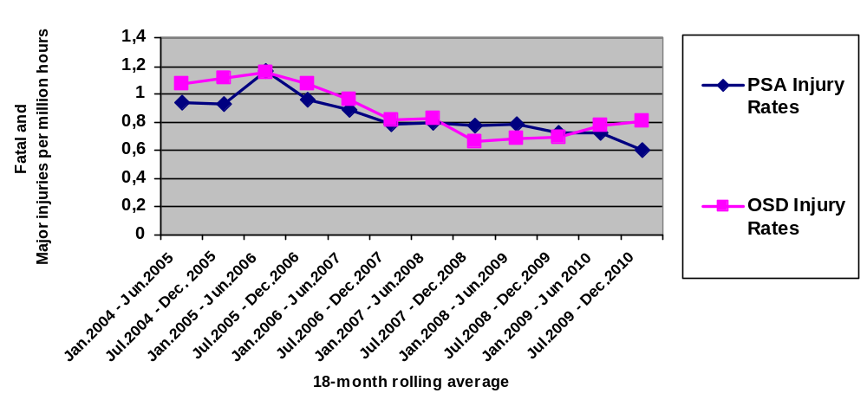

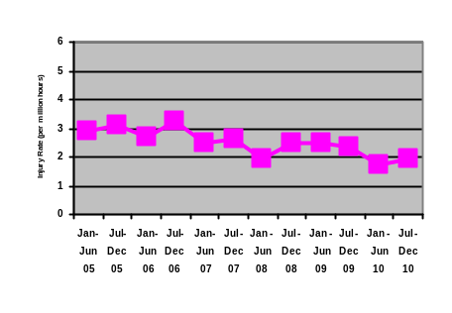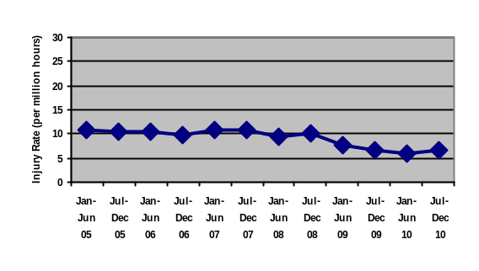
UK Over 3 day trends 2005/10 Norway minor injury trends 2005/10

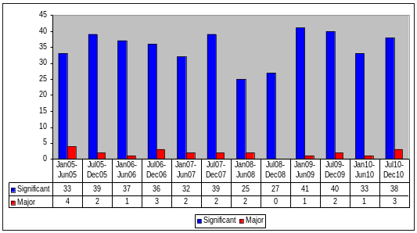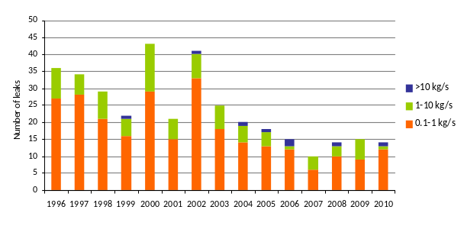

UK & Norway hydrocarbon releases – 'major & significant'

Table 3
14. All NSOAF members apply a goal setting regime based on risk assessment, following the essentials in the Drilling Hazardous Industries Directive 92/91/EC. The NSOAF plenary meetings provide for discussions and comparisons of safety performance trends and significant incidents. Harmonisation of data does require some interpretation, and only the UK and Norway appear to process their data in a bilateral exercise.
Mediterranean region
15. The 2009 report from Italy's Ministry of Economic Development (D.G. for Mining and Energy Resources) shows that lagging indicators for occupational health and safety performance is decreasing at a faster rate than the decline in production. Whilst this can be attributable partly to a low level of drilling activity overall, it is characteristic of the improvement globally in occupational safety performance. There were no reported occurrences of (potential) major hazards in the categories 'fires and explosions', 'ionising radiations' and 'loss of containment' The greater part of Italy's oil production (88%) is onshore, whereas 75% of gas production is from offshore areas. No offshore exploration wells were drilled in 2009, but 20 production and 'other' wells (e.g. for storage of gas) were drilled offshore.
Industry illustration
16. Industry associations have their own reporting systems for non governmental companies. These systems are obviously unable to enforce full or accurate reporting of injuries by making non-reporting a statutory offence. The Association of Oil and Gas Producers (OGP, comprising 42 major oil companies) produce the most respected statistics

OGP data 2009 | Europe | Best world comparator | Average
Lost time injury frequency (per 1m hours worked) | 1.31 – worst  (Italy worst  Germany best) | 0.26  (Middle East) | 0.45  (Africa 0.42 -nearest)
Total recorded injury rate (per 1m hours worked) | 3.05 – worst | 0.92  (Middle East) | 1.75  (Africa 1.25 -nearest)
Fatal accident rate* (per 100m hours worked) | 4.0 - worst | 2.1  (Asia/Australasia) | 3.2  (N & S America – 3.1 & 3.3 resp. – nearest)
Fatal accidents/fatal incident** | 3.5 - worst | 1.0  (Asia/Australasia) | 1.9  (N America 2.0 – nearest)
Table 4

* FAR is 5 year rolling average to even out spikes
** Average of number of persons killed in a single incident
That Europe should have the worst of all injury rates is not explained. Some of the major companies themselves report that Europe is not their best performing region. Another interpretation is that Europe has above average reporting rates, although this will not apply to fatal accidents. The North Sea region is prone to spikes of data arising from helicopter crashes because helicopters are the only mode of personnel transport – there were 21 fatal accidents reported in Europe in 2009, 16 as a result of a single helicopter incident. As a result, in 2009 Europe had a FAR of 6.58/100m hours worked – world's worst. Figures for 2010 for Europe were 0.97 – world's best. Last year's highest fatal accident rate was North America (Deepwater Horizon). When comparing OGP data with national data it should be noted that fatalities arising from helicopters in transit in Europe are counted as aviation incidents and not counted in the national authorities offshore sector databases

17. Comparing national (EU) data with OGP data we observe a common deficit, where OGP rates tend to be significantly lower than data collected under EU national statutory reporting schemes. For example both Netherlands, Norway (removing minor injury rates) and the UK report a lost time injury frequency of c. 4 / 1m hours worked for 2009, whereas the OGP reported rate for Europe (where the most significant proportion of the working population is in NL, No, UK) is 1.31.
18. Companies collect their own data, but generally do not publish specific information, tending instead to publish relative analysis (trends over time, normalised against industry. In general, companies show a steady improvement in occupational safety and health incident performance, reflecting the trends in the OGP data. Not all companies record accidents occurring to contractors that aren't in their direct employment. The accident rate amongst contractors is around twice the rate to oil company employees.
Environmental incident reporting
19. With the apparent exception of the Dutch regulator (State Supervision of Mines, SSM) reports of offshore environmental management data appears to be prepared by industry – either by companies, local trade associations, or OGP . Such reports may be coordinated by environmental regulators and accessible via the relevant Government agency website (for example, the Department of energy and Climate change, UK). Most EU environment regulators provide access to policy information and departmental guidance for environmental impact assessments and environmental supervision. However, details of sector spill performance and other failures of primary or secondary containment offshore related to potential accidents to the environment are somewhat more elusive than safety reports.
Leading indicators
20. Leading indicators focus on the process system not on incidents and injuries that have occurred. In major hazards sectors they comprise functions such as deep root cause analysis, application of risk assessment, levels of training and skills acquisition, and measurement of critical functions relating to potential failure of safety systems (such as barrier failures, and overpressure in closed systems). Their greatest value is where they are installation specific – i.e. they are selected for relevance to the prevailing circumstances – so they are less easy or useful to compare between different companies/countries/regions.
21. The value of well chosen leading indicators is in signalling an early warning of loss of integrity in the process control system, enabling remedy prior to failure occurring. The collection of site specific leading indicators is a positive indicator of a 'high reliability organisation' - a company with a strong safety culture, whose organisational arrangements and systems give a very high likelihood of outstanding safety and operational efficiency over the long term. Two European countries – Norway and UK - are recognised as leaders in the development and application of leading performance indicators. In addition, a current pilot NSOAF project is underway (with SSM chairing) to identify leading and lagging key indicators of safety performance (KPI's) in the oil and gas sector.
22. Looking back 30 years before Deepwater Horizon, there have been a number of offshore disasters in EU waters beginning with 123 deaths from the loss of Norway's Alexander Kielland in 1980. Whilst reliable data are hard to find, especially where disasters occurred in the pre-internet era, the North Sea has experienced a number of major hazard-type incidents in which lives were lost. Although not usually escalating to total platform and population loss (such as in the loss of Piper Alpha and 167 lives in 1988), these lesser events were nonetheless potential major disasters. We list some notable blowouts and other offshore disasters in Appendix 1 to this annex. Although not all of these incidents have been investigated in great depth, their frequency and scale are rough indicators that both likelihood and consequences of major offshore incidents are significant.
23. The development of goal setting regulation spreading out from Norway (1985) and the UK (1991) caused a significant reduction in major accidents involving loss of life due to process safety failures and blowouts during the 1990's. However during the 2000's major hazard incidents (well control incidents) and their precursor tell-tales (hydrocarbon leaks) have plateaued or begun to increase, whilst injury rates (which are mainly occupational in nature) have mostly fallen continuously. We are able to identify the favourable trends in occupational health and safety injury on a global scale from OGP data, but only in the North Sea and in some IRF countries (but not USA) can we look at major hazards indicators such as well incidents and hydrocarbon leaks and note the downward trend in this data category has stopped or is reversing.
24. The best available benchmarks of leading indicators are from the UK and Norway who have both published sequences of reports on major hazard risk indicators ^{3,} that indicate flat or upward trends in a number of major hazard risk indicators in the North Sea.
25. The latest Norwegian report is unequivocal in its risk trend report, concerning hydrocarbon leaks: "…a comparison of leak frequency on the Norwegian and British Continental Shelf shows there is potential for reduction on the Norwegian Continental Shelf". In other words, the targets for the period 2008 – 2010 have not been met and the trend is not one of continuous improvement. More directed, and not least continuous, effort is required to reverse the trend."
26. Norway has just published a hard-hitting report of its evaluation of the state of the offshore industry in the light of the Deepwater Horizon incident. In noting that the failures leading to that incident are familiar (and therefore implying that by now they should be effectively under control) Norway feels the Gulf of Mexico incident reflects unfavourably on the entire offshore community, including regulators and international processes. Norway also observes the Deepwater Horizon incident is symptomatic of inadequate safety culture going back 40 years. In looking at recent major incidents that include the Australia Montara incident, Norway further concludes there is significant diversity in the ways in which a major incident can occur (i.e. the incident shows the risk of incidents is higher than previously thought), and because Norway has a diverse environment, it must exercise increased vigilance on a number of risk fronts in its own offshore industry: areas such as technology, expertise and management. Norway also assesses that a goal setting and risk based approach to regulation is encouraged by the Deepwater Horizon incident (with which the US National Commission agrees). Norway concludes that it has more to do and sets out an early blueprint.
27. A 2009 report by the UK reported progress of industry on meeting the challenges in the UK Government's 2007 'KP3' report which found significant shortcomings in safety control in the UK sector. This report was widely hailed as a global indicator of the state of the global offshore oil sector. It is clear from the recent update report that progress has been made since 2007 but equally clear to the UK regulator that more effort and more consistency is necessary: "Asset integrity/process safety management: The review found evidence of considerably raised awareness of the need for effective process safety management and major hazard risk controls. It is clear, however, that further progress in the management of asset integrity is required. The industry must also focus effort on greater reduction of significant hydrocarbon releases to build upon progress already made."
28. In these two countries, both of whom have experienced offshore disasters on a terrible scale, there are robust, risk based regimes, diligent data collection and analysis, and objective, goal based intervention programmes. It is because of these characteristics that both countries are able to identify where efforts need to be made, and at the same time target expert resources to the key problems. Other North Sea countries - Netherlands, Denmark - exercise similar diligence and meet regularly to ensure cross-communication. Whereas it is not possible to quantitatively assess the risk everywhere of an offshore major incident, the view of those countries that are most penetrating in their oversight and assessment is that offshore risks are significant and can be reduced further.
29. The Netherlands regulator (SSM) currently chairs NSOAF's main committee. In this role, SSM has been actively encouraging the development of key performance indicators of major hazard risk controls. We include at Appendix 3 a recent letter sent on NSOAF's behalf to industry following a workshop on KPI's. The Netherlands is also active within its own regulatory frontier. For example SSM has requested its sector operators exceed the national reporting arrangement by recording process safety related incidents – near misses. These are not available for public examination, presumably because of the voluntary and therefore unenforceable nature of the data collection. The SSM is also active in IRF and NSOAF in pursuing the means to more usefully compare incident data between different jurisdictions – and acknowledges the difficulties in so doing.
30. It is clear that risk based regimes are doing most of the tightening of regulatory impact in response to their heightened sense of risk from their internal reviews. It is equally clear that other regimes are less able in this regard precisely because they are not organised as risk based major hazards regimes.
31. The overall and inevitable conclusion is that without a standard format for statutory reporting of offshore safety and near miss data – at least amongst regulators in the same region - there is little likelihood of any confidence in benchmarking any safety data – except fatal accident rates - between countries.
32. This conclusion is reflected in the ambition of members of NSOAF and IRF (both groups have members with first hand experience of offshore disasters – see Appendix 1) for achieving consistent reporting standards within their membership, and for developing better leading and lagging measures for process safety. The report of the National Commission inquiring into the Deepwater Horizon disaster finds, amongst its recommendations for improving the efficacy of its regulation of offshore, the need for "detailed requirements for incident and data concerning incidents and "near misses"" .
33. In Appendix 2 we reproduce an initial draft scoping list of potential indicators for standardised reporting. In Appendix 3 we show some of the work currently available or in development amongst EU countries on key performance indicators. The keys to good data transfer between jurisdictions will be in having relevant data to share, and in having this consistently defined and reliably reported by industry.
Appendix 1
Serious offshore incidents
Countries in red are non European IRF members
Countries in blue are European IRF members

1. Major offshore blow-outs causing big pollution/destruction since 1977
Norway Ekofisk (1977),
Mexico Ixtoc (1979/80),
UK Ocean Odyssey (1988)
USA Timbalier Bay (1992)
Egypt Temsah field (2004)
USA Deepwater Horizon (2010)
2. Offshore disasters in 30 years leading to Deepwater Horizon
Mexico Ixtoc - blowout 1979; 0 fatalities, 71 evacuees; oil flowed for 9 months
Norway Alexander Kielland – structural failure and capsize 1980; 123 killed
Canada Ocean Ranger 1982 - loss of buoyancy; 84 killed
China Glomar Java Sea – overwhelmed in storm1983; 81 killed
UK Piper Alpha – process plant explosion and fires 1988; 167 killed
Brazil Enchova – well blowout 1984; 42 killed (and rig totally destroyed in 1988)
Thailand Sea Crest – lost in storm 1989; 84-91 killed (8 of the dead were from the EU)
Brazil P.36 – explosions in process system 2001; 11 killed
India Mumbai High - fractured export riser and fires 2005; 22 killed
Mexico Usumacinta – gas leak then blowout of production wells 2007; 22 killed
USA Deepwater Horizon – blowout and fires 2010; 11 killed
Appendix 2
Scope of leading/lagging indicators for standardised reporting
1.Major incidents – occurrences & near misses
Major incidents are:
- collapse, overturning or failure of load-bearing parts of lifts, lifting equipment and other (temporary) structures (like scaffolds)
- explosion, collapse or bursting of any closed vessel or associated pipework
- failure of any freight container in any of its load-bearing parts
- electrical short circuit or overload causing fire or explosion
- any unintentional explosion of explosives
- accidental release of a biological agent likely to cause severe human illness
- failure of industrial radiography or irradiation equipment to de-energise or return to its safe position after the intended exposure period
- malfunction of breathing apparatus while in use or during testing immediately before use
- failure or endangering of diving equipment, the trapping of a diver, an explosion near a diver, or an uncontrolled ascent
- collapse or partial collapse of a scaffold over 5 metres high, or erected near water where there could be a risk of drowning after a fall
- incidents in relation to a well (e.g. uncontrolled release or diverted flow from a well)
- incidents in relation to a pipeline or pipeline works
- release of petroleum hydrocarbon on or from an offshore installation
- fire or explosion at an offshore installation, other than one to which the previous paragraph applies or not reported under the previous paragraph
- release or escape of a dangerous or toxic substance other than petroleum hydrocarbon on or from an offshore installation (e.g. H₂S release)
- collapse of an offshore installation or its plant
- failure of equipment required to maintain a floating offshore installation on station
- dropped objects on an offshore installation or on an attendant vessel or into water nearby
- damage to or on an offshore installation caused by adverse weather conditions
- (unauthorized) infringement of the safety zone around an offshore installation, including actual collision
- vessel on collision course towards an offshore installation
- subsidence or local collapse of the seabed near an offshore installation
- loss of stability or buoyancy of a floating offshore installation
- precautionary and emergency evacuation (not otherwise reportable) of an offshore installation, in the interests of safety
- any person falling into water ('man overboard')
2. Major incident – release to the marine environment (MATTE)
These are (unauthorized) release or spills of liquids and/or solids into the sea, over 1000 litre or 1000 kg. Examples:
- spills of liquid hydrocarbons (oil, diesel, OBM)
- chemicals, other than intended and/or permitted discharge
- waste
Notes
Injuries – fatal / major / over 3 day – reportable under domestic arrangements for occupational injury reporting – essential to harmonise N Sea criteria: Norway, UK/RIDDOR, and Netherlands (under Dir/92/91/EEC)
Where injuries result from major incident occurring, or consequential release to the marine environment, a major incident report must be submitted in addition to the occupational injury report

Appendix 3
Key Performance indicators
1. NSOAF report to industry
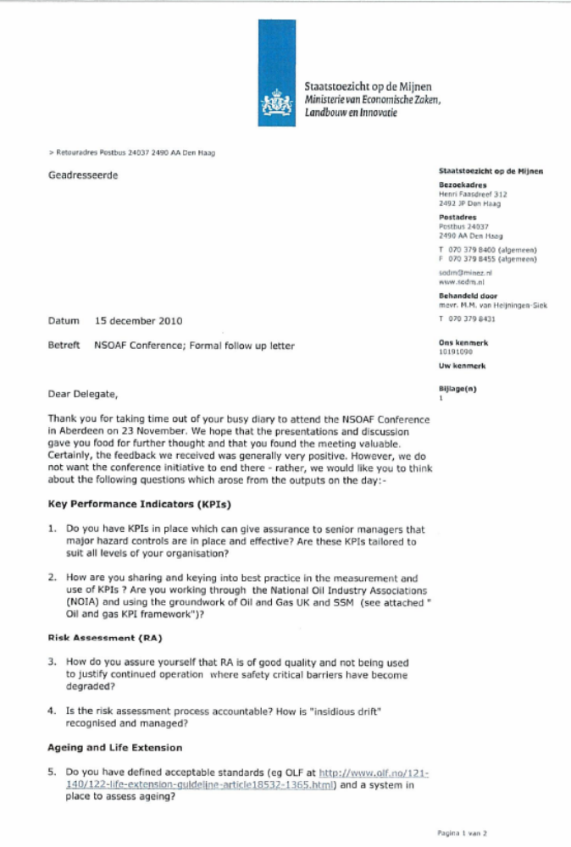
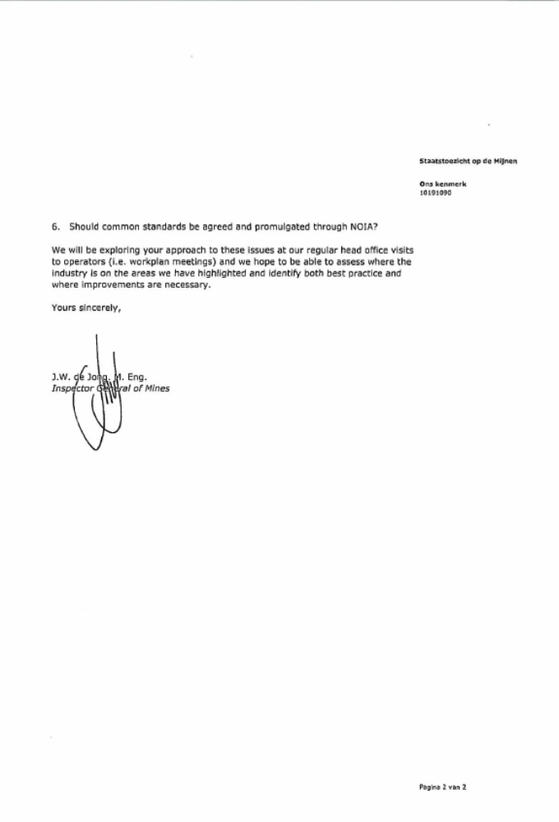
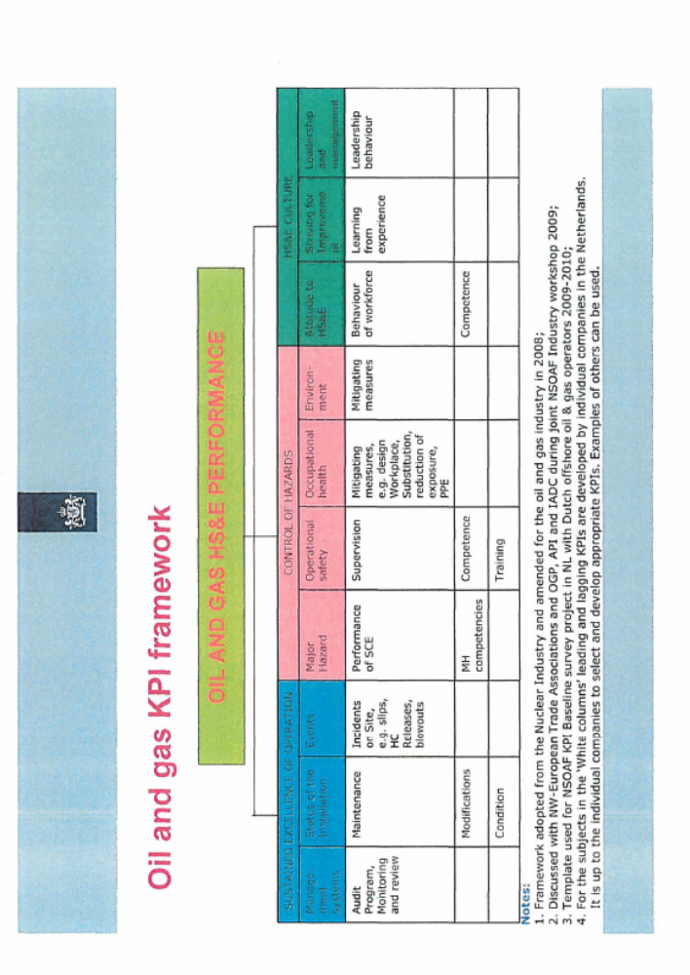

2. HSE leaflet on Key Performance Indicators
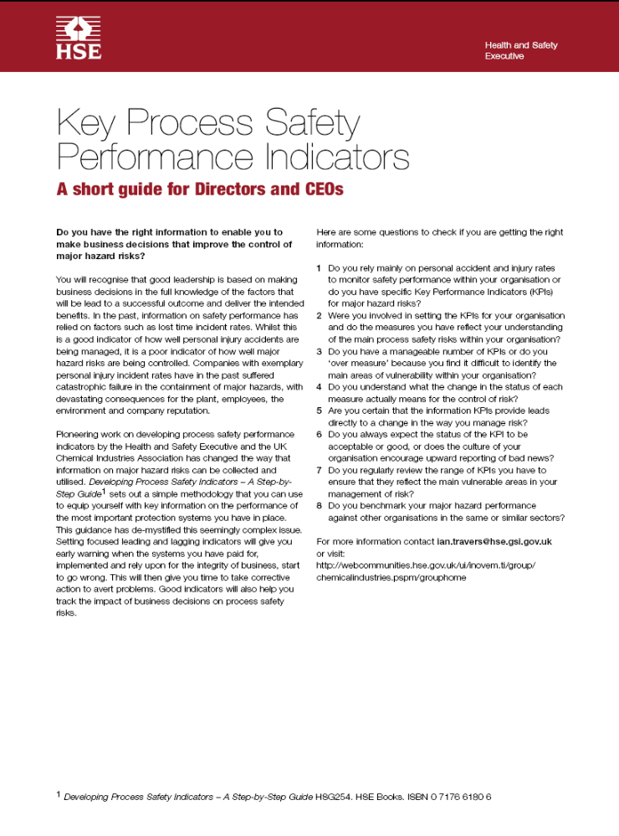

As defined in the Commission’s Impact Assessment Guidelines http://ec.europa.eu/governance/impact/commission_guidelines/docs/iag_2009_en.pdf, pp.45.
‘Testimony of Dr. Joseph R. Mason’, 06/04/2011, U.S. House of Representatives Subcommittee on Energy & Mineral Resources, http://naturalresources.house.gov/UploadedFiles/MasonTestimony04.06.11.pdf.
As per ‘Risk Assessment Data Directory – Major Accidents’, Report No. 434-17, March 2010, International Association of Oil & Gas Producers, http://www.ogp.org.uk/pubs/434-17.pdf
Total loss of the unit including constructive total loss from an insurance point of view; however, the unit may be repaired and put into operation again.
Severe damage to one of more modules of the unit; large/medium damage to load-bearing structures; major damage to essential equipment.
‘Impact Assessment Guidelines’, 15/01/2009, European Commission, SEC(2009) 92, p.43.
HSE Economic Analysis Unit (EAU) appraisal values, 2006 (Q3) Short version, 28/07/08, http://www.hse.gov.uk/economics/eauappraisal.htm
‘Transocean Ltd. Provides Deepwater Horizon Update’, 26/04/2010, Transocean Ltd, http://www.deepwater.com/fw/main/Transocean-Ltd-Provides-Deepwater-Horizon-Update-451C936.html?LayoutID=46
BP Sustainability Review 2010, http://www.bp.com/liveassets/bp_internet/globalbp/STAGING/global_assets/e_s_assets/e_s_assets_2010/downloads_pdfs/bp_sustainability_review_2010.pdf
BP fourth quarter and full year 2010 results, http://www.bp.com/liveassets/bp_internet/globalbp/STAGING/global_assets/downloads/B/bp_fourth_quarter_2010_results.pdf
Under the US Clean Water Act, 1,100 dollars are to be paid for each barrel spilled; this amount may increase to 4,300 dollars if the spill is the result of gross negligence.
Source: ‘Cost of Spills’, The International Tanker Owners Pollution Federation Limited, http://www.itopf.com/spill-compensation/cost-of-spills/
‘Risk Assessment Data Directory – Major Accidents’, Report No. 434-17, March 2010, International Association of Oil & Gas Producers, http://www.ogp.org.uk/pubs/434-17.pdf
Costs estimated in December 2009 US dollars and include property damage, debris removal, and cleanup. Excluded were the costs of business interruption, extra expense, employee injuries and fatalities, and liability claims. Source: ‘The 100 Largest Losses 1972-2009; Large Property Damage Losses in the Hydrocarbon-Chemical Industries’, 2009, Marsh Property Risk Consulting, http://www.marshriskconsulting.com/Load/article_1219057.pdf
Offshore blowouts result from gas, or gas and oil escaping out of control under high pressure from subsurface reservoirs during drilling or production. Oil may be released either at the water surface or on the sea bottom, depending on the type of drilling rig being used, and other factors. Every modern rig has a set of large control valves, known as blowout preventers, to stop the flow of oil, gas and other well fluids if problems occur during drilling.
Definition as per SINTEF, http://www.sintef.no/Home/Technology-and-Society/Safety-Research/Projects/SINTEF-Offshore-Blowout-Database/
‘Press release: Munich Re develops new insurance solution for oil catastrophes’, 12/09/2010, The Munich Reinsurance Company, http://www.munichre.com/en/media_relations/press_releases/2010/2010_09_12_press_release.aspx
Source: ITOPF, http://www.itopf.com/information-services/data-and-statistics/statistics/#major; Deepwater Horizon MC252 Gulf Incident Oil Budget (August 4, 2010), http://www.noaanews.noaa.gov/stories2010/PDFs/DeepwaterHorizonOilBudget20100801.pdf; Jane Lubchenco et al., BP Deepwater Horizon Oil Budget: What Happened to the Oil? (August 4, 2010), http://www.usgs.gov/foia/budget/08-03-2010...Oil%20Budget%20description%20FINAL.pdf
The Iran-Iraq war either caused or prevented blowouts in this field from being capped.
http://home.versatel.nl/the_sims/rig/ekofiskb.htm
‘Well Integrity: Big contributor to Major Accident Risk’, 20/02/2008, Petroleum Safety Authority, Norway, http://www.ptil.no/well-integrity/big-contributor-to-major-accident-risk-article4157-145.html
In the case of the offshore spill, there may be greater release, a greater degree of uncertainty about the size of the spill, a different type of oil dispersal due to release near the seabed, and a more complex (and potentially costly) process for capping a spill. Conversely, a large number of tanker wrecks occur on, or close to the coastline, potentially increasing cleanup costs when compared with offshore spills due to shoreline oiling.
Communication from the Commission to the European Parliament and the Council on a second set of Community measures on maritime safety following the sinking of the oil tanker Erika, COM(2000) 802 final, http://eur-lex.europa.eu/LexUriServ/LexUriServ.do?uri=COM:2000:0802:FIN:EN:PDF
The Prestige: one year on, a continuing disaster, http://www.wwf.fi/www/uploads/pdf/Prestige_raportti_marras03.pdf
‘Report of the Working Group on Environmental Risk Evaluation Criteria within the context of Formal Safety Assessment’, Agenda item 17, Marine Environment Protection Committee, 60th session, 24/03/2010, International Maritime Organization, http://www.martrans.org/documents/2009/sft/MEPC%2060-WP.11.pdf.
International Oil Pollution Compensation Funds, http://www.iopcfund.org.
UK Deepwater Drilling - Implications of the Gulf of Mexico Oil Spill - Energy and Climate Change Committee, UK House of Commons, p26, http://www.publications.parliament.uk/pa/cm201011/cmselect/cmenergy/450/450i.pdf
‘Worldwide Analysis of Marine Oil Spill Cleanup Cost Factors’, Dagmar Schmidt Etkin, 2000, Presented at Arctic and Marine Oilspill Program Technical Seminar, http://www.environmental-research.com/erc_papers/ERC_paper_2.pdf
‘Annual Report and Form 20-F 2010’, BP plc, http://www.bp.com/assets/bp_internet/globalbp/globalbp_uk_english/set_branch/STAGING/common_assets/downloads/pdf/BP_Annual_Report_and_Form_20F.pdf, p.73
‘Environmental Statement: Appraisal Well 204/10a-D (Cambo 4)’, 2011, http://www.hesscorporation.com/environmentalstatement/Well20410a-D_Cambo4ES-13-01-11.pdf
‘Risk Assessment Data Directory – Major Accidents’, Report No. 434-17, March 2010, International Association of Oil & Gas Producers, http://www.ogp.org.uk/pubs/434-17.pdf
‘Offshore Injury, Ill Health and Incident Statistics 2009/2010: HID Statistics Report HSR 2010 – 1’, 10/12/2010, UK Health and Safety Executive, http://www.hse.gov.uk/offshore/statistics/hsr0910.pdf; ‘Trends in Risk Level in the Petroleum Activity: Summary Report 2009– Norwegian Continental Shelf’, 27/04/2010, Norway Petroleum Safety Authority, http://www.ptil.no/getfile.php/PDF/RNNP%202009/Trends%20in%20risk%20levels%20-%20Summary%20Report%202009.pdf
Source: ‘Offshore Injury, Ill Health and Incident Statistics 2009/2010: HID Statistics Report HSR 2010 – 1’, December 2010, Health & Safety Executive, Hazardous Installations Directorate, Offshore Division (OSD), http://www.hse.gov.uk/offshore/statistics/hsr0910.pdf
‘Impact Assessment Guidelines’, 15/01/2009, European Commission, SEC(2009) 92, p.43.
HSE Economic Analysis Unit (EAU) appraisal values, 2006 (Q3) Short version, 28/07/08, http://www.hse.gov.uk/economics/eauappraisal.htm
SINTEF Offshore Blowout Database, http://www.sintef.no/sintefcom/Technology-and-Society/Safety-Research/Projects/SINTEF-Offshore-Blowout-Database/
An incident where hydrocarbons flow from the well at some point where flow was not intended and the flow was stopped by use of the barrier system that was available on the well at the time of the incident. Definition as per SINTEF.
https://www.og.decc.gov.uk/information/wells.htm
http://factpages.npd.no/factpages/Default.aspx?culture=en
‘Blowout and Well Release Frequencies – Based on SINTEF Offshore Blowout Database, 2005’, 26/06/2006, Scandpower, http://www.oljevernportalen.no/nofo/Dokumenter/90005001_r2_2006_1.pdf
HPHT wells are wells with expected shut-in pressure equal to or above 690 bar (10,000 psi) and/or bottomhole temperature exceeding 150°C. ‘Well integrity in drilling and well operations’, NORSOK standard D010, Rev. 3, August 2004, http://www.npd.no/Global/Norsk/5%20-%20Regelverk/Skjema/Br%C3%B8nnregistrering/Norsok_standard_D-010.pdf
‘HSE Information sheet: Guidance on Risk Assessment for Offshore Installations’, Offshore Information Sheet No. 3/2006, 2006, UK Health and Safety Executive.
As provided in ‘Risk Assessment Data Directory – Blowout Frequencies’, Report No. 434-2, March 2010, International Association of Oil & Gas Producers, http://www.ogp.org.uk/pubs/434-02.pdf
Excluding shallow gas incidents and assuming: 1) 7% of all wells drilled are HPHT; 2) 0.08 coiled tubing operations per well year; 3) 0.05 snubbing operations per well year; and 4) 0.17 workover operations per well year, all as per Scandpower. Number of wells does not include those in Bulgaria, Cyprus, Germany, Malta, or Romania.
‘Accident Statistics for Offshore Units on the UKCS 1990-2007 Issue 1’, April 2009, Oil & Gas UK, http://www.oilandgasuk.co.uk/cmsfiles/modules/publications/pdfs/EHS30.pdf. Data from the UK Corporate Operational Information system, SINTEF Offshore Blowout Database, DNV’s Worldwide Offshore Accident Databank and UK Marine Accident Investigation Branch.
Det Norske Veritas defined blowout as: “An uncontrolled flow of gas, oil or other fluids from the reservoir, i.e. loss of 1. barrier (i.e. hydrostatic head) or leak and loss of 2. barrier, i.e. BOP/DHSV.”
In correspondences with the Commission, HSE disputes these figures, noting that HSE wells specialists would only have identified only one of the four incidents Det Norske Veritas used to calculate blowout probabilities as a blowout.
Oil wells are defined as wells where the formation has an estimated gas/oil ratio of less than 1,000. Gas wells are defined as wells where the formation has an estimated gas/oil ratio of more than 1,000.
Scandpower figures are based on a sample of 95,270 oil well years and 82,204 gas well years in the combined areas of US GoM and North Sea.
Det Norske Veritas, Environmental Risk Assessment of Exploration Drilling in Nordland VI, Report No. 20/04/2010, http://www.olf.no/PageFiles/6525/Environmental%20risk%20assessment%20of%20exploration%20drilling%20in%20Nordland%20VI.pdf
‘Environmental Statement: Appraisal Well 204/10a-D (Cambo 4)’, 2011, http://www.hesscorporation.com/environmentalstatement/Well20410a-D_Cambo4ES-13-01-11.pdf
‘Notification of order to Statoil – Gullfaks C’, 19/11/2010, Petroleum Safety Authority Norway, http://www.ptil.no/news/notification-of-order-to-statoil-gullfaks-c-article7409-79.html.
‘Communication from the Commission on the Precautionary Principle’, Brussels, 02/02/2000, Commission Of The European Communities, COM(2000) 1, http://ec.europa.eu/dgs/health_consumer/library/pub/pub07_en.pdf
Source: http://www.ptil.no/ageing-and-life-extension/category626.html
Source: http://www.offshore-mag.com/index/article-display/9114015229/articles/offshore/equipment-engineering/north-sea-northwest-europe/2010/08/hse-launches_uk_platform.html
There are activities planned in the UK, west of Shetlands at sea depths of up to 1,600 metres, near the Faroe Islands at sea depths of 1,100 metres and in Norway at up to 1,700 metres.
Prospecting is taking place in the Barents Sea and off Greenland. In April 2011, Statoil announced a significant oil discovery on the Skrugard prospect in the Barents Sea.
"HPHT developments in the UKCS" Ref http://www.hse.gov.uk/research/rrpdf/rr409.pdf
"kick" is an industry term used for situations of sudden escalation of well pressure leading to temporary disruption of the standard operation of the well.
Council Directive 96/82/EC of 9 December 1996 on the control of major-accident hazards involving dangerous substances, OJ L 345, 31.12.2003, p. 97–105, amended by Directive 2003/105/EC of the European Parliament and of the Council of 16 December 2003 amending Council Directive 96/82/EC on the control of major-accident hazards involving dangerous substances, OJ L 345, 31.12.2003, p. 97–105
It comprises identifying major accident scenarios, assessing consequences and likelihood to evaluate risks, identifying control and mitigation measures, and developing suitable management arrangements for implementing the measures. The approach to each MAH site should be contained within a company safety report or safety case. This may be provided to the national regulator for regulatory assessment.
The UK HSE’s Advisory Committee on the Safety of Nuclear Installations (ACSNI: HSC, 1993) produced a definition of safety culture that has been re-used extensively: ‘The safety culture of an organisation is the product of individual and group values, attitudes, perceptions, competencies, and patterns of behaviour that determine the commitment to, and the style and proficiency of, an organisation’s health and safety management. And: 'Organisations with a positive safety culture are characterised by communications founded on mutual trust, by shared perceptions of the importance of safety and by confidence in the efficacy of preventive measures’ This is referred to in the USA Presidential Commission report Ch.8 pp 217.
More details on available studies and reports in Annex IX.
UK offshore enforcement statistics since 2001/02 (comprising the total number of prosecutions and statutory improvement or prohibition notices) are broadly steady over the past 10 years at 49/year (2010/11 provisionally = 47). See Annex XIII for more information on benchmarking between sectors/countries.
E.g. of OSPAR countries five (UK, N, NL, DK and D) have evaluated their operations and all have identified improvement needs.(source: Investigations of Drilling in Extreme Conditions and their Relevance to Potential Environmental Impacts - Preliminary report)
For example along the lines of Senior Labour Inspectors' Committee (SLIC), or the North Sea Offshore Authorities Forum in other regions. Refer to DG.EMPL/B3 website for further information.
Often focus only on lagging performance indicators such as past incidents but not on leading ones, deep cause analyses, lessons learned etc
The Seveso Directive requires extensive reporting by both operators and Member States.
Ref United Nations Convention on the Law of the Sea, 1964.
Under this approach, operators are required to identify and assess the major risks case by case and demonstrate to the national authorities how these risks would be managed. In certain jurisdictions, the document used is called 'safety case'.
For example, Romania and Bulgaria have seemingly less comprehensive regulatory regimes than the North Sea states.
As defined in the Commission’s Impact Assessment Guidelines http://ec.europa.eu/governance/impact/commission_guidelines/docs/iag_2009_en.pdf, pp.45.
Some aspects, in particular workers' health and safety in the sector are addressed in EU legislation.
http://ec.europa.eu/governance/impact/commission_guidelines/docs/ia_guidelines_annexes_en.pdf.
Such as the Offshore Installations (Prevention of Fire and Explosion, and Emergency Response) Regulations 1995 (PFEER) the Offshore Installations and Wells (Design and Construction, etc) Regulations 1996 (DCR) and the Offshore Installations (Safety Case) Regulations 2005 (SCR05).
Source: ‘Offshore Injury, Ill Health and Incident Statistics 2009/2010: HID Statistics Report HSR 2010 – 1’, December 2010, Health & Safety Executive, Hazardous Installations Directorate, Offshore Division, http://www.hse.gov.uk/offshore/statistics/hsr0910.pdf
‘Assessment Principles for Offshore Safety Cases (APOSC)’, March 2006, Health & Safety Executive, Hazardous Installations Directorate, Offshore Division (OSD), http://www.hse.gov.uk/offshore/aposc190306.pdf
Source: ‘Offshore Injury, Ill Health and Incident Statistics 2009/2010: HID Statistics Report HSR 2010 – 1’, December 2010, Health & Safety Executive, Hazardous Installations Directorate, Offshore Division, http://www.hse.gov.uk/offshore/statistics/hsr0910.pdf.
Source: Det Norske Veritas, WOAD - Worldwide Offshore Accident Databank, v5.0.1. Summarized in ‘Risk Assessment Data Directory – Major Accidents’, Report No. 434-17, March 2010, International Association of Oil & Gas Producers.
Blowout frequencies, Report no. 434-2, March 2010, http://www.ogp.org.uk/pubs/434-02.pdf
‘Summary of differences between offshore drilling regulations in Norway and U.S. Gulf of Mexico’, 02/08/2010, Det Norske Veritas, http://www.nofo.no/stream_file.asp?iEntityId=924
Source: International Regulator's Forum, IRF Country Performance Measures, http://www.irfoffshoresafety.com/country/performance/
International Regulator's Forum, IRF Country Performance Measures, http://www.irfoffshoresafety.com/country/performance/
Det Norske Veritas, Environmental Risk Assessment of Exploration Drilling in Nordland VI, Report No. 20/04/2010, http://www.olf.no/PageFiles/6525/Environmental%20risk%20assessment%20of%20exploration%20drilling%20in%20Nordland%20VI.pdf
‘Large spills’ defined as spills of over 1,000 bbl. ‘Risk Assessment Data Directory – Major Accidents’, Report No. 434-17, March 2010, International Association of Oil & Gas Producers, http://www.ogp.org.uk/pubs/434-17.pdf
Source: European Commission questionnaire data.
Although the baseline scenario has been calculated on this basis, it is likely that actual figures are higher because of the higher accident indicator rates associated with prescriptive offshore safety regimes.
See, for example, ‘PSA seeks explanation from Statoil after Gullfaks B gas leak’, 24/03/2011, Petroleum Safety Authority, Norway, http://www.ptil.no/news/psa-seeks-explanation-from-statoil-after-gullfaks-b-gas-leak-article7730-79.html.
Number of staff include all management, professional (senior inspectors, inspectors and other technical staff), legal and administrative staff combined. Installations include all fixed, mobile and subsea production and drilling units. Source: European Commission questionnaire data collected from Denmark (Danish Energy Agency, but not including the relevant staff of the Ministry of the Environment), Italy (National Office for Mining, Hydrocarbons and Geothermal Resources), the Netherlands (State Supervision of Mines), Norway (Petroleum Safety Authority and Climate and Pollution Agency), and the UK (Health and Safety Executive, Department of Energy and Climate Change).
The Italian regulator was unable to supply details of its overall budget, preventing a direct comparison of other this indicator of regulator resources.
Source: European Commission questionnaire data.
Source: European Commission questionnaire data collected from Denmark (Danish Energy Agency, but not including the relevant staff of the Ministry of the Environment), Italy (National Office for Mining, Hydrocarbons and Geothermal Resources), the Netherlands (State Supervision of Mines), Norway (Petroleum Safety Authority and Climate and Pollution Agency), and the UK (Health and Safety Executive, Department of Energy and Climate Change).
Installations include all fixed, mobile and subsea production and drilling units. Source: European Commission questionnaire data collected from Denmark (Energi Styrelsen, but not including the relevant staff of Miljøministeriet), Spain (Minesterio de Industria, Turismo y Comercio), the Netherlands (Staatstoezicht op de Mijnen) and the UK (Health and Safety Executive, Department of Energy and Climate Change).
Corrected for differences in national hourly wage rates according to Eurostat hourly labour costs, 2004, http://epp.eurostat.ec.europa.eu/tgm/table.do?tab=table&init=1&plugin=0&language=en&pcode=tps00173.
Source: European Commission questionnaire data.
Source: European Commission questionnaire data.
This figure is based on only the running costs reported by the company in question and indicated in the Figure 6. One off expenditures have been excluded.
Source: European Commission questionnaire data.
This figure is based on only the running costs reported by the company in question and indicated in the Figure 6. One off expenditures have been excluded.
‘Deep Water: The Gulf Oil Disaster and the Future of Offshore Drilling’, National Commission on the BP Deepwater Horizon Oil Spill and Offshore Drilling, 01/2011, pp. 129-171, http://www.gpoaccess.gov/deepwater/deepwater.pdf; Report of the Montara Commission of Inquiry, Commissioner David Borthwick, 18/06/2010, Commonwealth of Australia. Presented to parliament on 24 November 2010, pp. 23, 294-5, 315, 370, http://www.ret.gov.au/Department/Documents/MIR/Montara-Report.pdf
COM(2010) 600 final, 26.10.2010
‘Deep Water: The Gulf Oil Disaster and the Future of Offshore Drilling’, National Commission on the BP Deepwater Horizon Oil Spill and Offshore Drilling, 01/2011, pp. 245-6, http://www.gpoaccess.gov/deepwater/deepwater.pdf; ‘Emergency Response, Doctrinal Confusion, and Federalism in the Deepwater Horizon Oil Spill’, Thomas A. Birkland and Sarah E. DeYoung, 2011, Publius 41(3), pp. 471-493.
Impact assessment study into possible options for amending the Seveso II Directive, Final Report, September 2010, COWI, http://ec.europa.eu/environment/seveso/pdf/Seveso%20IA_Final%20report.pdf
After levelling-up to North Sea standards, the running safety compliance costs to industry are estimated at €100,000 per well per year, as the reader will recall from Section 1.2 of this annex. There are 6,315 operational wells in Europe.
‘Press Release: Offshore industry warned over ‘not good enough’ safety statistics’, 24/08/2010, Health & Safety Executive, http://www.hse.gov.uk/press/2010/hse-offshorestats.htm
UK data on dangerous occurrences, which can also be seen as an indicator of the likely risk of a major incident, does not go back long enough to be able draw any conclusions from it (2003/04). This data has, therefore, not been presented.
Source: ‘Trends in Risk Level – Summary report 2010’, 29/04/2011, Petroleum Safety Authority, Norway, http://www.ptil.no/getfile.php/PDF/RNNP%202010/Summary_Report_2010_rev1a1.pdf.
Source: European Commission questionnaire data collected from Italy (Ufficio Nazionale Minerario per gli Idrocarburi e le Georisorse), the Netherlands (Staatstoezicht op de Mijnen), and the UK (Health and Safety Executive, Department of Energy and Climate Change).
Assuming a linear relationship between activity levels and resources devoted to activities. Source: European Commission questionnaire data collected from Denmark, Italy, the Netherlands, Norway, Spain and the UK. Figure does not include the budgets of the regulators of Germany, the Faroe Islands, Ireland or Malta.
‘The principle of Radioactive Waste Management’, 1995, IAEA Publications, http://www-pub.iaea.org/MTCD/publications/PDF/Pub989e_scr.pdf.
‘Proposal for a COUNCIL DIRECTIVE on the management of spent fuel and radioactive waste’, COM/2010/0618 final - NLE 2010/0306
‘Conference Summary: 3rd International Regulators’ Offshore Safety Conference’, 20/10/2010, International Regulators’ Forum, http://www.irfoffshoresafety.com/conferences/2010conference/summary.aspx.
Source: European Commission questionnaire data.
The figure used for the total combined budget was €87.7 million.
Total offshore authority staff for the aforementioned EEA Member States is 506. Source: European Commission questionnaire data collected from Denmark (Danish Energy Agency, but not including the relevant staff of the Ministry of the Environment), Italy (National Office for Mining, Hydrocarbons and Geothermal Resources), the Netherlands (State Supervision of Mines), Norway (Petroleum Safety Authority and Climate and Pollution Agency), and the UK (Health and Safety Executive, Department of Energy and Climate Change).
Source: European Commission questionnaire data collected from Spain (Ministry of Industry, Tourism and Trade), the Netherlands (State Supervision of Mines), Norway (Petroleum Safety Authority and Climate and Pollution Agency), and the UK (Health and Safety Executive, Department of Energy and Climate Change).
This estimation does not include Bulgaria, Germany, Ireland, Malta or Romania.
‘Capping and Containment: Global Industry Response Group Recommendations’, Report No. 464, May 2011, International Association of Oil & Gas Producers, http://www.ogp.org.uk/pubs/464.pdf.
‘EMSA 2011 Budget’, European Maritime Safety Agency, http://www.emsa.europa.eu/component/flexicontent/download/966/214/23.html.
‘EMSA 2011 Budget’, European Maritime Safety Agency, http://www.emsa.europa.eu/component/flexicontent/download/966/214/23.html.
Source: European Commission questionnaire data collected from Denmark (Danish Energy Agency, but not including the relevant staff of the Ministry of the Environment), Italy (National Office for Mining, Hydrocarbons and Geothermal Resources), the Netherlands (State Supervision of Mines), Norway (Petroleum Safety Authority and Climate and Pollution Agency), and the UK (Health and Safety Executive, Department of Energy and Climate Change).
Article 194
Article 153(1) and (2)
Article 191(2), first indent
See COM(2008) 791 final of 25.11.2008 and COM(2010) 771 of 17.12.2010
COM(2010) 461 final of 8.9.2010
ECJ case C-188/07 (Commune de Mesquer v Total France SA and Total International Ltd.) provides important jurisprudence. The ECJ in the abovementioned case concerning maritime transport (Erika tanker accident) came to the conclusion that oil accidentally spilled at sea following a shipwreck, mixed with water and sediment and drifting along or being washed at the coast of a Member States constitutes waste within the meaning of the Waste Framework Directive.
See for instance the Van de Walle case (C-1/03) with Texaco being considered as holder of waste or Mesquer case (C-187/03) with Total being potential holder of waste.
Directive 94/22/EC of the European Parliament and of the Council of 30 May 1994 on the conditions for granting and using authorizations for the prospection, exploration and production of hydrocarbons
Focus is only on the main elements of this capability as opposed to detailed requirements which vary according to the different geological, geophysical, technical and other circumstances of each individual case.
ALARP refers to 'risks as low as reasonably practicable'. It is at the centre of UK health and safety law and as such is referred to by a number of respondents. For a risk to be ALARP it must be demonstrated that the cost involved in reducing the risk further would be grossly disproportionate to the benefit gained. In its most general (European wide) sense it is a best common practice of judgement of the balance between risk in absolute terms, and societal benefit - deciding at which point further expenditure to reduce the residual risk is unreasonable
Refer to S. 3.3.2 (6) for clarification of the term Competent Authority, which is related to law and not to skill
NSOAF stands for the North Sea Offshore Authorities Forum, a voluntary grouping of offshore regulatory authorities from the North Sea area used by them for exchange of information and views on issues of common interest.
Explanatory reference
International groups like OGP, and national ones like OLF (Norway) and Oil and Gas UK work intensively with national agencies on hardware and operational solutions to respond to deepwater drilling incidents.
Such as those developed for the Baltic Sea under the Helsinki Convention (http://www.helcom.fi/).
Directive 2004/35/CE of the European Parliament and of the Council of 21 April 2004 on environmental liability with regard to the prevention and remedying of environmental damage
Directive 2000/60/EC
Directive 2008/56/EC
Lifecyle stages: Design options, construction and commissioning; operations and maintenance; modification and decommissioning
This would include aspects like good practices for major hazards control; revised technical standards in, for example, well control and process safety, well capping and emergency response; and establishment of cooperative associations for sharing assets for tackling major pollution events.
Lifecyle stages: Design options, construction and commissioning; operations and maintenance; modification and decommissioning
Regulation (EC) No 1013/2006 of the European Parliament and of the Council of 14 June 2006 on shipments of waste
These include: guidance on good practices for major hazards control; revised technical standards in, for example, well control and process safety, well capping and emergency response; and establishment of cooperative associations for sharing assets for tackling major pollution events.
Commission Decision 95/319/EC
International Association of Oil and Gas Producers, http://www.ogp.org.uk/
Global Industry Response Group recommendations – OGP Reports 463, 464 and 465, May 2011
International Petroleum Industry Environmental Conservation Association: the global oil and gas industry association for environmental and social issues – www.ipieca.org
OSPRAG Second Interim Report – April 2011.
BOP: Blow-Out Preventer: safety device to close-in or seal off a (flowing) well.
Offshore Pollution Liability Association Ltd. A voluntary, industry mutual agreement to settle claims as a result of an oil spill. Current limit for claims is set at $ 250 million per occurrence.
Operators Co-operative Emergency Service, provides a framework around which an operator may acquire equipment from another operator in an emergency, even across international boundaries.
UK:- http://www.hse.gov.uk/pubns/priced/l73.pdf
DG SANCO:- https://webgate.ec.europa.eu/idb/documents/2009-IDB-Report_screen.pdf
OGP 2010 report Appendix D. http://www.ogp.org.uk/pubs/455.pdf There are 11 reports from Europe in the latest report: 1 each from Denmark and NL, and 9 from Greenland.
Sanco report says "Please note that despite the harmonisation efforts undertaken by the respective data centres and data providers in the member states, the injury statistics may not always be completely comparable and the differentiation in sections of injury surveillance is not always clear-cut. There are many reasons for this ranging from differences in the organisation of the national health care systems to cultural differences in the reporting of injury causes".
IRF data sheet 2009: http://www.irfoffshoresafety.com/country/performance/IRF_CountryPublicationData_2009.xls
For entry to the data bank: http://www.hse.gov.uk/statistics/index.htm
Latest (to 2010) is at: http://www.hse.gov.uk/offshore/statistics/hsr0910.pdf ; see also a quick synopsis (to 2011) at: http://www.hse.gov.uk/offshore/statistics/stat1011.htm
Ministero dello Sviluppo Economico/ Dipartimento per l'Energia / Direzione Generale per le Risorse Minerale ed Energetiche 2009: http://unmig.sviluppoeconomico.gov.it/unmig/stat/ra2009.pdf
http://www.ogp.org.uk/pubs/455.pdf
OGP 2009 environmental report: http://www.ogp.org.uk/pubs/442.pdf
DECC portal for OSPAR agreed environmental management statements is at: https://www.og.decc.gov.uk/environment/ospar_eems_recomm_opers.htm ; environmental emissions management system, operated by O&G UK is at: https://www.og.decc.gov.uk/EEMS/index.htm
Danish Energy Agency annual report 2010 pp 35-42: http://www.ens.dk/Documents/Netboghandel%20-%20publikationer/2011/Denmarks_oil_and_gas_production_2010.pdf ; see also DECC policy and guidance at: https://www.og.decc.gov.uk/
Developing process safety key performance indicators http://www.hse.gov.uk/pubns/priced/hsg254.pdf ; Norway: Trends in risk level in the petroleum activity 2010: http://www.ptil.no/getfile.php/PDF/RNNP%202010/Summary_Report_2010_rev1a1.pdf
The UK trade body, Oil & Gas UK, has recently initiated a voluntary arrangement amongst its members to report on 2 leading indicators of safety – non compliances with the independent verification scheme; and safety critical maintenance backlogs
UK KP3 report update 2009: http://www.hse.gov.uk/offshore/kp3review.pdf Norway Safety – status & signals 2010 http://www.ptil.no/getfile.php/PDF/SAFETY%202010.pdf
English summary of PSA's evaluation of DwH disaster: http://www.ptil.no/getfile.php/PDF/DwH_PSA_summary.pdf

