

**ANNEX III – Formula for a distribution key**

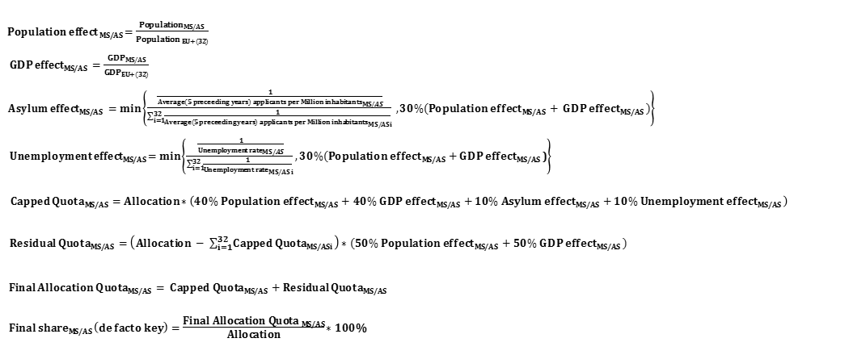

**ANNEX IV**

**Detailed procedural rules to apply the crisis relocation mechanism**

1. Each Member State shall appoint a national contact point, whose address it shall communicate to the other Member States and to EASO. Member States shall, in liaison with EASO and other relevant agencies, take all the appropriate measures to establish direct cooperation and an exchange of information between the competent authorities, including about the grounds referred to in paragraph 8.

2. Member States shall, at regular intervals, and at least every three months, indicate the number of applicants who can be relocated swiftly to their territory and any other relevant information.

3. Based on information referred to in paragraph 2, the Member State benefiting from relocation shall with the assistance of EASO and, where applicable, Member States' liaison officers referred to in paragraph 9, identify the individual applicants who could be relocated to the other Member States and, as soon as possible, submit all relevant information to the contact points of those Member States. Priority shall be given for that purpose to vulnerable applicants within the meaning of Articles 21 and 22 of Directive 2013/33/EU.

4. Following approval of the Member State of relocation, the Member State benefiting from relocation shall, as soon as possible, take a decision to relocate each of the identified applicants to a specific Member State of relocation, in consultation with EASO, and shall notify in writing the applicant of the decision to relocate him or her to a specific Member State of relocation.

5. Member States shall ensure that family members to whom the relocation applies are relocated to the territory of the same Member State.

6. Applicants whose fingerprints are required to be taken pursuant to the obligations set out in Article 9 of Regulation (EU) No 603/2013 may only be proposed for relocation if their fingerprints have been taken and transmitted to the Central System of Eurodac, pursuant to that Regulation.

7. The relocation of the applicant to the territory of the Member State of relocation shall take place as soon as possible following the date of the notification to the person concerned of the relocation decision referred to in Article 33d. The Member State benefiting from relocation shall transmit to the Member State of relocation the date and time of the relocation as well as any other relevant information.

8. Member States shall have the right to refuse to relocate an applicant only where there are reasonable grounds for regarding him or her as a danger to their national security or public order or where there are serious reasons for applying the exclusion provisions set out in Article 12 and 17 of Directive 2011/95/EU.

9. For the implementation of all aspects of the relocation procedure described in this Article, Member States may decide to appoint in the Member State benefiting from relocation liaison officers after exchanging all relevant information.

10. Identification, registration and fingerprinting for the relocation procedure shall be guaranteed by the Member State benefiting from relocation and the necessary facilities shall be in place. Applicants that elude the relocation procedure shall be excluded from relocation.

11. The relocation procedure provided for in this Annex shall be completed as swiftly as possible and not later than two months from the time of the indication given by the Member State of relocation referred to in paragraph 2, unless the approval by the Member State of relocation referred to in paragraph 4 takes place less than two weeks before the expiry of this two months period. In such case, the time limit for completing the relocation procedure may be extended by no more than two weeks. In addition, this time limit may also be extended, with a further four weeks period, as appropriate, where the Member State benefiting from relocation justify objective practical obstacles preventing the transfer from taking place.

Where the relocation procedure is not completed within this time limit and unless the Member State benefiting from relocation agree with the Member State of relocation to a reasonable extension of the time limit, the Member State benefiting from relocation remain responsible for examining the application for international protection.

12. Following the relocation of the applicant, the Member State of relocation shall take and transmit to the Central System of Eurodac the fingerprints of the applicant in accordance with Article 9 of Regulation (EU) No 603/2013 and update the data sets in accordance with Article 10, and where applicable, with Article 18 of that Regulation.