

*ANNEX I*Testing, grading and measurement of tyre parameters

Part A: Fuel efficiency classes

The fuel efficiency class shall be determined and illustrated on the label on the basis of the rolling resistance coefficient (RRC) according to the ‘A’ to ‘G’ scale specified below and measured in accordance with Annex 6 to UNECE Regulation No 117 and its subsequent amendments and aligned according to the procedure laid down in Annex VI.

If a tyre type is approved for more than one tyre class (e.g. C1 and C2), the grading scale used to determine the fuel efficiency class of this tyre type shall be that which is applicable to the highest tyre class (e.g. C2, not C1).

|  |  |  |  |  |  |
| --- | --- | --- | --- | --- | --- |
| C1 tyres | | C2 tyres | | C3 tyres | |
| RRC *in kg/t* | *Energy*  *efficiency*  *class* | RRC *in kg/t* | *Energy*  *efficiency*  *class* | RRC *in kg/t* | *Energy*  *efficiency*  *class* |
| RRC ≤ *5,4* | *A* | RRC ≤ *4,4* | *A* | RRC ≤ *3,1* | *A* |
| *5,5 ≤* RRC ≤ *6,5* | *B* | *4,5 ≤* RRC ≤ *5,5* | *B* | *3,2 ≤* RRC ≤ *4,0* | *B* |
| *6,6 ≤* RRC *≤ 7,7* | *C* | *5,6 ≤* RRC ≤ *6,7* | *C* | *4,1 ≤* RRC ≤ *5,0* | *C* |
| *7,8 ≤ RRC ≤ 9,0* | *D* | *6,8 ≤ RRC ≤ 8,0* | *D* | *5,1 ≤* RRC ≤ *6,0* | *D* |
| *9,1 ≤* RRC ≤ *10,5* | *E* | *8,1 ≤* RRC ≤ *9,2* | *E* | *6,1 ≤* RRC ≤ *7,0* | *E* |
| RRC ≥ *10,6* | *F* | RRC ≥ *9,3* | *F* | RRC ≥ *7,1* | *F* |

Part B: Wet grip classes

1. The wet grip class shall be determined and illustrated on the label on the basis of the wet grip index (G) according to the ‘A’ to ‘G’ scale specified in the table below, calculated in accordance with point 2 and measured in accordance with Annex 5 to UNECE Regulation 117.
2. Calculation of wet grip index (G)

G = G(T) - 0,03

where:

G(T) = wet grip index of the candidate tyre as measured in one test cycle

|  |  |  |  |  |  |
| --- | --- | --- | --- | --- | --- |
| C1 tyres | | C2 tyres | | C3 tyres | |
| G | *Wet grip class* | G | *Wet grip class* | G | *Wet grip class* |
| *1,68 ≤* G | *A* | *1,53 ≤* G | *A* | *1,38 ≤* G | *A* |
| *1,55 ≤* G ≤ *1,67* | *B* | *1,40 ≤* G ≤ *1,52* | *B* | *1,25 ≤* G ≤ *1,37* | *B* |
| *1,40 ≤* G ≤ *1,54* | *C* | *1,25 ≤* G ≤ *1,39* | *C* | *1,10 ≤* G ≤ *1,24* | *C* |
| *1,25 ≤ G ≤ 1,39* | *D* | *1,10 ≤ G ≤ 1,24* | *D* | *0,95 ≤* G ≤ *1,09* | *D* |
| *1,10 ≤* G ≤ *1,24* | *E* | *0,95 ≤* G ≤ *1,09* | *E* | *0,80 ≤* G ≤ *0,94* | *E* |
| G ≤ *1,09* | *F* | G ≤ *0,94* | *F* | *0,65 ≤ G ≤ 0,79* | *F* |
| *Empty* | *G* | *Empty* | *G* | *G ≤ 0,64* | *G* |

Part C: External rolling noise classes and measured value

The external rolling noise measured value (N) shall be declared in decibels and calculated in accordance with Annex 3 to UNECE Regulation No 117.

The external rolling noise class shall be determined and illustrated on the label on the basis of the limit values (LV) set out in Part C of Annex II of Regulation (EC) No 661/2009 as follows.

*N* in dB

External rolling noise class



*N ≤ LV* - 6



*LV* - 6 < *N ≤ LV - 3*



*N* > *LV - 3*

Part D: Snow grip

The snow performance shall be tested in accordance with Annex 7 to UNECE Regulation No 117.

A tyre which satisfies the minimum snow index values set out in UNECE Regulation No 117 shall be classified as a snow tyre and the following icon shall be included on the label.

[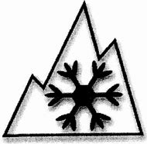](https://www.bing.com/images/search?view=detailV2&ccid=gbwP6gKs&id=06A6A9741E4F458CC3F8F1DD8229EE2C745AFAB6&thid=OIP.gbwP6gKsZYyXXkoSCNTvFwHaHP&q=alpine++tyre+icon&simid=608034313243066907&selectedIndex=0)

Part E: Ice grip:

The ice performance shall be tested in accordance with ISO 19447.

A tyre which satisfies the minimum ice index value set out in ISO 19447 shall be classified as an ice tyre and the following icon shall be included on the label.



*ANNEX II*Format of the label

# Labels

## The following information shall be included in the labels in accordance with the illustrations below.

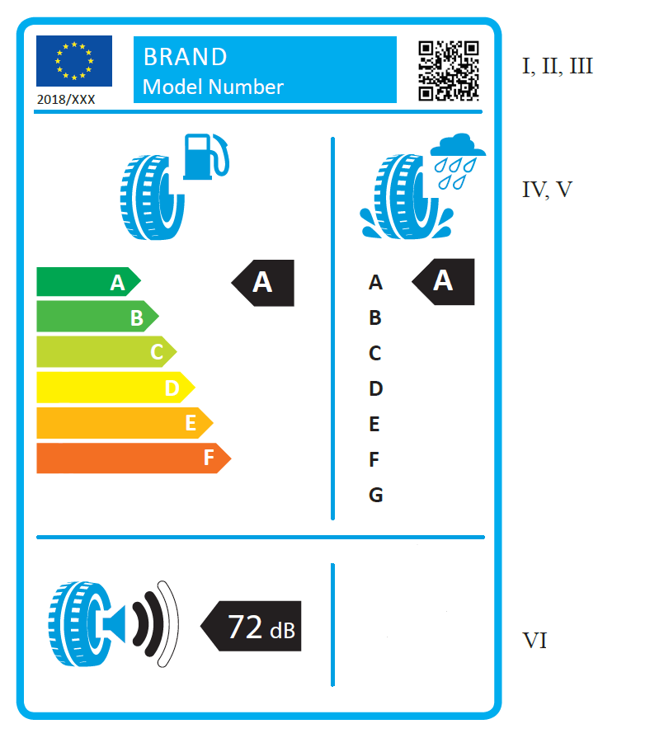

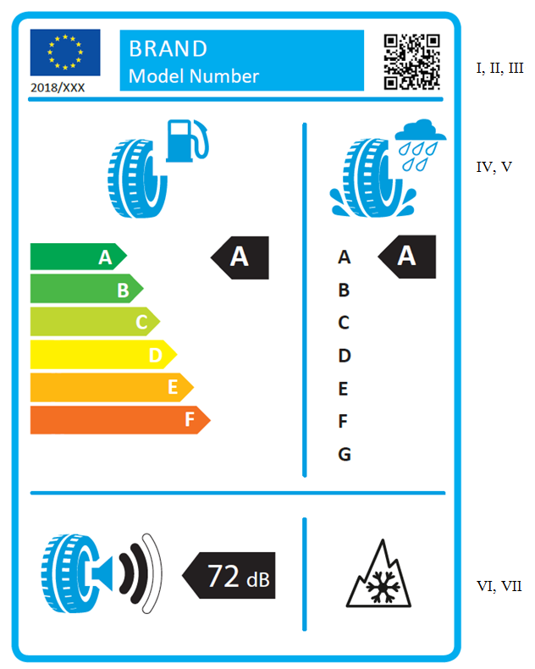

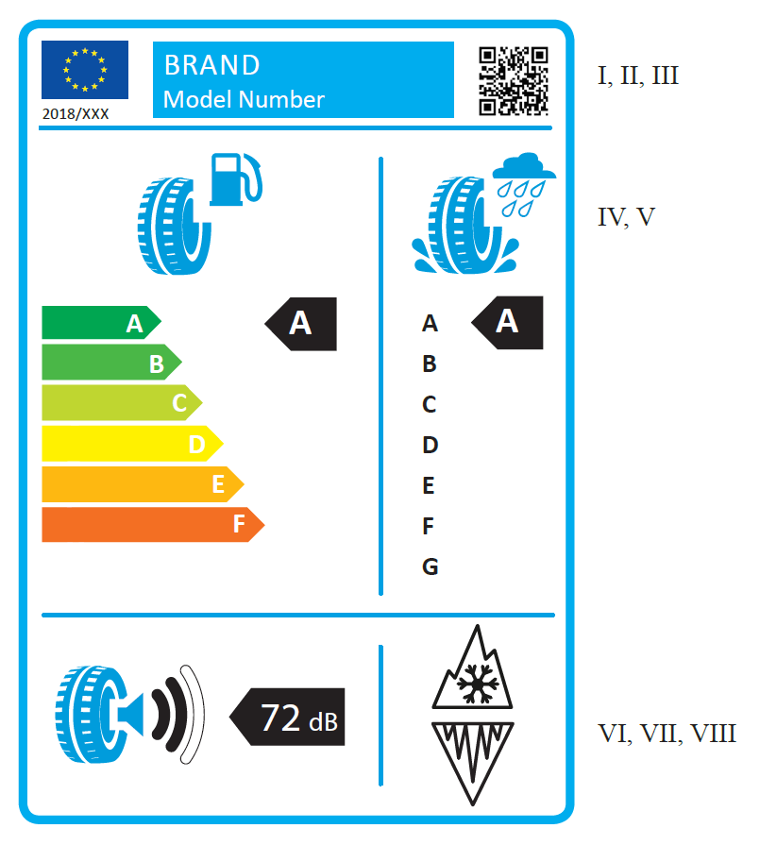

I. Supplier's name or trademark;

II. Supplier’s model identifier, where ‘model identifier’ means the code, usually alphanumeric, which distinguishes a specific tyre type from other type with the same trade mark or supplier’s name;

III. QR code;

IV. Fuel efficiency;

V. Wet grip;

VI. External rolling noise;

VII. Snow grip;

VIII. Ice grip.

# Label design

## The design of the label shall be as in the figure below:

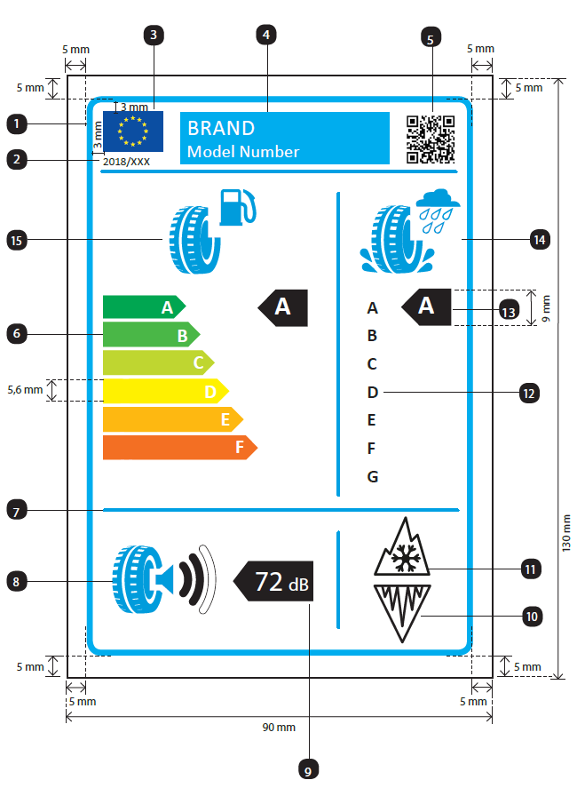

## The label shall be at least 90 mm wide and 130 mm high. Where the label is printed in a larger format, its content shall nevertheless remain proportionate to the specifications above.

## The label shall conform to the following requirements:

* + - 1. Colours are CMYK - cyan, magenta, yellow and black - and are given following this example: 00-70-X-00: 0 % cyan, 70 % magenta, 100 % yellow, 0 % black;
      2. The numbers listed below refer to the legends indicated in point 2.1.:
         1. Label border: stroke: 1,5 pts - colour: X-10-00-05;
         2. Calibri regular 8 pts;
         3. European flag: width: 15 mm, height: 10 mm;
         4. Banner: width: 51,5 mm, height: 13 mm;

Text "BRAND": Calibri regular 15 pts, 100 % white;

Text "Model Number": Calibri regular 13 pts, 100 % white;

* + - * 1. QR code: width: 13 mm, height: 13 mm;
        2. ‘A’ to ‘F’ scale:

Arrows: height: 5,6 mm, gap: 0,78 mm, black stroke: 0,5 pt - colours:

* A: X-00-X-00;
* B: 70-00-X-00;
* C: 30-00-X-00;
* D: 00-00-X-00;
* E: 00-30-X-00;
* F: 00-70-X-00.
  + - * 1. Line: width: 88 mm, height: 2 pts - Colour: X-00-00-00;
        2. Pictogram external rolling noise:

Pictogram as supplied: width: 25,5 mm, height: 17 mm - colour: X-10-00-05;

* + - * 1. Arrow:

Arrow: width: 20 mm, height: 10 mm, 100 % black;

Text: Helvetica Bold 20 pts, 100 % white;

Unit text: Helvetica Bold 13 pts, 100 % white;

* + - * 1. Pictogram ice:

Pictogram as supplied: width: 15 mm, height: 15 mm – stroke: 1,5 pts - colour: 100 % black;

* + - * 1. Pictogram snow:

Pictogram as supplied: width: 15 mm, height: 15 mm – stroke: 1,5 pts - colour: 100 % black;

* + - * 1. ‘A’ to ‘G’: Calibri regular 13 pts – 100% black;
        2. Arrows:

*Arrows*: width: 11,4 mm, height: 9 mm, 100 % black;

Text: Calibri Bold 17 pts, 100 % white;

* + - * 1. Pictogram fuel efficiency:

Pictogram as supplied: width: 19,5 mm, height: 18,5 mm - colour: X-10-00-05;

* + - * 1. Pictogram wet grip:

Pictogram as supplied: width: 19 mm, height: 19 mm - colour: X-10-00-05.

* + - 1. The background shall be white.

## The tyre class shall be indicated on the label in the format prescribed in the illustration in point 2.1.

*ANNEX III*Technical documentation

The technical documentation referred to in Article 4(7) shall include the following:

* + - 1. the name and address of the supplier;
      2. identification and signature of the person empowered to bind the supplier;
      3. trade name or trade mark of the supplier;
      4. the tyre model,
      5. the tyre dimension, load index and speed rating;
      6. the references of the measurement methods applied.

*ANNEX IV*  
Product information sheet

The information in the product information sheet of tyres shall be included in the product brochure or other literature provided with the product and shall include the following:

* + - 1. supplier's name or trade mark;
      2. supplier's model identifier;
      3. fuel efficiency class of the tyre in accordance with Annex I;
      4. wet grip class of the tyre in accordance with Annex I;
      5. external rolling noise class and decibels in accordance with Annex I;
      6. whether the tyre is a snow tyre;
      7. whether the tyre is an ice tyre.

*ANNEX V*Information provided in technical promotional material

1. Information on tyres included in technical promotional material shall be provided in the order specified as follows:
   * + 1. the fuel efficiency class (letter ‘A’ to ‘F’);
       2. the wet grip class (letter ‘A’ to ‘G’);
       3. the external rolling noise class and measured value (dB);
       4. whether the tyre is a snow tyre;
       5. whether the tyre is an ice tyre.
2. The information provided in point 1 shall meet the following requirements:
   * + 1. be easy to read;
       2. be easy to understand;
       3. if different grading is available for a given tyre type depending on dimension or other parameters, the range between the least and best performing tyre is stated.
3. Suppliers shall also make the following available on their websites:
   * + 1. a link to the relevant Commission webpage dedicated to this Regulation;
       2. an explanation of the pictograms printed on the label;
       3. a statement highlighting the fact that actual fuel savings and road safety depend heavily on the behaviour of drivers, and in particular the following:

* eco-driving can significantly reduce fuel consumption;
* tyre pressure needs to be regularly checked to optimise wet grip and fuel efficiency performance;
* stopping distances must always be strictly respected.

*ANNEX VI*Laboratory alignment procedure for the measurement of rolling resistance

# Definitions

For the purposes of the laboratory alignment procedure, the following definitions shall apply:

1. ‘reference laboratory’ means a laboratory that is part of the network of laboratories the name of which have been published for the purpose of the alignment procedure in the Official Journal of the European Union, and is able to achieve the accuracy of test results determined in Section 3 with its reference machine;
2. ‘candidate laboratory’ means a laboratory participating in the alignment procedure that is not a reference laboratory;
3. ‘alignment tyre’ means a tyre that is tested for the purpose of performing the alignment procedure;
4. ‘alignment tyres set’ means a set of five or more alignment tyres for the alignment of one single machine;
5. ‘assigned value’ means a theoretical value of the Rolling Resistance Coefficient (RRC) of one alignment tyre as measured by a theoretical laboratory which is representative of the network of reference laboratories that is used for the alignment procedure;
6. ‘machine’ means every tyre testing spindle in one specific measurement method. For example, two spindles acting on the same drum shall not be considered as one machine.

# General provisions

## Principle

The measured (*m*) Rolling Resistance Coefficient in a reference laboratory (l), (*RRCm,l*), shall be aligned to the assigned values of the network of reference laboratories.

The *measured (m) Rolling Resistance Coefficient obtained by a machine in a candidate laboratory (c), RRCm,c*, shall be aligned through one reference laboratory of the network of its choice.

## Tyre selection requirements

A set of five or more alignment tyres shall be selected for the alignment procedure in compliance with the criteria below. One set shall be selected for C1 and C2 tyres together, and one set for C3 tyres.

* + - 1. The set of alignment tyres shall be selected so as to cover the range of different RRCs of C1 and C2 tyres together, or of C3 tyres. In any event, the difference between the highest RRCm of the tyre set, and the lowest RRCm of the tyre set shall be, before and after alignment, at least equal to:

(i) 3 kg/t for C1 and C2 tyres; and

(ii) 2 kg/t for C3 tyres.

* + - 1. The RRCm in the candidate or reference laboratories (*RRCm,c* or *RRCm,l*) based on declared RRC values of each alignment tyre of the set shall be distributed evenly.
      2. Load index values shall adequately cover the range of the tyres to be tested, ensuring that the rolling resistance force values also cover the range of the tyres to be tested.

Each alignment tyre shall be checked prior to use and replaced when:

* + - 1. it shows a condition which makes it unusable for further tests; and/or
      2. there are deviations of *RRCm,c* or *RRCm,l* greater than 1,5 per cent relative to earlier measurements after correction for any machine drift.

## Measurement method

The reference laboratory shall measure each alignment tyre four times and retain the three last results for further analysis, in accordance with paragraph 4 of Annex 6 of UNECE Regulation No 117 and its subsequent amendments and applying the conditions set out in paragraph 3 of Annex 6 of UNECE Regulation No 117 and its subsequent amendments.

The candidate laboratory shall measure each alignment tyre (n + 1) times with n being specified in Section 5 and retain the n last results for further analysis, in accordance with paragraph 4 of Annex 6 of UNECE Regulation No 117 and its subsequent amendments and applying the conditions set out in paragraph 3 of Annex 6 of UNECE Regulation No 117 and its subsequent amendments.

Each time an alignment tyre is measured, the tyre/wheel assembly shall be removed from the machine and the entire test procedure specified in paragraph 4 of Annex 6 of UNECE Regulation No 117 and its subsequent amendments shall be followed again from the start.

The candidate or reference laboratory shall calculate:

* + - 1. the measured value of each alignment tyre for each measurement as specified in Annex 6, paragraphs 6.2 and 6.3, of UNECE Regulation No 117 and its subsequent amendments (i.e. corrected for a temperature of 25 °C and a drum diameter of 2 m);
      2. the mean value of the three (in the case of reference laboratories) or n (in the case of candidate laboratories) last measured values of each alignment tyre; and
      3. the standard deviation (σm) as follows:





where:

i is the counter from 1 to p for the alignment tyres;  
j is the counter from 2 to n+1 for the n last repetitions of each measurement of a given alignment tyre  
n+1 is the number of repetitions of tyre measurements (n+1=4 for reference laboratories and n+1 ≥4 for candidate laboratories);  
p is the number of alignment tyres (p ≥ 5).

## Data formats to be used for the computations and results

* The measured RRC values corrected from drum diameter and temperature shall be rounded to 2 decimal places.
* Then the computations shall be made with all digits: there shall be no further rounding except on the final alignment equations.
* All standard deviation values shall be displayed to 3 decimal places.
* All RRC values will be displayed to 2 decimal places.
* All alignment coefficients (A1l, B1l, A2c and B2c) shall be rounded and displayed to 4 decimal places.

# Requirements applicable to the reference laboratories and determination of the assigned values

The assigned values of each alignment tyre shall be determined by a network of reference laboratories. Every second year the network shall assess the stability and validity of the assigned values.

Each reference laboratory participating in the network shall comply with the specifications of Annex 6 of UNECE Regulation No 117 and its subsequent amendments and have a standard deviation (σm) as follows:

* + - 1. not greater than 0,05 kg/t for class C1 and C2 tyres; and
      2. not greater than 0,05 kg/t for class C3 tyres.

The sets of alignment tyres, conforming to the specification of Section 2.2 shall be measured in accordance with Section 2.3 by each reference laboratory of the network.

The assigned value of each alignment tyre is the average of the measured values given by the reference laboratories of the network for this alignment tyre.

# Procedure for the alignment of a reference laboratory to the assigned values

Each reference laboratory (l) shall align itself to each new set of assigned values and always after any significant machine change or any drift in machine control tyre monitoring data.

The alignment shall use a linear regression technique on all individual data. The regression coefficients, A1l and B1l, shall be calculated as follows:



where:

*RRC* is the assigned value of the rolling resistance coefficient;

*RRCm,l* is the individual measured value of the rolling resistance coefficient by the reference laboratory “l” (including temperature and drum diameter corrections).

# Requirements applicable to candidate laboratories

Candidate laboratories shall repeat the alignment procedure at least once every second year for every machine and always after any significant machine change or any drift in machine control tyre monitoring data.

A common set of five different tyres, conforming to the specification of Section 2.2 shall be measured in accordance with Section 2.3 firstly by the candidate laboratory and later on by one reference laboratory. More than five alignment tyres may be tested at the request of the candidate laboratory.

The alignment tyre set shall be provided by the candidate laboratory to the selected reference laboratory.

The candidate laboratory (c) shall comply with the specifications of Annex 6 of UNECE Regulation No 117 and its subsequent amendments and preferably have standard deviations (am) as follows:

* + - 1. not greater than 0,075 kg/t for C1 and C2 tyres; and
      2. not greater than 0,06 kg/t for C3 tyres.

If the standard deviation (σm) of the candidate laboratory is higher than the above values with four measurements, the last three ones being used for the computations, then the number n+1 of measurement repetitions shall be increased as followsfor the entire batch:

*n+1 = 1+(σm/γ)2*, rounded up to the nearest higher integer value

where:

γ = 0,043 kg/t for Class C1 and C2 tyres

γ = 0,035 kg/t for Class C3 tyres

# Procedure for the alignment of a candidate laboratory

One reference laboratory (i) of the network shall calculate the linear regression function on all individual data of the candidate laboratory (c). The regression coefficients, A2c and B2c, shall be calculated as follows:



where:

*RRCm,l* is the individual measured value of the rolling resistance coefficient by the reference laboratory (i) (including temperature and drum diameter corrections)

*RRCm,c* is the individual measured value of the rolling resistance coefficient by the candidate laboratory (c) (including temperature and drum diameter corrections)

If the coefficient of determination R² is lower than 0,97, the candidate laboratory shall not be aligned.

The aligned RRC of tyres tested by the candidate laboratory is calculated as follows:



*ANNEX VII*Verification procedure

The conformity with this Regulation of the declared fuel efficiency, wet grip and external rolling noise classes, as well as the declared values, and any additional performance information on the label, shall be assessed for each tyre type or each grouping of tyres as determined by the supplier, according to one of the following procedures:

* + - 1. a single tyre or tyre set is tested first:

1. if the measured values meet the declared classes or external rolling noise declared value within the tolerance defined in Table 1, the test is successfully passed;

2. if the measured values do not meet the declared classes or external rolling noise declared value within the range defined in Table 1, three more tyres or tyre sets are tested. The average measurement value stemming from the three tyres or tyre sets tested is used to assess conformity with the declared information within the range defined in Table 1;

* + - 1. where the labelled classes or values are derived from type approval test results obtained in accordance with Regulation (EC) No 661/2009, or UNECE Regulation No 117 and its subsequent amendments, Member States may make use of measurement data obtained from conformity of production tests on tyres.

Assessment of the measurement data obtained from the conformity of production tests shall take into account the allowances defined in Table 1.

*Table 1*

|  |  |
| --- | --- |
| Measured parameter | Verification tolerances |
| Rolling resistance coefficient (fuel efficiency) | The aligned measured value shall not be greater than the upper limit (the highest RRC) of the declared class by more than 0,3 kg/1 000kg. |
| External rolling noise | The measured value shall not be greater than the declared value of N by more than 1 dB(A). |
| Wet grip | The measured value G(T) shall not be lower than the lower limit (the lowest value of G) of the declared class. |
| Snow grip | The measured value shall not be lower than the minimum snow performance index. |
| Ice grip | The measured value shall not be lower than the minimum ice performance index. |

*ANNEX VIII*Correlation table

|  |  |
| --- | --- |
| Regulation (EC) No 1222/2009 | This Regulation |
| Article 1(1) | Article 1(1) |
| Article 1(2) | Article 1(2) |
| Article 2(1) | Article 2(1) |
| Article 2(2) | Article 2(2) |
| Article 3(1) | Article 3(1) |
| Article 3(2) | Article 3(2) |
| - | Article 3(3) |
| Article 3(3) | Article 3(4) |
| Article 3(4) | Article 3(5) |
| **-** | Article 3(6) |
| Article 3(5) | Article 3(7) |
| - | Article 3(8) |
| - | Article 3(9) |
| Article 3(6) | Article 3(10) |
| Article 3(7) | Article 3(11) |
| Article 3(8) | Article 3(12) |
| Article 3(9) | Article 3(13) |
| Article 3(10) | Article 3(14) |
| Article 3(11) | Article 3(15) |
| - | Article 3(16) |
| Article 3(12) | Article 3(17) |
| Article 3(13) | Article 3(18) |
| - | Article 3(19) |
| Article 4 | Article 4 |
| Article 4(1) | Article 4(1) |
| Article 4(1)(a) | Article 4(1)(b) |
| Article 4(1)(b) | Article 4(1)(b) |
| Article 4(2) | - |
| - | Article 4(2) |
| - | Article 4(3) |
| Article 4(3) | Article 4(4) |
| Article 4(4) | Article 4(6) |
| - | Article 4(5) |
| - | Article 4(6) |
| - | Article 4(7) |
| - | Article 4(8) |
| - | Article 4(9) |
| - | Article 5 |
| Article 5 | Article 6 |
| Article 5(1) | Article 6(1) |
| Article 5(1)(a) | Article 6(1)(a) |
| Article 5(1)(b) | Article 6(1)(b) |
| - | Article 6(2) |
| - | Article 6(3) |
| Article 5(2) | Article 6(4) |
| Article 5(3) | - |
| - | Article 6(5) |
| - | Article 6(6) |
| - | Article 6(7) |
| Article 6 | Article 7 |
| Article 7 | Article 8 |
| Article 8 | Article 9 |
| Article 9(1) | Article 10(1) |
| Article 9(2) | - |
| Article 10 | Article 10(2) |
| Article 11 | Article 12 |
| - | Article 12(a) |
| - | Article 12(b) |
| - | Article 12(c) |
| Article 11(a) | - |
| Article 11(b) | - |
| Article 11(c) | Article 12(d) |
| Article 12 | Article 11 |
| - | Article 11(1) |
| - | Article 11(2) |
| - | Article 11(3) |
| - | Article 13 |
| Article 13 | - |
| Article 14 | - |
| - | Article 14 |
| Article 15 | - |
|  |  |
| - | Article 15 |
| - | Article 16 |
| Article 16 | Article 17 |